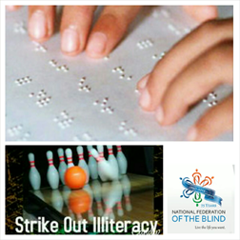

Strike Out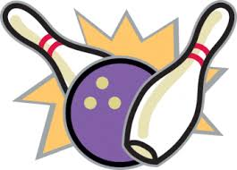 Illiteracy

BOWL-A-THON

Benefiting National Federation of the Blind of Maryland, Maryland Parents of Blind Children
Dear Bowl-a-Thon Team Captain:
Thank you in advance for your contribution to the Strike Out Illiteracy Bowl-a-Thon, by joining our annual tradition of bowling for dollars! This bowl-a-Thon raises critical funds for blind children in Maryland and is a great way for work and social groups to team-build and have fun!
The Strike Out Illiteracy Bowl-a-Thon will be held on April 18, 2015. We’re counting on you to join in the
fun by bringing a team of your own to compete at AMS Bowling in Woodlawn, Maryland.
AMS Woodlawn Lanes
6410 Security Blvd Baltimore Maryland 21207
April 18, 2015 2pm -4pm
Behind the scenes our volunteers, generous donors and sponsors will be back to make this a successful
event.
The National Federation of the Blind of Maryland, Maryland Parents of Blind Children knows that blindness is not the characteristic which defines blind children and their futures. Every day we raise the expectations of blind children and their families because low expectations create obstacles between blind people and their dreams. Blind children can live the lives they want. Blindness is not what holds them back.
Funds raised from this event will be used to support
The National Federation of the Blind Braille Enrichment for Literacy and Learning (NFB BELL) program—being held July 27-August 7 for students in elementary school in three locations this year!
Stipends for blind elementary, middle and high school students to attend summer training programs
Grants for families of blind children to attend the 75th annual National Convention of the National Federation of the Blind July 5-10 in Orlando, FL

Thank you for your past Bowl-a-Thon support! If you’re new, we are glad you’re here!

TEAM CAPTAIN KICK-OFF MEETING
Monday, MARCH 18 at 3:30 p.m. CONFRENCE CALL
Please find in your packets:
Team Sign-up Sheet
Team Captain/Individual Responsibilities
Fundraising Incentive Awards
GO FUND ME (online fundraising)
Pledge Sheets
Donation Receipts
STRIKE OUT BOWL-A-THON Benefiting NFBMD MDPOBC
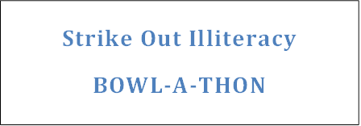

TEAM CAPTAIN SIGN-UP
Please print clearly and include each bowler's name. (Lane reservations are not confirmed until team information is received by a MDPOBC Board Member.)
Bowling:
Team Name:_________________________________________________________________________
Business/Company/Name:______________________________________________________________
Address:_____________________________________________________________________________
Captain’s Name:__________________ ___________ Captain’s Phone:_____________________ _____ Captain’s Email:________________________________________________________________________
BOWLER’S NAMES and T-Shirt Size (men’s sizes)
1.________________________________________________________________________
(Captain)
2.________________________________________________________________________
3.________________________________________________________________________
4.________________________________________________________________________
5.________________________________________________________________________
6.________________________________________________________________________
Please fax, mail or email this form to:
Mail:
Teresa Graham
Bowl-a-Thon Coordinator
8535 Harvest View Court
Ellicott City, MD 21043
Phone: (443) 557-8696
Fax: 410-783-4974 Attn: Teresa Graham
Email: TeresaGraham3@gmail.com
Please review team captain/
bowler responsibilities page

Strike Out Illiteracy

BOWL-A-THON
Benefiting NFB MD POBC

TEAM CAPTAIN/ BOWLER RESPONSIBILITIES
CAPTAIN RESPONSIBILITIES:
1. Organize one or more bowling teams…Six people on a team.
2. Pass out Individual Bowler Packets to your team as soon as you get them!
Please forward Individual Bowler Packet to your bowlers which includes the following forms:
Team Captain/Individual Responsibilities, Donation receipts
Pledge sheet (online fundraising) Go Fund Me Instructions
Fundraising Incentive Awards
3. Motivate your team and encourage them to gather donations beyond the $50 perperson minimum! The more your team raises, the better chance you have to win prizes.
4. Attend the Bowl-a-Thon Kick-Off Meeting to get tips on getting pledges, confirm your bowling time, socialize with other team captains, and be eligible to win fun prizes.
5. Remind your bowlers to be at the bowling alley approximately 30 minutes before we begin.
6. Decide on Team Name & Team Logo design for the back of your team t-shirt. Gather individual team sizes.
7. Complete Team Signup sheet and return to Bowl-A-Thon Coordinator.

INDIVIDUAL BOWLER RESPONSIBILITIES:

1. Each bowler MUST collect a minimum of $50 to participate in the event.
2. Complete pledge sheets or contact team captain. Pledge sheets are available on
printed envelopes upon request.
3. Top Fundraising Teams and individual bowlers will be eligible for extra prizes! (See Fundraising Incentive Awards).
HOW TO GET PLEDGES
Keep pledge sheet with you at all times, you never know when opportunity will strike!
“Go Fund Me” link to individualized online GoFundMe. com
Get non-bowlers (office or family) involved
Raffles – enter all who pledge in a drawing (gift basket, plant, service)
Give people a reason to give - bake sale, garage sale, book sale, etc.
Post pledge sheets where walk-ins, clients, customers, co-workers see them
Use a big decorated coin jar/bowling pin for loose change contributions

STRIKE OUT ILLITERACY BOWL-A-THON
Benefiting NFB MD POBC

FUNDRAISING INCENTIVE AWARDS
Based on pledges received at your Bowl-a-Thon
All Bowlers with pledges of $50 or more receive a
Commemorative Bowl-a-Thon T-shirt

All Bowlers with pledges of $100 or more
One Ticket for Our Grand Prize Drawing

Double your chances to win
All Bowlers with pledges of $300 or more
Two Tickets for Our Grand Prize Drawing

Triple your chances to win
Bring in pledges of $500 or more
Three Tickets for our Grand Prize Drawing

Grand Prize Drawing Winner
$150 Visa Gift Card
Drawing held at the end of Bowl-a-Thon, April 18, 2015 at Bowling Alley

OUR TOP CONTRIBUTORS CLUB

Pledge money must be received by April 18, 2014

Top Fundraising Team
Pizza Party for 10 held at Pizza location of there choice

Online Donations: GoFundMe
Thanks for participating in the 2nd Annual Strike Out Illiteracy Bowl-a-Thon benefiting NFBMD MDPOBC.
We are excited to announce that we are using a donation site to help our bowlers collect money. GoFundMe is a very user-friendly program that we hope you will be able to utilize to its full potential.
Instructions to set up your own Fundraising Page
To set up your own personal fundraising page click GoFundMe
Select the Register button. If you already have a GoFundMe account then just sign in. If not, then fill out the Create a New account information.Create your fundraising Page: This is where you can title your fundraiser. It will become a part of your URL address (along with your name) that you can send out to supporters. Ideas include: team names, strike out illiteracy Bowl-a-Thon.
Now your page is created and the fun begins! You can personalize this page with photos and tell your story and why you are bowling to support NFBMD MDPOBC. You can also tell people how much money you are hoping to raise. In order to bowl, each team member needs to raise at least $50 but we hope your target goal will be higher.
On the site is also your opportunity to thank people for their donation personally. This message will be shown to your supporters once their donation is complete.
Please note that there is also a section to set up your page to control the amount of info shared publicly about the people who donate to your cause. Such as their name, date of donation, amount of donation and any comments they leave for you.
There is also a section to check to receive notification through email whenever you receive a donation.
Once everything is set up you have an opportunity to email your page directly from the site or you can copy and paste your personal URL into an email or Facebook/Twitter post, etc.
You will have also received emails from GoFundMe with tips on how to share your page with others.
We hope that this fundraising page is a helpful tool for you. Thank you again for your support of the Strike Out illiteracy Bowl-a-Thon!
STRIKE OUT ILLITERACY BOWL-A-THON NFBMD MDPOBC

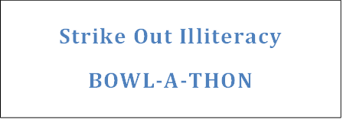
BOWLER’S PLEDGE SHEET
Bowler’s Name:______________________________________________________Date:_____________
Address:____________________________________________________Phone:____________________
Email:________________________________________________________________________________
Team Name:_________________________Captain’s Name:____________________________________

Name | Phone | Email | Cash | Check | Online
1.

2.

3.

4.

5.

6.

7.

8.

9.

10.

11.

12.

Totals

(CASH + CHECK + ONLINE) = MY GRAND TOTAL RAISED $____________
OFFICE USE ONLY
Cash $_____________Check $___________TOTAL in envelope $___________+ONLINE $____________=

GRAND TOTAL $_____________
1st Auditor initial______ 2nd Auditor intial_________
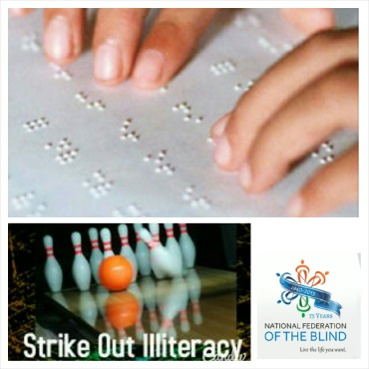

Strike Out Illiteracy

BOWL-A-THON

------------------------------------------------------------------------------------------------------------------------------------
STRIKE OUT ILLITERACY BOWL-A-THON
Benefiting National Federation of the Blind of Maryland, Maryland Parents of Blind Children
DONATION/PLEDGE RECEIPT
Business/Individual Name:____________________________________________________________
Your tax deductible contribution of $____________is greatly appreciated. NFBMD MDPOBC, a private, not for profit 501(c)3 organization; tax identification number ___________________.
Donations support National Federation of the Blind Maryland Parents of Blind Children
Please call ___________________for general information, Bowl-a-Thon participation, sponsorship and volunteer opportunities, or to make additional donations.

------------------------------------------------------------------------------------------------------------------------------------

STRIKE OUT ILLITERACY BOWL-A-THON
Benefiting National Federation of the Blind of Maryland, Maryland Parents of Blind Children
DONATION/PLEDGE RECEIPT
Business/Individual Name:____________________________________________________________
Your tax deductible contribution of $____________is greatly appreciated. NFB MD POBC, a private, not for profit 501(c)3 organization; tax identification number ___________________.
Donations support National Federation of the Blind Maryland Parents of Blind Children
Please call ___________________for general information, Bowl-a-Thon participation, sponsorship and volunteer opportunities, or to make additional donations.

------------------------------------------------------------------------------------------------------------------------------------
STRIKE OUT ILLITERACY BOWL-A-THON
Benefiting National Federation of the Blind OF Maryland, Maryland Parents of Blind Children
DONATION/PLEDGE RECEIPT
Business/Individual Name:____________________________________________________________
Your tax deductible contribution of $____________is greatly appreciated. NFB MD POBC, a private, not for profit 501(c)3 organization; tax identification number ___________________.
Donations support National Federation of the Blind Maryland Parents of Blind Children
Please call ___________________for general information, Bowl-a-Thon participation, sponsorship and volunteer opportunities, or to make additional donations.

