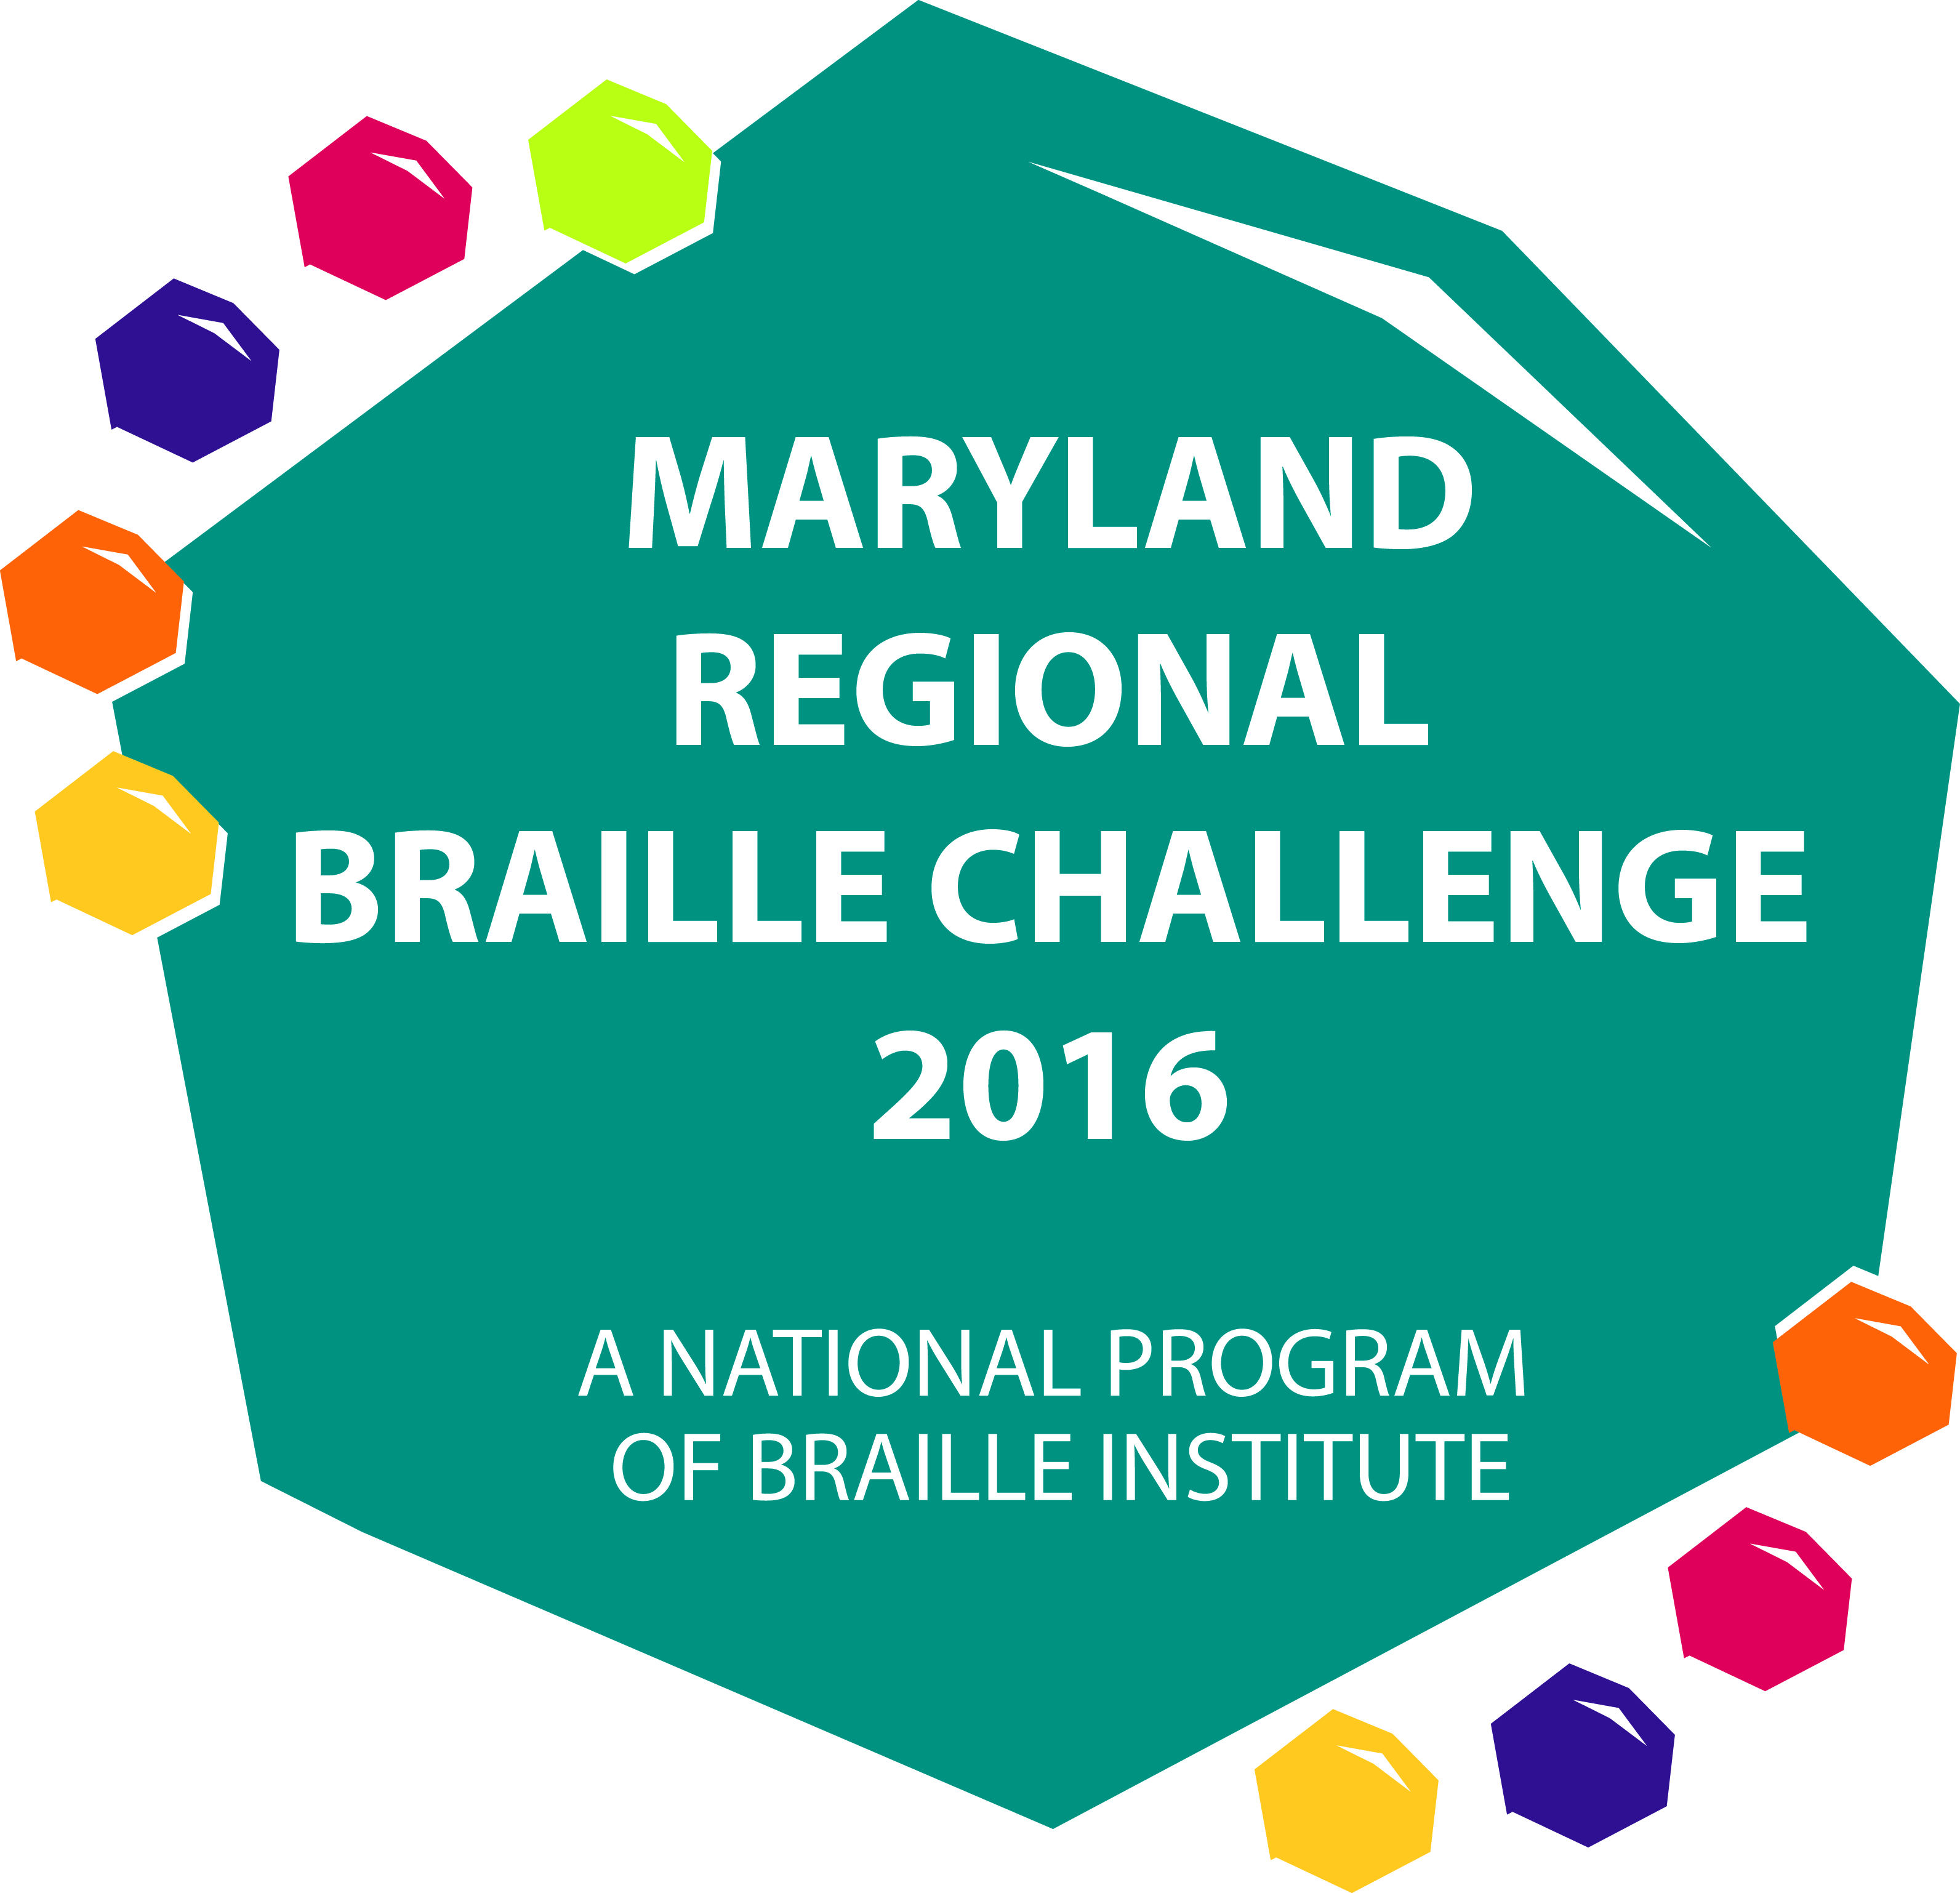

THE MARYLAND REGIONAL
BRAILLE CHALLENGE
January 30th, 2016
(Snow Date – February 6th, 2016)
Location: The Maryland School for the Blind
www.marylandschoolfortheblind.org

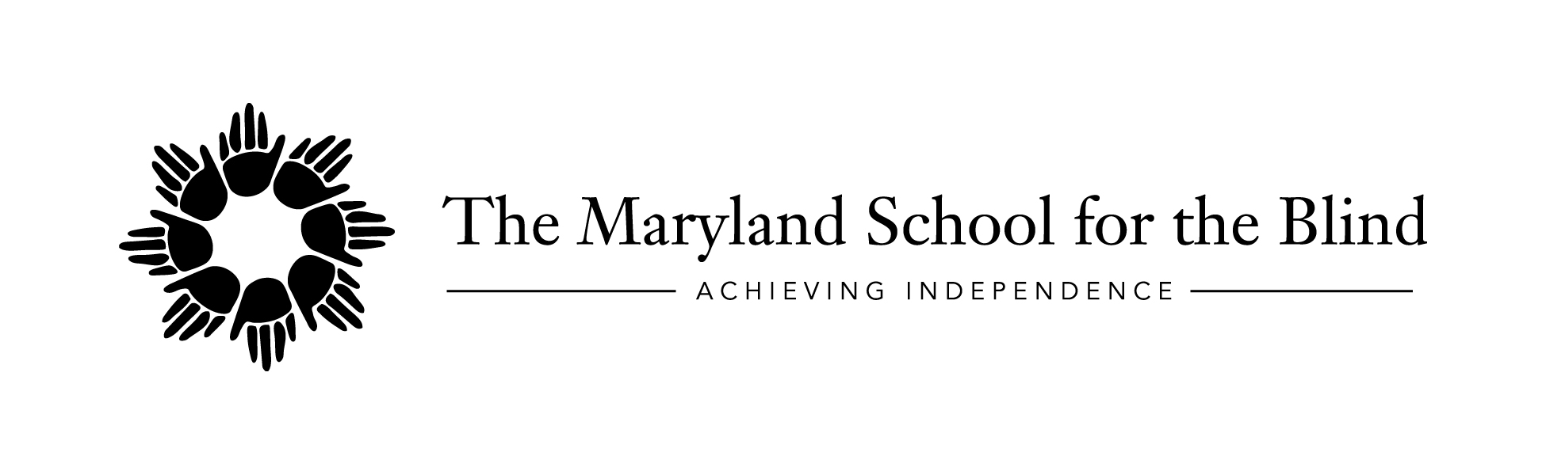
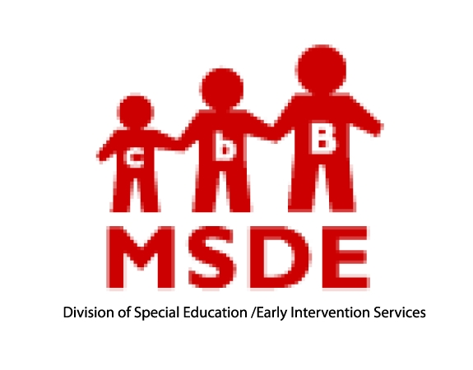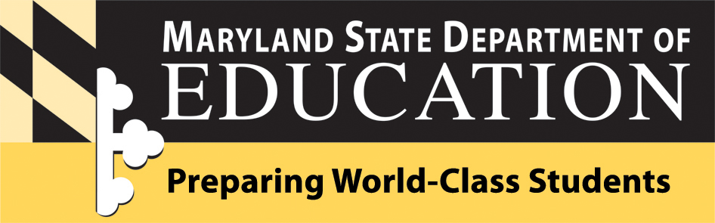

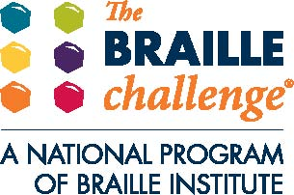
The Maryland State Department of Education and The Maryland School for the Blind will be hosting the Maryland 2016 Regional Braille Challenge

Braille is an important key to literacy! It allows for the enjoyment of reading, leads to school success, and opens the doors to future employment. Come celebrate braille literacy with a day filled with fun, competition, learning, prizes, and enjoyment! In addition, bring in Braille books you no longer read for our Braille Book Exchange!

Students who read braille in grades Prekindergarten through Grade 12 are invited to participate in the Maryland Regional Braille Challenge reading and writing contests. Parents are invited to participate in workshops while students are taking the tests. Teachers and school staff are invited to assist with test proctoring and scoring and helping to facilitate the day.

The following information below was taken directly from the Braille Institute’s website regarding the transition to UEB and the Braille Challenge:
- All contracted Apprentice contests will be in UEB ONLY. There will be no EBAE option.
- Apprentice students may take the uncontracted version, but are not eligible for the Finals.
- Freshman contestants may choose to take their Challenge contests in UEB or EBAE this year, depending on what they know best.
- To simplify this option as much as possible, Spelling will not be impacted: words will be ‘code neutral:’ they will not contain contractions that are different in EBAE and UEB. Reading Comprehension and Proofreading will be available in both UEB and EBAE.
- Contestants may not mix codes—they must select one code for all three contests.BIA will provide contests and answer keys in both EBAE and UEB.
- Sophomore through Varsity contests will be in EBAE.
- Students with the best scores nationally will advance, regardless of code. Freshman contestants must take finals in the code they chose for preliminaries.
- All forms, registration spreadsheets and other supporting documents will reflect these options.
- We will post 2015 Apprentice and Freshman practice contests in UEB as samples. Practice contests for all other levels and from previous years will be in EBAE.
To learn more about the Braille Challenge visit brailleinstitute.org and to find practice materials go to http://www.brailleinstitute.org/braillechallenge-for-students.html and select the “Sample Contests” link.
WHEN: Saturday, January 30, 2016 (Rain Date: February 6, 2016)
COST: FREE
TIME: 8:00 AM to 4:00 PM (Lunch will be provided)
WHERE: The Maryland School for the Blind
3501 Taylor Avenue
Baltimore, MD 21236

THANK YOU FOR THE SUPPORT FROM OUR NATIONAL SPONSORS!!!

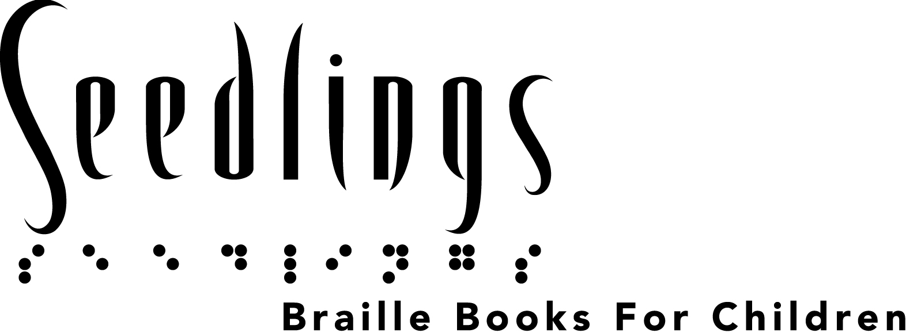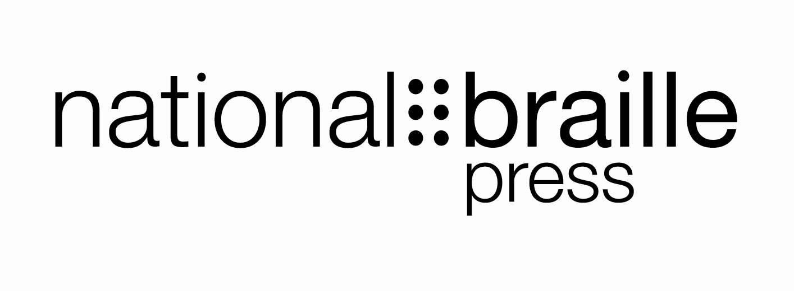

Maryland 2016 Regional Braille Challenge
Tentative Agenda

8:00-8:45 Registration (Knefley)
9:00-9:30 Opening Ceremony (Knefley)
- Welcome and Introductions
- Group Formation
9:45-10:45 Session 1 (Knefley)
    - Students in PreK-12 Testing
    - Parents attend workshops
11:00-12:00 Session 2 (Knefley or MDB Multi-Purpose Room)
    - Students in PreK-12 Testing
    - Parents attend workshops
12:00-12:45 Lunch (Dining Hall)
1:00-2:00 Session 3 (MDB Multi-Purpose Room)
    - Students in Grades 1-12 Testing
    - Parents attend workshops and students in Pre-K and K attend activity
2:00-3:15 Session 4 (MDB Multi-Purpose Room)
- Parents attend workshop
    - Students in Grades 5-12 Testing
    - Braille Book Exchange and Activities Pre-K through Grade 4 and older students as they complete testing (Knefley)
3:15-4:00 Awards (Knefley)

MARYLAND REGIONAL BRAILLE CHALLENGE
Baltimore – January 30, 2016 Snow Date: February 6

Hosted by Maryland State Department of Education
and The Maryland School for the Blind

STUDENT PERMISSION FORM

Please return forms by January 8, 2016 to The Maryland School for the Blind, Attn: Outreach Department, ATTN: Victoria Watt, 3501 Taylor Ave. Baltimore, MD 21236. FAX: 410-319-5708. Only contests submitted with a signed permission form will be eligible for the Braille Challenge® Finals at Braille Institute®.
Please print legal name clearly and fill out completely * Required fields
* Last Name ________________________________* First Name ___________________________________
* Address _________________________________________________________ Apt. No. _____________
* City _______________________________________ * State _______ * ZIP ____________________
* Birthdate _______________*Age _______Grade _______ * Telephone _________________________
* Parent E-mail __________________________ Alternate phone ___________________________________
TO BE COMPLETED BY TEACHER OF THE VISUALLY IMPAIRED (Please fill out completely)
Name of Teacher of the Visually Impaired _______________________________________________________

Teacher’s Email ______________________________ Teacher’s Phone _____________________________
Mark one:
Student Contest Level: □ App □ Fresh EBAE □ Fresh UEB □ Soph □ JV □ Varsity
(NOT Grade in School) Grades 1–2 Grades 3–4 Grades 5–6 Grades 7–9 Grades 10–12

□ At Grade Level Or □ Below Grade Level (BGL)
*(If Apprentice BGL □ Contracted or □ Uncontracted)
*Students who take a contest below their academic grade level in school or who take the uncontracted Apprentice contest are not eligible to attend the Finals.
CONTENT RELEASE
□ _I hereby give permission to Maryland State Department of Education, The Maryland School for the Blind, and Braille Institute of America, Inc. (“BIA”), for my child to participate in The Braille Challenge preliminary contest. I understand that if my child qualifies, he or she is eligible to attend The Braille Challenge final contest in Los Angeles on June 18, 2016.
PHOTOGRAPHIC RELEASE
□ _I hereby authorize Maryland State Department of Education, The Maryland School for the Blind, and BIA to photograph, videotape, or otherwise record by visual, audio, electronic or manual means, the visual likeness and/or voice or other sounds created by the above named contestant (collectively “Reproductions”). Maryland State Department of Education, The Maryland School for the Blind, and BIA may use or permit to be used the Reproductions in any CD, DVD, exhibition, display, publication, solicitation or promotional or educational material or on any website including without limitation BIA’s website, Facebook, or YouTube without compensation to the contestant, the contestant’s heirs, successors or assigns.
Parent Name PRINT _____________________________________
Signature_________________________________________________
1-800-BRAILLE (272-4553) • www.braillechallenge.org

MARYLAND REGIONAL BRAILLE CHALLENGE
Baltimore – January 30, 2016 Snow Date: February 6
PARENT REGISTRATION

Participant’s Name: _________________________________________ Lunch Option (circle one): A B C D

Name of Parents/Guardians Attending:
__________________________________________________________ Lunch Option (circle one): A B C D

__________________________________________________________ Lunch Option (circle one): A B C D
Lunch Options: A – Chicken Wrap B – Turkey Wrap C – Roast Beef Wrap D- Vegetarian Wrap

T-Shirt Size: Child: Small Medium Large Adult: Small Medium Large X-Large

Accommodations to be provided upon request (for Parents/Guardians). Please specify. Large Print Braille Electronic
For Students in Grade 5-12 Only: Students may bring their own or school system Victor Reader Stream and headphones to use for the “Speed and Accuracy” contest. If they cannot bring one, a Bookport Plus will be provided for use. Please check one box.
I will bring a Victor Reader Stream OR I know how to use a BookPort Plus
Yes, I would like to bring books to exchange at the Braille book exchange. I will bring approximately ____ books (count each volume as a separate book please, this is to help with planning).
*Is your child a member of the Maryland State Library for the Blind and Physically Handicapped? If not, visit www.lbph.lib.md.us to download an application.*
Workshops will be provided throughout the day for parents.
NOTE: At least one parent must attend and remain on site throughout the day while their child is present and competing. Parents are not allowed in the testing rooms with their child. You are encouraged to participate in the workshops provided. Your children will be escorted and supervised by teachers and staff from the Local School Systems and The Maryland School for the Blind.

Parent Signature: ____________________________________________

THIS FORM MUST BE SIGNED and SENT TO VICTORIA WATT BY JANUARY 8, 2016
FAX 410-319-5708 or Email @ victoriaw@mdschblind.org

