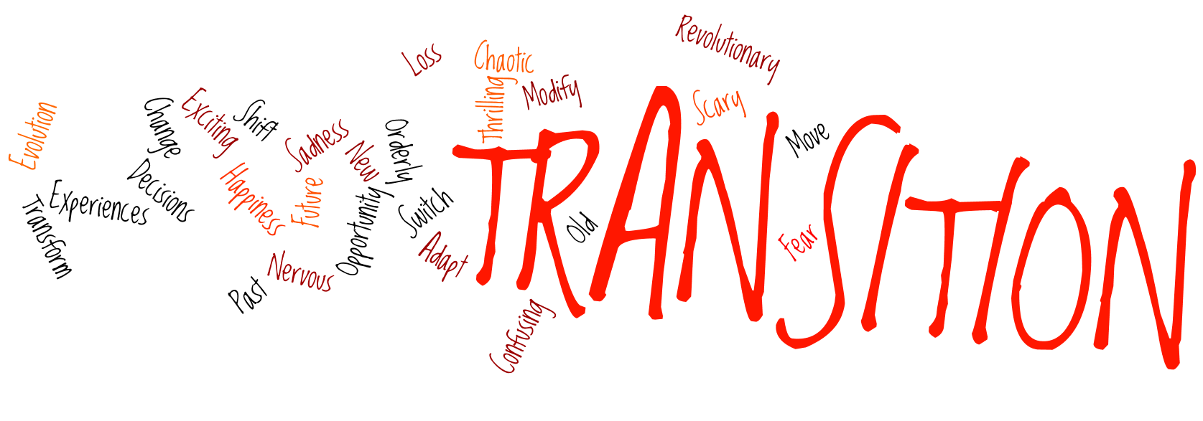

Networking Face to Face: Better Than Facebook

Transitions: exciting, scary, thrilling, confusing? What image comes to mind? What feelings does the word evoke? How would you like to spend time with parents of blind children going through similar transitions and talk with experienced parents and blind mentors?

Social networking is convenient and popular, but how much better to share experiences with other parents Face to Face! The Maryland Parents of Blind Children are excited to present this opportunity for local networking while discussing topics about transitions for our children.

Meet families in your area. Choose from the following locations:

* April 30th – Blind Industries & Services of Maryland

2240 Northwood Drive, Salisbury, MD 21801

<https://www.bism.org/salisbury%20directions>

* May 14th - Hope Lutheran Church

4201 Guilford Drive, College Park, MD 20740

<http://www.hopecp.org/directions.html>

* May 21st - Ramada Plaza

1718 Underpass Way, Hagerstown, MD 21740

<http://www.ramadaplazahagerstown.com>

All three events will be held 10 AM – 3 PM, lunch and child care/activities included!

Topics will be determined by interest. Choices include:

* Academic challenges/Rebounding from setbacks
* Ages & stages: developmental and social skills
* Evaluations & IEP updates
* Braille: EBAE (old literary format) to UEB (new literary format)
* Large print to dual media reader

Registration is required for this event. Please mail the attached form to:

Sandra Bishop, 787 Forsythe Terrace, Severna Park, MD 21146

or email to: mdpobc@nfbmd.org

Deadline for registrations 5 days prior to the date of the event.

Networking Face to Face: Better Than Facebook

Which location/date are you planning to attend?

* Salisbury, April 30th
* College Park, May 14th
* Hagerstown, May 21st

Adult(s)

First Name Last Name

|  |  |
| --- | --- |
|  |  |
|  |  |
|  |  |

Street Address City, State ZIP

|  |  |
| --- | --- |
|  |  |

Phone Number Email

|  |  |
| --- | --- |
|  |  |

How would you prefer resource materials?

* Regular print
* Large print
* Braille

Child(ren)

Name Age Vision Condition

|  |  |  |
| --- | --- | --- |
|  |  |  |
|  |  |  |
|  |  |  |
|  |  |  |

Transition Topics: Indicate your 1st and 2nd choice preferences for topics.

_____ Academic challenges/Rebounding from setbacks

_____ Ages & stages: developmental and social skills

_____ Evaluations & IEP updates

_____ Braille: EBAE (old literary format) to UEB (new literary format)

_____ Large print to dual media reader

What other transition topic(s) are you interested in for this session or future sessions?

|  |
| --- |
|  |