Columbia Lighthouse for the Blind & the

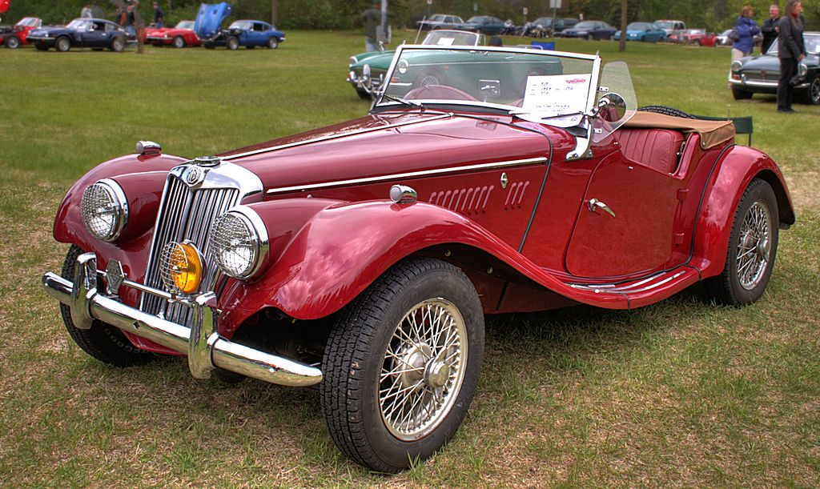MG Car Club Washington DC Centre
Invite You to the 55th Annual BRAILLE RALLYE!
WHO: Adults and youth who are blind or low vision are invited to participate as navigators, reading directions in braille or large print to their assigned drivers of classic automobiles.
WHERE: The Rallye course begins at a picnic shelter in the park and proceeds through about 30 miles of the surrounding countryside.
WHAT: At the starting line, each navigator is provided with a set of instructions pointing out keys to the route. The driver must rely upon the navigator to read and communicate the directions correctly and the navigator is dependent upon the driver to locate each of the landmarks while driving the course.
CELEBRATE: Following the Rallye, drivers, navigators and their families participate in a picnic during which awards for several different classifications are presented to the winning drivers and navigators.

Date: Saturday, July 22nd, 2017

Time: Rallye begins at 10:00 a.m. (Please arrive promptly at

9:30 a.m.) Picnic and awards will follow the Rallye.

Event concludes at approximately 1:30 p.m.

**If using Metro Access, please schedule pick-up for 1:00 p.m.**
Location: Burke Lake Park, 7315 Ox Road, Fairfax Station, VA 22039
** If traveling to the park independently (with family/friend or via cab), please notify attendant at the park gate that you are attending the Braille Rallye and no entrance fee will be charged.

Transportation will be provided by Columbia Lighthouse
**You MUST request transportation when you RSVP to insure a seat on the van.**

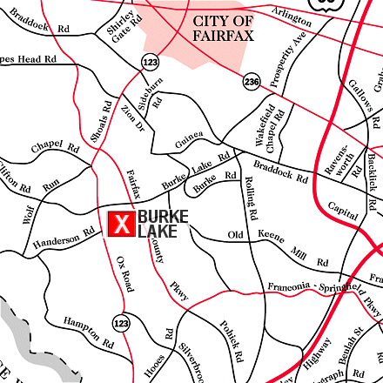
Braille Rallye
Burke Lake Park
7315 Ox Road, Fairfax Station, Virginia
From I-95 South:
Take exit 160 (Route 123 North). The sign will say Woodbridge, Occoquan, and Lakeridge.
Follow 123 North for 7.5 miles to the park entrance on the right. (If you see the golf course then you have gone too far.)

From the Beltway (495) and From Washington D.C. (395): Take the Braddock Road West exit and travel approximately 2 miles. Turn left onto Burke Lake Road (at Kings Park Shopping Center). Follow Burke Lake Road for 5 miles.
Turn left onto Ox Road (Route 123 South).

From Route 66
Take the Fairfax County Parkway, Exit 55.
Continue on the Fairfax County Parkway for approx. 5 miles.
Take a right onto Burke Lake Road. At the next light, turn left onto Ox Road (Route 123).

RSVP to: Patti Lyman at 240-737-5136 or plyman@clb.org.
By Friday, July 15th!

