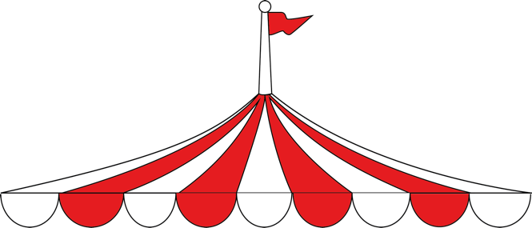

|  |  |
| --- | --- |
| |  | | --- | | **Big Apple Circus Your Way!**  **March 9, 10:30 am Circus of the Senses**  **March 9, 7:00 pm Live AD and ASL!**  **../BAC_new%20FB%20header_Jan24/BAC_FB%20Header%20noGrandma_851x315_300dpi.jpg**    **Group rates Available**  National Harbor Washington, DC  238 Waterfront St.  National harbor, Oxen Hill, MD 20745  Contact [LLewis@BigAppleCircus.com](mailto:LLewis@BigAppleCircus.com) for more information and groups  Circus of the Senses is an enhanced version of the Circus' annual Big Top production. Circus of the Senses provides audience members who are Blind, Deaf, or have vision, hearing, or cognitive challenges with an exciting, multi-dimensional performing arts experience, integrating theater, dance, and live music with the circus arts.  Infrared Audio Descriptive Headsets, ASL Interpreters, Braille and Large Print Programs, both a pre-show interactive touch experience for everyone and post show touch session for blind and low vision individuals brings the magic of circus to life! | |