Maryland State Library for the Blind and Physically Handicapped Presents
“Back to School”
Youth Storytime Event

“Sideways Stories from Wayside School”
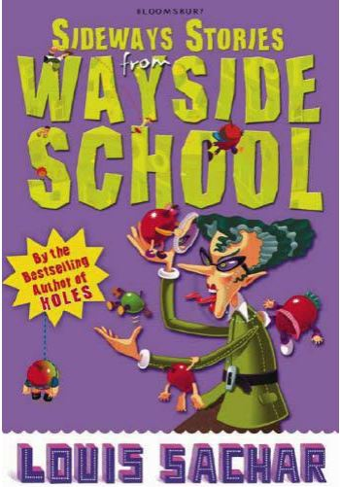
By: Louis Sachar

Date: September 22, 2018
Time: 12:00 – 12:30 p.m.
Ages: Preschool- Grade 3

Listen and participate via teleconference
DIAL-IN: 605-472-5682
ACCESS CODE: 384524

