Kid’s Ice Skating

Calling low-vision and blind kids of all ages to come out and learn to skate or practice for FREE!

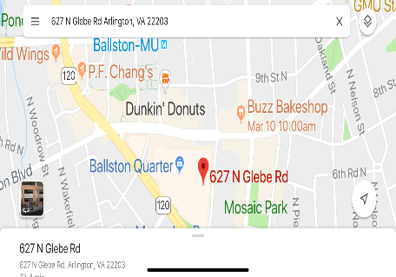

DATE: APRIL 7th, 2019

TIME: 10:00 AM – 12:00 PM

LOCATION: Medstar Capitals Iceplex

627 N Glebe Rd. Unit 800

Arlington, VA 22203

In partnership with the Washington Blind Hockey Club, the National Federation of the Blind of DC would like to invite all blind and visually impaired children ages 3 to 20 years old to come out to the MedStar Capitals Iceplex on April 7th for a fun day of practicing and learning how to ice skate with our trained mentors and teachers.
This is an entirely FREE event. Ice skates will be provided for those who need them. Bring a bicycle helmet if you have one. Contact Anna Givens (contact below) if you need transportation to or from the event, or if you have any other questions.
All participants must register for the event at: https://dbcblindhockey.sportngin.com/register/form/031318729
Or go to DCBlindHockey.org click on “more”, then “NFB skating” then “Register”.
SPOTS ARE LIMITED! REGISTER NOW! AND SEE YOU THERE!

Anna Givens,
Program Coordinator,
402-817-8934
Annajee82@gmail.com
