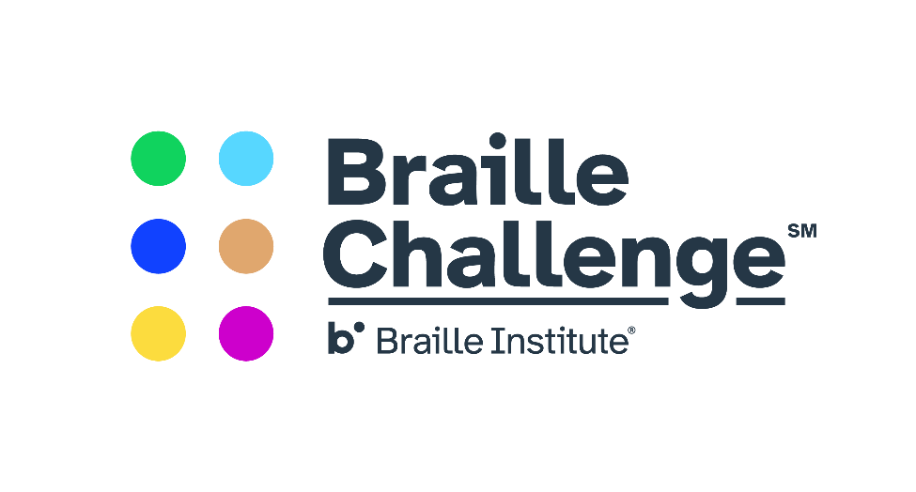
2nd Annual Sidney Iubelt Memorial Spirit Award

This annual award is established in memory of Sidney Iubelt, an avid participant in the Maryland Regional Braille Challenge, and a champion of the spirit of braille literacy.
Nominees should demonstrate:
- A positive attitude about braille
- Enthusiasm about the Braille Challenge
- Support of others in their efforts to improve braille skills
Nominees also need to be registered for the 2020 Maryland Regional Braille Challenge by January 17, 2020 in order to be considered for selection.
Nominations by Teachers of the Visually Impaired are due by January 16, 2020 and can be submitted at https://forms.gle/BXfWtKB3Wvi4V2wBA Questions can be directed to Jackie Otwell at jacquelineo@mdschblind.org
The award will be given on February 8th at the Maryland Regional Braille Challenge. Recipient’s family and Teacher of the Visually Impaired will be contacted in advance if they are selected.

