REGISTRATION OPEN!
GRIT in the Home: Part 2 Short Course!

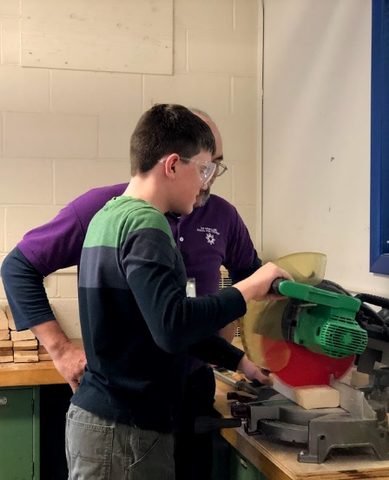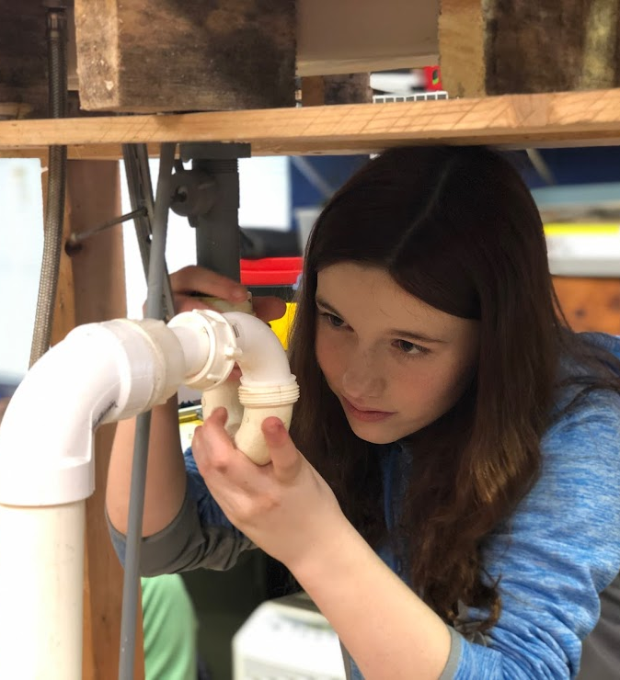

As a follow-up to our very popular “GRIT in the Home” program, MSB’s Outreach Department would like to announce our “GRIT in the Home: Part 2” short course for 14 – 21 year olds. The course will involve a series of Saturday meetings on 1/11, 2/15, 3/14, 4/4, & 5/9 and will focus on adaptive strategies to perform daily household routines, including dishwashing, ironing, washing and drying clothes, clothing identification, vacuuming, organization of belongings and rooms, and MUCH MORE!!!

Independent living skills are critical for all students to live safely and independently as adults. While some independent living skills are addressed briefly in the general education core curriculum, children with visual impairments have limited opportunities to observe adults and peers engaging in these activities. Therefore, their encounters with independent living skills may be passive, rather than active, learning opportunities. Children with visual disabilities receive a lot of "help" from well-meaning adults and peers who take care of, as opposed to taking time to teach, self-care tasks. The result is children experience activities and objects as appearing, disappearing, and then reappearing out of nowhere. This course will teach students the steps involved in routine home skills from beginning to end with the goal of increasing their confidence in being able to do tasks in the home on their own.

Register at https://forms.gle/1EEmdNySFe1zEKJN9

