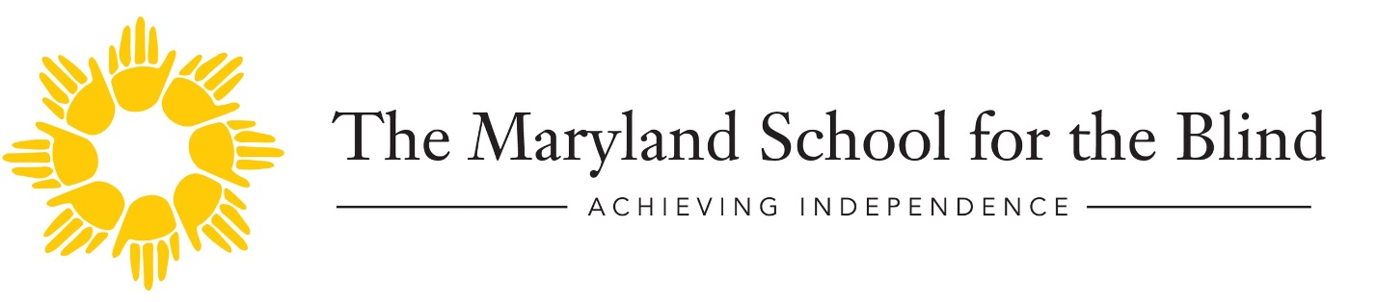
Discover Your Inner Artist
A creative workshop facilitated by Renee Kirby, Artist & MICA graduate.
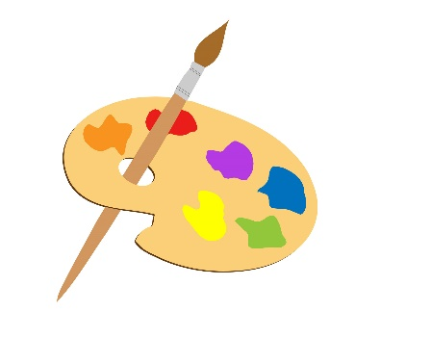

Saturday, January 25, 2020 9:00 am – 1:00 pm.
Maryland School for the Blind Early Learning Building
Lunch will be provided.

With artistic guidance and support, our staff will assist students on subject matter, medium choice, and application to begin an art piece to enter in the APH InSights Art 2020 competition. InSights is an art competition and exhibition for visually impaired and blind artists of all ages. Take advantage of guidance from our staff to create artwork that could be part of history; the possibilities are endless!

For more information and for competition rules, go to aph.org. The deadline for entries is March 27, 2020.

To register for this exciting event go to https://forms.gle/puFs4K725EtBc2Z46

