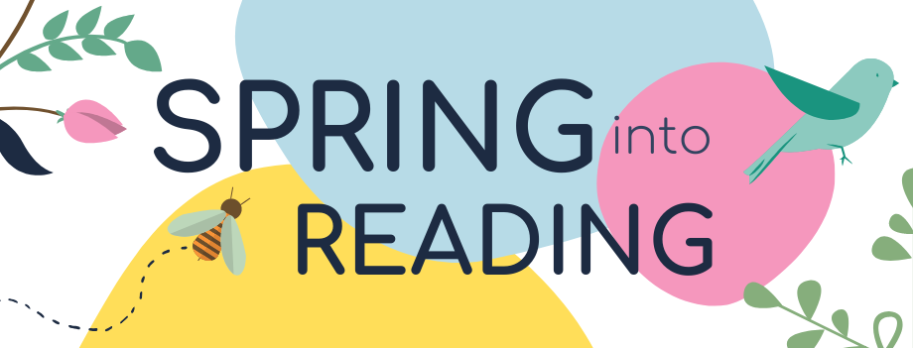

“A book is like a garden carried in the pocket."
Spring is here! What better way to bring in the new season than with great books and imaginative poetry. For the month of April, LBPH is inviting you take part in the “Spring into Reading” book and Haiku writing challenge. The program starts April 1st and ends on April 30th. There are several ways to participate. Read on to learn how!

JOIN “Spring into Reading” Book Challenge. Sign up at https://marylandlbph.beanstack.org. Log your reading and activities. Earn badges along the way. It is that simple and fun!

READ Request books or magazines from MD LBPH, download from BARD, or use Bookshare. It doesn’t matter, as long as you read!

VOTE While looking for some great books, check out the 2020 Maryland Black-Eyed Susan Nominees. Students may cast one vote for the book they consider being the most outstanding book in each of the categories. All votes will be tallied in order to determine the winners. Submit your vote by April 25, 2020
Best Picture Book
Best Grades 4- 6 Chapter Book
Best Grades 6-9 Chapter Book
Best High School Book
Write
LBPH challenges you to come up with your best Haiku. What is a “Haiku”? Haiku poems celebrate an appreciation for beauty and nature. Plants, animals, water, weather, and seasons are often subjects of a haiku. These poems require the writer to count syllables instead of words. This form of poetry always uses 3 lines and 17 syllables.

Line 1: 5 syllables
Line 2: 7 syllables
Line 3: 5 syllables

Example #1
Green and speckled legs,
Hop on logs and lily pads
Splash in cool water.

Example #2
Cherry blossom buds
Do they hear someone coughing?
Better to stay shut!
— Marilyn Berger
(https://www.washingtonpost.com/)

Resources to Visit
https://writeshop.com/writing-haiku-poem/
https://www.kidzone.ws/poetry/haiku.htm
Send us your quarantine-composed haiku and we’ll select our favorites to share with readers. Email your poem(s) to: lashawn.myles@maryland.gov

