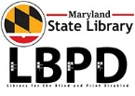
November’s Youth Featured Book
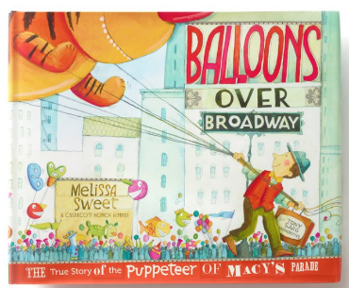
(Image: book cover, man in a parade guiding a large cat balloon using several lines)
Balloons over Broadway:
The True Story of the Puppeteer of Macy's Parade
Author/ Illustrator: Melissa Sweet
It’s that time of year… Thanksgiving! Every year millions tune in to watch or participate in the Macy’s Thanksgiving Day Parade in New York City. It is a time honored American tradition. Cheers, smiles and festive moments are sprinkled with the delights of floats, music, and the giant helium balloons. But how did all this begin? Read this award winning book which recounts the history of the giant helium-filled character balloons that float every year since 1928. All of it started with Tony Sarg's love for puppets, which set the stage for his creations. Book Number DB075815

DIY MARIONETTE CRAFT
Need a STEM craft to support this book, try out your very own marionette. A perfect Thanksgiving Craft for a hands-on DIY project for kids.

Additional Resources
YouTube: Read Out Loud | BALLOONS OVER BROADWAY
Author/ Illustrator: https://www.melissasweet.net/balloons-over-broadway

