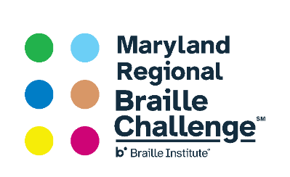

DON’T MUTE ME! I’M PLANNING FOR MY FUTURE!
January 30, 2021
4 pm Eastern Time

Attention Families! Come attend a virtual meet and greet with blind professionals from a range of careers and life experiences so you can begin planning for your future! Included in this document is a set of questions to act as a springboard for discussions.
Read about panelist’s biographies in advance, so that if you choose, you can meet with specific individuals. Biographies can be found at Don't Mute Me! I'm Planning for My Future!
Families that visit 5 or more panelists will be entered into a raffle offering several prizes!
Families will be provided with a set of questions to help guide conversations. Register Here
Don’t Mute Me Panelist Questions
We are happy that you are participating in the event! Below are a set of questions that might act as a springboard for discussions with the panelists. You are not obligated to ask these questions. Thank you for joining us!

- What schooling did you have to complete for your job?
- How did you tell your employer about your disability?
- What technology do you use at your job?
- What is the best piece of advice you could give someone looking for a job?
- What is the best piece of advice you could give for figuring out what you want to do with your life?
- Do you live independently? Do you live close to your job? How do you get to your job?
- If there is one skill someone should learn what should it be? What do you feel are essential skills to being successful on a job as blind person?
- How many jobs have you had?
- What is an accomplishment you are most proud of?
- What do you do if you are facing a challenge in your job?

