MD Library for the Blind and Print Disabled
Summer 2021
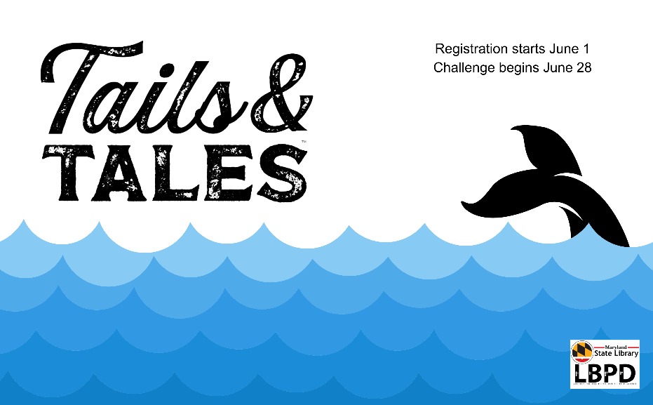
[Image: Whale’s tail breaches ocean’s waves]
Tails & Tales 2021 Summer Reading Program
Registration begins June 1st @ LBPD’s Beanstack
Challenge begins June 28th – August 6, 2021
Save the Date:
Two exciting programs from the National Aquarium are kicking off our summer fun. Registration is forthcoming!

Sharks!
June 22 @ 2:00 p.m.
Sharks are not the fearsome eating machines portrayed in the movie “Jaws.” Explore these unique creatures and their amazing survival adaptations, while dispelling myths about these “monsters.” This program is suited for students of all ages. Adults are welcome.

Mysterious and Dangerous Creatures of the Sea
June 24th @ 3 p.m.
Learn why some of the mysterious and dangerous creatures of the sea may not actually be so mysterious or dangerous as you meet and explore with Dr. Laminaria C. Weed and D.T. This program is best suited for students in pre-k through grade 6. Adults are welcome.

