MD Library for the Blind and Print Disabled
Summer 2021
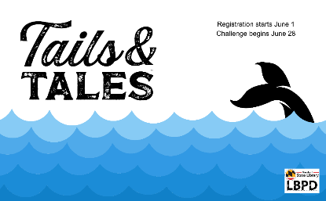
[Image: Whale’s tail breaches ocean’s waves]
Tails & Tales 2021 Summer Reading Program
Registration begins June 1st @ LBPD’s Beanstack
Challenge begins June 28th – August 6, 2021

This year, our theme is all about animals and the stories around them. All ages are welcome to participate as there is a challenge for everyone.
We challenge our patrons to read books, attend library programs, and complete activities throughout the summer. Keep track of your reading on our Beanstack site or download a game board (*newborn to 3 challenge only). Read about our challenges below.

Tails & Tales Summer Learning 2021 (Newborn to 3)
Encourage your child’s early literacy skills by completing any of the Read, Talk, Sing, Write, or Play activities. Earn a rubber ducky when you complete 10 activities. Additionally, keep reading to earn a board book, another rubber ducky, and entry into the grand prize raffle drawing!
1 point will be earned for each activity your child completes.
10 points: rubber ducky
20 points: rubber ducky, a board book, and an entry into raffle drawing.

Tails & Tales Summer Learning 2021 (Kids -Teens)
MD LBPD is giving our readers options on how to earn 30 points toward completion. When you are finished, collect your completion prize. Additionally, keep reading to earn an entry into the grand prize drawing! The number of completion points can be earned according to your age group. Grand Prizes will consist of gift cards, toys, or tickets to special events.
Points can be earned in a number of ways.
- 1 point: 1 book or 15 minutes read
- 1-5 points: Summer Passport activity
- Additionally, check for other challenges throughout the summer to gain more points.

Summer Reading Kickoff (Virtual Programs)
Save the Date:
Two exciting virtual programs from the National Aquarium are kicking off our summer fun. There are limited seats, so register early.
Register: Summer Reading Kickoff https://bit.ly/3yCZdKO

Sharks!
June 22 @ 2:00 p.m.
Sharks are not the fearsome eating machines portrayed in the movie “Jaws.” Explore these unique creatures and their amazing survival adaptations, while dispelling myths about these “monsters.” This program is suited for students of all ages. Adults are welcome.

Mysterious and Dangerous Creatures of the Sea
June 24th @ 3 p.m.
Learn why some of the mysterious and dangerous creatures of the sea may not actually be so mysterious or dangerous as you meet and explore with Dr. Laminaria C. Weed and D.T. This program is best suited for students in pre-k through grade 6. Adults are welcome.

Need help?
Email: kidsdesk.lbpd@maryland.gov or call 410-230-2424

