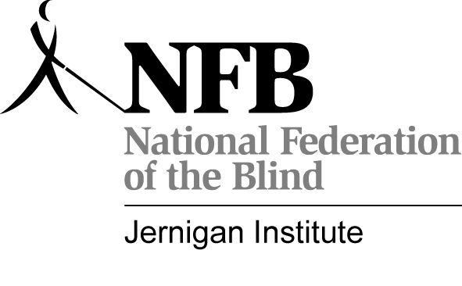National Federation of the Blind of Michigan
No Limits Youth Outreach
CONSENT TO CONDUCT BACKGROUND CHECK

Prior to working with you, all potential mentors will be subject to a criminal background check. Completion of this form and signing and dating in the space provided below authorizes the NFB of MI to conduct a background check through ICHAT, Michigan State Police, Please complete the form and return to Melinda Latham via email at youthslammi@yahoo.com. If you have any questions or problems, please call Melinda at (517)505-1637.

FULL NAME: ________________________________________________________________

DATE OF BIRTH: _____________________________________________________________

Race_________________________________________----
I have read the conditions outlined above, agree to them, and grant permission for the Youth Outreach Coordinator to conduct a routine check of my background.

Signed: ______________________________________________________________________

Date: ________________________________________________________________________

