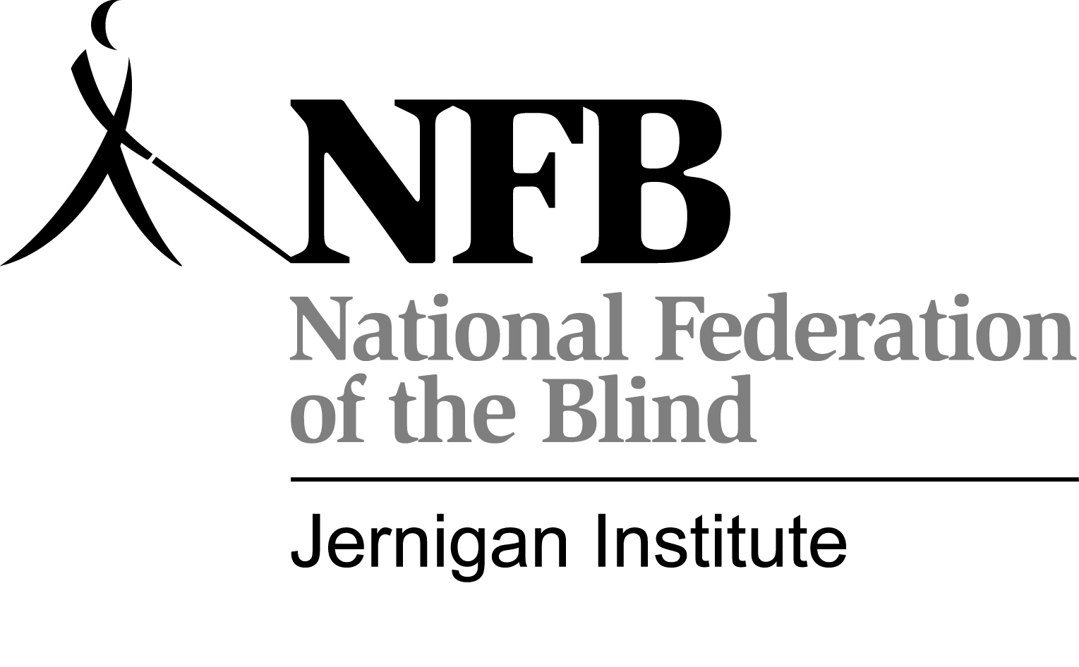

National Federation of the Blind

Media Release
The National Federation of the Blind (NFB) often takes photographs and video of children and adults for educational and promotional purposes. These images may be used in our printed materials, Web sites, social media outlets, and in training and promotional videos. We may also send them to the news media.
I give permission to the NFB to use my image or likeness in materials produced by the NFB for promotional and educational purposes or for any other purpose and in any manner and medium.
Participant Name (please print): ______________________________________
Participant Signature: _______________________________________________
Date: ___________________________
Phone: __________________________
Address: __________________________________________________________
City: _________________________ State: ___________ ZIP Code: __________
If participant is under age 18:
Parent/Guardian Name ______________________________ Date ___________
Parent/Guardian Signature ____________________________Date ___________

