January 14, 2011

Dear Prospective Applicant:

The National Federation of the Blind of Minnesota announces its 2011 scholarship program. This year we will be awarding one scholarship for $1,500 and one scholarship for $1000 to qualified applicants. In addition to the monetary award, one of the winners will attend the annual convention of the National Federation of the Blind from July 3-8 in Orlando, Florida. At the convention, the scholarship winner will have the opportunity to meet other blind students and gain insights into succeeding as a blind person. Additionally, both winners will attend the National Federation of the Blind of Minnesota convention in Fall, 2011. The scholarships will be presented at the banquet of this convention. Candidates must be students who are legally blind and attending a post-secondary school in Minnesota.

In order to be eligible for the scholarship, complete the application and attach the following documents or arrange to have them sent to the scholarship committee:

- Personal letter from applicant. NFB scholarships are awarded on the basis of scholastic excellence and community/campus service. In your letter, discuss the goals you have for the future as well as your academic and community activities. Tell us about yourself and why you are a deserving recipient of the scholarship. Since the awards are restricted to legally blind people, the committee will also be interested in the techniques you use to succeed as a student who is blind.
- Two letters of recommendation.
- Current official transcript from institution now attending and transcripts from all other post-secondary institutions attended. If you have not yet completed one year of college study, submit an official transcript from the high school you previously attended.
- Interview with Committee Member: All applicants will be contacted by phone by a member of the scholarship committee. This interview will enable the committee to learn more about you and your goals for the future. The interviews will be conducted after the application deadline.

Applications and attachments should be received by April 15, 2011. Send applications to:
Sheila Koenig
2207 Girard Av S, #2

Minneapolis, MN 55405

If you or anyone else should have any questions regarding these awards, please contact me at: (612) 977-9110 or shekoenig@comcast.net In addition to these state scholarships, the National Federation of the Blind offers 30 national scholarships each year. If you would like more information about these scholarships, visit www.nfb.org/nfb/scholarship_program.asp
.
Sincerely,
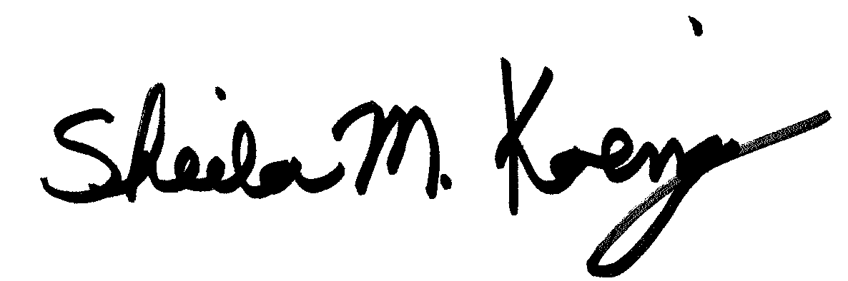
Sheila Koenig, Chairperson
Scholarship Committee
National Federation of the Blind of Minnesota

National Federation of the Blind of Minnesota
2011 Scholarship Application

Name ____________________________________________

Date of birth: _______________________________________

Are you legally blind? ____ yes ____ no

School address: _____________________________________

School phone number: ________________________________

Home address: ______________________________________

Home phone number: _________________________________

At which number can you be located after April 15, 2011? ________________

School currently attending_________________________________
Current class standing (Freshman, sophomore, etc.) __________________
Cumulative grade point at this institution: ___________________

School attending in Fall, 2011 ________________________________

List all postsecondary schools attended with highest class standing attained and cumulative GPA:

________________________________________________________________________

High school attended and cumulative grade point average: ______________________________________________________________________________

Major: __________________________________________

Professional/vocational objective: _________________________________________

Awards and honors (attach list if necessary):

Community service (attach list if necessary):

Letters of recommendation: Please list the names and phone numbers of the people from whom you will be requesting a letter of recommendation.

- __________________________________________________________________

- __________________________________________________________________

