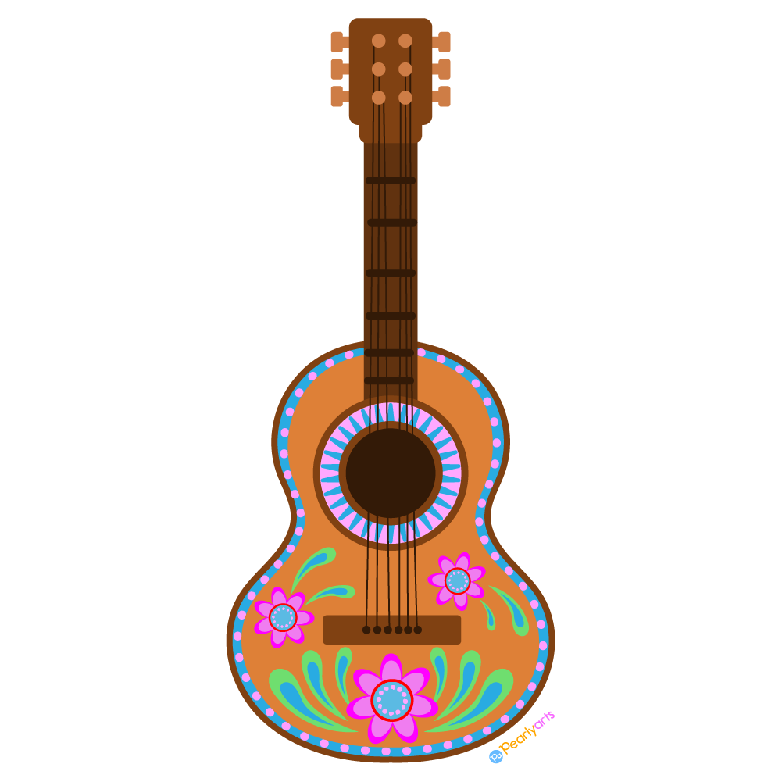
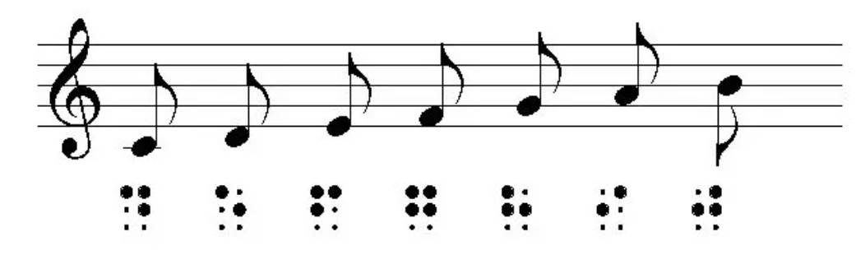
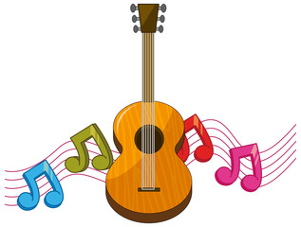
Learn Braille Music!
An introductory class for 7-12th graders who are blind and visually impaired

When: Four classes on Saturdays, 9am-12pm
October 28, November 4, 11, & 18, 2023
Where: State Services for the Blind
2200 University Ave W # 240, St Paul, MN
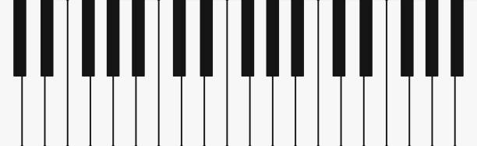
Cost: Free!
---------------------------------------------------------------------------------------------
What students will learn (curriculum is flexible based on students’ needs and experience):
- Discover the importance of learning braille music, and its history
- Learn an introduction to music theory (steps, intervals, octaves, etc.)
- Demonstrate the basics of solfege (through singing and playing)
- Recognize scale steps in numeric and braille music, Do through Ti
- Read and write short braille music melodies
- Use various instruments, braillers, music Tact-Tiles
Prerequisites: Students must be in 7-12th grade, blind or visually impaired with an interest in music, experience with literary braille, and desire to pursue music through and/or after high school.
About the instructors:
Kaiti Shelton kaitlin.shelton@spps.org is a Board Certified Music Therapist with the St. Paul Public School District.
Beth McGarr bmcgarr@swmetro.k12.mn.us is a teacher of the Blind and Visually Impaired with SouthWest Metro Intermediate District 288.
Jenny Pelletier jennifer.pelletier@state.mn.us is an Orientation and Mobility Specialist with State Services for the Blind and is a Board Certified Music Therapist.

Register HERE by October 1, 2023

* This project is carried out in collaboration with the Minnesota Department of Education *

