Join FedEx Express
FedEx Express Hiring Event – Thursday, June 06, 2019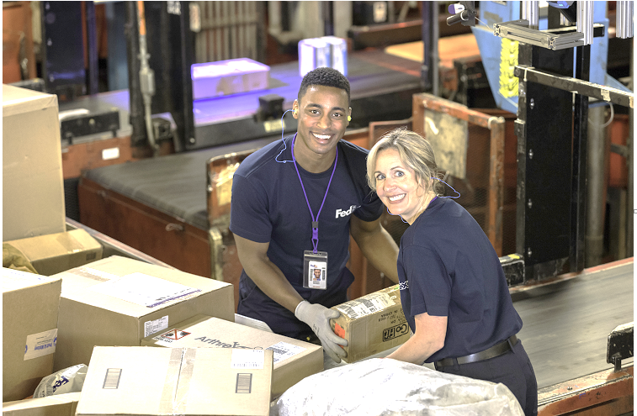

Looking for a part-time position that guarantees you 17.5 hours/week? Join FedEx Express!
• Excellent starting wage up to $16.49/hr.
• Full benefits package
• Medical coverage with premiums less than
$10 per month
• Training and growth opportunities to build a great career
• Vision and dental benefits
• College Tuition assistance/ 3,000 Year
• Promote from within philosophy
• Nationwide career opportunities

FedEx Express Hiring Event Job Fair
Date: Thursday, June 06, 2019
Location: FedEx Building 2825 Cargo Road, Minneapolis, MN 55450
Time: 11:00 a.m. to 7:00 p.m.

Applicant Eligibility
• Must be at least 18 years old
• No minimum education requirements
• Must be able to lift 50 pounds
• Valid driver’s license required for Material
Handler position
• Subject to criminal background check and drug screen
• Must have lived in the United States for the past 5 years
To Apply Online! careers.fedex.com/express
Under ‘Join FedEx Express’, please make the selections to search and apply for available career openings at a FedEx Express near you:

• Enter website address
• Type a job category (in the search box on the photo)
• Type a location (state)
• Click “FIND JOBS”
• Click job title link
• Read job description and duties
• Click “Apply” and complete the application

EOE, M / F / D / V

