ClipArt: 5 characters holding a sign that says “Join Us”

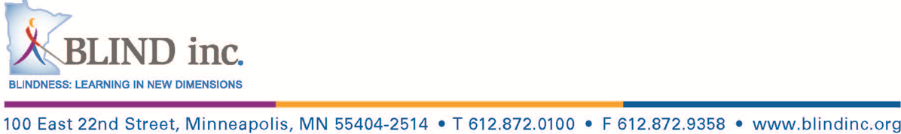**STAR Transition Programs at BLIND, Inc.**

* Are you looking for something to do this summer?
* Are you a high school student 14-21 years of age?
* Would you like to learn how to live independently?
* Succeed in college?
* Find and keep a job?

**The STAR Transition Programs are for you!**

**July 18-July 22, 2016: “Living on Your Own”-** Develop budgets, cook delicious meals, shop for your own groceries, explore all aspects of finding and renting an apartment or house, meet with people who rent out apartments or houses, learn about when to use different types of public/private transportation and practice the skills needed to live independently while you hang out with old and new friends!

**July 25-July 29, 2016: “Success in Post Secondary Education”-** Explore Minneapolis area college campuses, meet with staff from disabled student service offices, learn about scholarships and other funding for school, research on-campus employment, get to know mentors who have graduated from or are currently attending college as you work cooperatively with blind/low vision peers who are also considering post-secondary education.

**August 1-August 5, 2016: “Navigate the World of Work”-** Join fellow high school students as you produce a resume, learn how to find the right job for you, explore possible careers, develop and enhance successful interview techniques through hands-on activities including mock interviews, learn about how to determine and request reasonable accommodations on the job, determine the best time and method to disclose your blindness while increasing your chance to receive a job offer.

Please note:

* Transportation or reimbursement for transportation is offered as part of the program.
* The program has qualified staff, including capable adult blind role-models.
* Age appropriate recreational activities are part of all STAR Programs.
* Overnight lodging for the STAR Programs may be available for those outside the twin cities area..

Join us for one, two or all three programs!

If you have questions, Please contact Robert Hobson, Travel and Transition Coordinator at:

612-872-0100 Ex 220 or Email [rhobson@blindinc.org](mailto:rhobson@blindinc.org)

Our application is up on our website: <http://www.blindinc.org/programs/transition-program/>