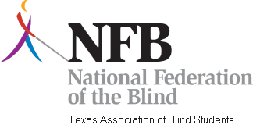

Southern Strums Comes to Dallas Texas.

From the Desk of the President:

The Texas Association of Blind Students is pleased to announce the return of Southern Strums!
Southern Strums is TABS’ biggest fundraiser of the year and our biggest event second only to our Spring Conference.

Southern Strums provides a showcase for blind musicians to play for convention goers from all over the United States.
The event will be held on Monday July 5,2010 from 7:00pm-11:00pm. at

Uptown Bar & Grill
www.uptownbarandgrill.com
2523 McKinney Avenue
Dallas, TX 75201-1964
(214) 969-9433

The Uptown Bar and Grill boasts it has the “best burgers in Dallas” and offers half price burgers on the day it hosts our Southern Strums.
The venue is conveniently located just 2.5 miles away from the Hilton Anatole Hotel. Get Directions from Mapquest Here.
We are aware that the hotel does not have a shuttle, and so TABS is pleased to announce that we will be providing transportation between the bar and hotel from 6:30pm-11:15pm at no cost to those who purchase a Southern Strums ticket.
Come support our Student Division while enjoying great food, drinks, music and mingling all for just $5!
For more information, please visit:
www.nfb-texas.org/tabs.html

if you would like to participate in Southern Strums, email Juan Munoz at
jcmunoz1989@gmail.com

Juan Del Rosario
President
Texas Association of Blind Students
7823 Comal St.
Houston TX. 77051
Phone; 713-320-5519
Email; delrosariomartinez.juan@gmail.com

