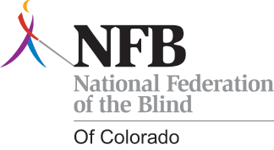

2011 Scholarship Awards Program

Building Opportunities for the Blind in Education and Beyond

This year the National Federation of the Blind of Colorado will be awarding up to $15,000 in scholarship funds for deserving students.

If you are a legally blind student from Colorado,

PLEASE APPLY IMMEDIATELY!

www.nfbco.org

If you know a legally blind student from Colorado, please encourage them to apply now!

DEADLINE: April 15, 2011

For more information please contact:
Buna Dahal, Chairperson
Scholarship Committee
NFB of Colorado
2233 W. Shepperd Avenue
Littleton, CO 80120
303-758-1232
bunadahal@dynamicbuna.com

