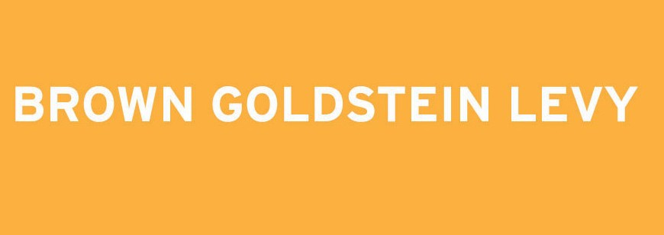

The BGL Disability Rights Fellowship is a One-Year Fellowship for a Law School Graduate
with a Disability and Up to Three Years of Legal Experience.

The Recipient of the Fellowship will litigate cases with a Focus on Disability Rights Law.
Applicant Information

The Brown, Goldstein & Levy Disability Rights Fellowship is available to law school graduates with a disability and up to three years of legal experience. Applicants should have strong academic credentials, excellent writing skills, and a demonstrated commitment to disability rights.

Salary and benefits will be commensurate with the salaries paid and benefits provided to non- Fellowship Brown, Goldstein & Levy attorneys of equivalent experience and qualifications. The firm offers health insurance, group life insurance, and group disability insurance. Brown, Goldstein & Levy values diversity and is an equal opportunity employer.

For more information and to download an application form, please visit: www.browngold.com/fellowship

Application Deadline for the 2013
Fellowship: November 16, 2012.

Brown, Goldstein & Levy LLP
120 E. Baltimore Street
Suite 1700
Baltimore, MD 21202
T: 410.962.1030
F: 410.385.0869
E-mail: info@browngold.com www.browngold.com

DISABILITY RIGHTS FELLOWSHIP

About Brown, Goldstein & Levy

Brown, Goldstein & Levy is a 16-lawyer, Baltimore-based law firm devoted principally to litigation. We initially earned a reputation as Maryland’s leading civil rights firm, successfully bringing many high-profile constitutional and civil rights cases. We’ve built on that experience and are now recognized among the nation’s leading litigation boutiques, having won significant victories for both plaintiffs and defendants in a wide variety of complex and high-stakes cases and appeals. Our peers have recognized our accomplishments by including our lawyers in the American College of Trial Lawyers, Best Lawyers in America, Maryland’s Top 50 Super Lawyers, and naming one of us Maryland Trial Lawyer of the Year.

Our high-profile, high-impact disability rights cases have included the groundbreaking “technology-access” cases against, among others, Target and America Online (establishing that web sites can be places of “public accommodation” that must be accessible to the blind), a class action on behalf of thousands of Social Security Administration employees alleging failure to promote individuals with disabilities, the first judgment in the country under the design and construction accessibility requirements of the Fair Housing Act, a lawsuit against the country’s largest private developer of college dormitories for building inaccessible dormitories, the landmark Potomac Group Home case that led directly to elimination of the requirement that group homes submit to public hearings and neighbor notification before opening, and a suit against the Washington Redskins for failing to caption the public address system at FedEx Field.

Recently, the ABA selected one of our attorneys to receive the 2011 Paul G. Hearne Award for Disability Rights, an award given annually to an individual who has made significant contributions to furthering the rights, dignity, and access to justice for people with disabilities.

Another one of our attorneys was appointed by the Governor of Maryland to serve as Chair of the Maryland Commission on Disabilities.

Make a Difference in Y our Life and
the Live s o f Others .

People with disabilities, including attorneys, continue to face many barriers to employment. A major goal of this fellowship is to provide mentoring to a new generation of lawyers with disabilities as they enter the workplace.

Promoting Justice
The Fellowship offers a talented and committed new attorney the opportunity to litigate cutting-edge disability rights cases under the mentorship of experienced practitioners at the firm’s office in downtown Baltimore. The attorneys at Brown, Goldstein & Levy created the Fellowship to further the firm’s mission of providing clients with quality legal services while promoting justice through the enforcement of our nation’s civil rights laws.

Making a Difference
The Fellowship recipient will have the opportunity to participate in every aspect of the litigation process, from legal research, interviewing clients, and brainstorming strategy, to drafting pleadings, taking depositions, and appearing in court.* Whether a landmark legal decision or a small settlement on behalf of a single client, this is an opportunity to gain experience while truly making a difference in the lives of individuals with disabilities.

* Contingent on bar admission.

