A Quick Guide to Accessible Voting
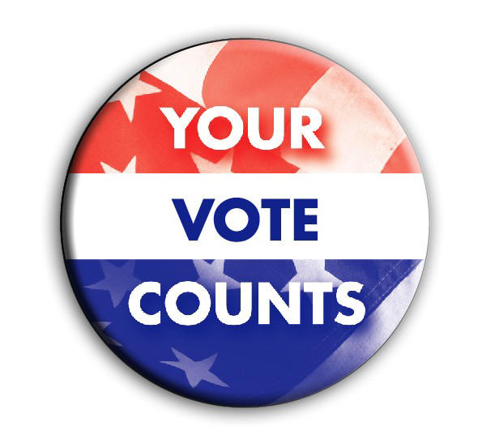

The Issue
A democratic society depends on the ability and willingness of its people to voice their opinions by voting. Your ability to vote privately and independently is a fundamental right, not a privilege. We should therefore make it as easy as possible for people to participate in this essential process. For people with disabilities, we should make it at least as easy as it is for non-disabled people.
Unfortunately, people with disabilities, especially those who are blind or visually impaired, have too often had to choose between assisted voting and not voting at all. This is most frequently due to the lack of a functioning accessible voting machine at the polling place, the sub-par quality instructions provided by the accessible voting machine tutorial, and/or the absence of properly trained poll personnel.

Know your rights: The Help America Vote Act (HAVA)

Title III of the Help America Vote Act (HAVA) of 2002 states:
“The voting system shall—

(A) be accessible for individuals with disabilities, including nonvisual accessibility for the blind and visually impaired, in a manner that provides the same opportunity for access and participation (including privacy and independence) as for other voters;

(B) satisfy the requirement of subparagraph (A) through the use of at least one direct recording electronic voting system or other voting system equipped for individuals with disabilities at each polling place…”

In other words, according to federal law, every polling place is to have an accessible polling machine on site so that every disabled person can vote privately and independently like all other voters.

Filing a Complaint
If you encounter a situation where you cannot vote privately and independently as mandated by federal law, you can (and should!) file a Title III complaint.
A violation of Title III would include issues dealing with the following HAVA sections:

- voting system standards
- provisional voting
- voter information requirements
- statewide voter registration database and
- accessibility for persons with disabilities

Filing a complaint requires filling out a Title III HAVA complaint form, which can be found at your local county election office or online. After it has been filled out, take the form to either the Coordinator of Elections or to your local county election office.

More Information
For more information about the HAVA and filing a complaint, go to:
http://www.tn.gov/sos/election/hava/index.htm

Further information on the 2012 election and general voting information can be found at:
http://www.tn.gov/sos/election/voterinfo.htm

For disability advocacy, visit:
http://www.dlactn.org and www.nfb.org for blind/visually impaired issues.

