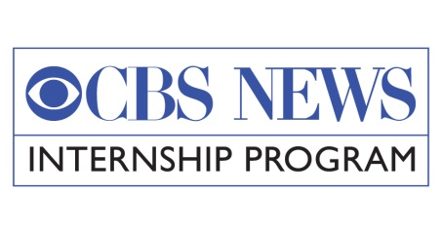

CBS News/ADA25 Internship
Dear Colleagues:

Please disseminate this announcement to your academic and community networks – thanks!

In honor of ADA25 (25th Anniversary of the Americans with Disabilities Act), CBS News in collaboration with Lights! Camera! Access! 2.0 Initiative and City University of New York (CUNY) Coalition of Students with Disabilities, is expanding its paid internship program to include outreach to college juniors, seniors and graduate students with disabilities for CBS News/ADA25 Internship for Spring 2016.

Applicants with insight into lived experiences of disability are strongly encouraged to apply. Applications are due 11:59 pm ET Friday, October 23, 2015; Spring Internship program: January 11 – April 22, 2016.

The CBS News internship program is designed for students who are interested in pursuing a career in journalism, broadcasting or communication. Juniors, seniors, and graduate students are eligible. Students majoring in journalism, broadcasting or communications are preferred, but those majoring in public relations, marketing, advertising, English, history, international studies and political science are welcome to apply and will be considered.

Placement possibilities include The Evening News, 60 Minutes, 48 Hours, CBS This Morning, Sunday Morning, National Desk, Newspath, Newspath Sports, Radio News, Press Office, Weekend News, News Marketing, Investigative Unit and Broadcast Marketing. The location is New York City. Participants must have good computer skills, excellent written and verbal communication abilities and knowledge of current events. A 3.0 GPA or above is recommended. Assignments vary day-to-day. Interns can expect to log tapes, coordinate script, research stories, conduct preliminary interviews, assist during shoots, select footage, perform light clerical duties and assist staff members.

Deadline for 2016 Spring applications is 11:59 pm on Friday, October 23, 2015. The program runs from 1/11/16 – 4/22/16. This is a paid position. CBS News does not require students to receive college credit. Students are solely responsible for coordinating and meeting the credit requirements of their college/university.

Please complete the attached application including requests for accommodations/productivity tools, and one-page essay “How your personal experience with a disability will enrich this internship experience.” A panel of media professionals with disabilities and media allies without disabilities will determine the top three finalists, and then the winner will be decided by CBS News.

Kindly email (CBS News/ADA25 Internship in the subject line) your application, one letter of recommendation, transcripts (can be unofficial) and one-page essay to: Kate (Rothaus) Wong,
CUNY LEADS Job Developer, City University of New York (CUNY); at KWong@qcc.cuny.edu, 718-631-6257. For additional questions, please call Barbara Bookman at 646 664 8811 or email Barbara.Bookman@cuny.edu.

Thank you!

