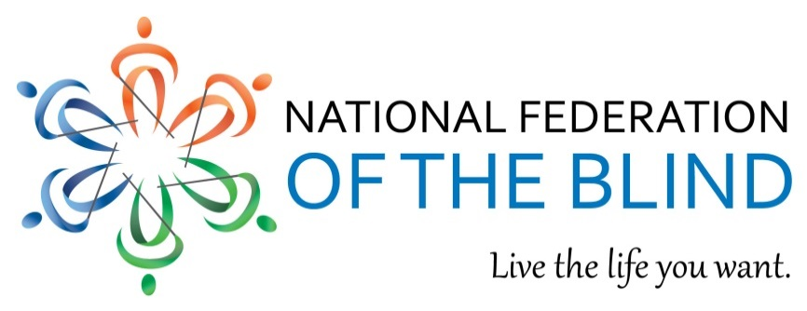

Accessible Instructional Materials in Higher Education (AIM HE) Act
Until colleges and universities drive the demand for accessible instructional materials,
blind college students will be denied access to critical course content.

Technology has fundamentally changed the education system. The scope of instructional materials used at institutions of higher education has expanded. Curricular content comes in digital books, PDFs, webpages, etc., and most of this content is delivered through digital databases, learning management systems, and applications. The print world is inherently inaccessible to students with disabilities, but technology offers the opportunity to expand the circle of participation. Studies have found that, of the six million plus students with print disabilities in the system, the number who go on to pursue postsecondary education is growing.

Blind students are facing insurmountable barriers to education. Instead of fulfilling the promise of equal access, technology has created more problems than the print world ever did. Data show that students with disabilities face a variety of challenges, including matriculation failure, solely because colleges and universities are sticking with the ad-hoc accommodations model instead of embracing accessibility. Schools deploy inaccessible technology and then modify another version for blind students, usually weeks or even months into class, creating a “separate-but-equal” landscape with nearly impenetrable barriers. With only a 20 percent employment rate, blind students should not be denied access by the innovations that could have ensured full participation.

Institutions of higher education need help to identify accessible material and comply with nondiscrimination laws. Section 504 of the Rehabilitation Act and Titles II and III of the Americans with Disabilities Act require schools to provide equal access, and in 2010, the US Departments of Justice and Education clarified that the use of inaccessible technology is prohibited under these laws. In the five years since, over a dozen institutions have faced legal action for using inaccessible technology, and complaints are on the rise. Most litigation ends with a commitment from the school to embrace accessibility, but that commitment does little in a vast, uncoordinated higher education market that mostly forgets about blind students.

Accessibility solutions are available, but guidelines are sorely needed to guide the market. Equal access requirements have no criteria for accessibility that schools can use when selecting technology. Innovations in text-to-speech, refreshable Braille, and other accessibility features are widely available, but developers and manufacturers will incorporate only solutions that are demanded by the market. Accessibility guidelines are needed so that schools can streamline demand, stimulate the market, and better identify accessible material. If schools seeking to avoid litigation embrace this path to compliance, blind students will truly attain equal access.
Mark Riccobono, President | 200 East Wells Street at Jernigan Place Baltimore, MD 21230 | 410 659 9314 | www.nfb.org
Accessible Instructional Materials in Higher Education Act:

Develops accessibility guidelines for instructional materials used in postsecondary education. A purpose-based commission is tasked with developing accessibility criteria for instructional materials and the delivery systems/technologies used to access those materials. Additionally, the commission is tasked with developing an annotated list of existing national and international standards so that schools and developers can identify what makes a product usable by the blind.

Provides incentive for institutions of higher education to follow the guidelines. Institutions of higher education that use only technology that conforms with the guidelines will be deemed in compliance with the provisions of Section 504 of the Rehabilitation Act and Titles II and III of the Americans with Disabilities Act that pertain to schools’ use of technology.

Offers flexibility for schools while reiterating that pre-existing obligations still apply. Colleges and universities are permitted to use material that does not conform to the guidelines as long as equal access laws are still honored. Conformity with the AIM HE guidelines is only one path to compliance; schools can pursue a different path, but will forfeit the safe harbor legal protection.
REMOVE BARRIERS TO EQUALITY IN THE CLASSROOM.
Sponsor the Accessible Instructional Materials in Higher Education Act.

For more information contact:
Gabe Cazares, Government Affairs Specialist, National Federation of the Blind
Phone: (410) 659-9314, Extension 2206, Email: gcazares@nfb.org

For more information visit: www.nfb.org/aim_he

National Federation of the Blind
Mark Riccobono, President | 200 East Wells Street at Jernigan Place Baltimore, MD 21230 | 410 659 9314 | www.nfb.org

Association of Research Libraries. “Report of the ARL Joint Task Force on Services to Patrons with Print Disabilities.” Research Library Issues. (2012) 6.
“Report of the Advisory Commission on Accessible Instructional Materials in Postsecondary Education for Students with Disabilities.” (2011) 13.
United States Department of Labor. “Current Disability Employment Statistics.” Last modified November, 2015. http://www.dol.gov/odep/.
Department of Justice Civil Rights Division and Department of Education Office of Civil Rights letter to College and University Presidents, June 29, 2010.
National Federation of the Blind. “The Accessible Instructional Materials in Higher Education (AIM-HEA) Act.” Last modified December, 2015. https://nfb.org/TEACH.
Government Accountability Office. “Education Needs a Coordinated Approach to Improve Its Assistance to Schools in Supporting Students.” Report to the Chairman, Committee on Education and Labor, House of Representatives.10-33 (2009).

