1.1 Astronomy Packet

- Planets: Please write down the planets in order from the sun…including Pluto!

Mercury, Venus, Earth, Mars, Jupiter, Saturn, Uranus, Pluto
Overview of Our Solar System
- Earth is one of nine planets revolving around, or orbiting ______________, the sun_______.
- All the planets, as well as most of their moons, also called satellites ____________, orbit the Sun in the same direction, and all their orbits, except Pluto’s, lie near the same plane.
- The planets _________________ of our solar system have various sizes, surface conditions, and internal structures.
What’s in our Solar System?
- The terrestrial ____________________ planets are the inner four planets of Mercury, Venus, Earth, and Mars that are close to the size of Earth and have solid, rocky surfaces.
- The jovial _________________ planets are the outer planets of Jupiter, Saturn, Uranus, and Neptune which are much larger, more gaseous, and lack solid surfaces.
- Pluto _________________, the ninth planet from the Sun, has a solid surface, but it does not fit into either category.
How do we know what’s in our Solar System?
- Astronomers ___________________ use Earth-based observations and data from probes to derive theories about how our solar system formed.
- The significant observations related to our solar system’s formation include the shape ________________ of our solar system, the differences among the planets, and the oldest planetary surfaces, asteroids, meteorites, and comets.

A Collapsing Interstellar Cloud aka Nebula
- Stars and planets are formed from clouds of gas and dust, called interstellar clouds or a Nebula _________________.
- The interstellar clouds consist mostly of gas, especially hydrogen _______________ and helium ___________________ that often appear as blotches of light and dark.
- Many interstellar clouds can be observed along the milky way ______________________ in regions that have relatively high concentrations of interstellar gas and dust.
- Our solar system may have begun when interstellar gas started to __________________ as a result of and became concentrated enough to form the Sun and planets.
- The collapse is initially slow, but it accelerates and the cloud soon becomes much denser _______________ at its center.
- Rotation slows the ___________________ in the equatorial plane, and the cloud becomes .
- The cloud eventually becomes a rotating disk with a dense concentration at the _________________.

Sun and Planet Formation
- The disk of dust and gas that formed the Sun and planets is known as the solar nebula __________________.
- The dense concentration of gas at the center of this rotating disk eventually became the sun _____________.
- In the disk surrounding the Sun, the temperature varied greatly with location________________________.
- As the disk began to cool _____________, different elements and compounds were able to condense depending on their distance from the Sun which impacted the compositions of the forming planets.

Sun and Planet Formation
- Elements ________________ and compounds _____________________ that were able to condense close to the Sun, where it was warm, are called refractory elements, and far from the Sun, where it was cool, volatile elements could condense. Refractory elements, such as iron, comprise the terrestrial planets, which are close to the Sun. Volatile elements, such as ices and gases like hydrogen, comprise the planets further from the Sun, where it is cool.

The Growth of Objects
- Once the condensing _____________________ slowed, the tiny grains of condensed material started to accumulate and merge together to form larger bodies.
- Planetesimals __________________________ are the solid bodies, reaching hundreds of kilometers in diameter, that formed as smaller particles collided and stuck together.
- Further growth _____________________ continued through collisions and mergers of planetesimals resulting in a smaller number of larger bodies: the planets.

Merging into Planets
- _Jupiter __________________ was the first large planet to develop in the outer solar system.
- As its size increased, its gravity __________________ began to attract additional gas, dust, and planetesimals.
- As each gas giant ____________________ material from its surroundings, a disk formed in its equatorial plane, much like the disk of the early solar system.
- In the disk, matter coalesced to form satellites _________________.
- The inner _______________ also formed by the merging of planetesimals.
- These planetesimals were composed primarily of refractory elements, so the inner planets are ________ and dense.
- The Sun’s ___________________ force is theorized to have swept up much of the gas in the area of the inner planets, preventing them from acquiring much additional material.
- The inner planets initially ended up with no _______________.

Debris
- The amount of interplanetary debris _____________ thinned out as it crashed into planets or was diverted out of the solar system.
- The planetesimals in the area between Jupiter and Mars, known as the asteroid belt __________________, remained there because Jupiter’s gravitational force prevented them from merging to form a planet.

Overview
- _______________ is part of our Solar system (1 Sun)
- Our ___________ is part of our galaxy (Milky Way)
- Our _______________ is part of the universe.
Kepler’s First Law
- Using Brahe’s data, Johannes Kepler demonstrated his first law which states that each planet orbits the Sun in a shape called an elipse __________________.
- An ellipse is an oval shape centered on two points called the foci______________.
    - Draw one here: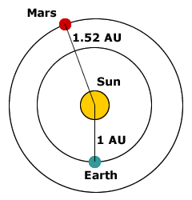

  - The major axis ______________________, the maximum diameter of the ellipse, is the line that runs through both foci, one of which is always the Sun.
  - Half of the length of the major axis is called the semimajor axis and is equal to the average distance between the Sun and the planet.
- An astronomical unit (AU), 1.496 × 10⁸ km, is the average distance between the sun __________ and Earth____________.
  - The average distances between the Sun and each planet _____________ are measured in astronomical units.

Eccentricity
- A planet in an elliptical orbit is not at a constant __________________ distance from the Sun.
  - Perihelion is when a planet is at the closest _________________ point to the Sun in its orbit.
  - Aphelion is when a planet is furthest ______________________ point from the Sun during its orbit.
- Exentricity _____________________, which is the ratio of the distance between the foci to the length of the major axis, defines the shape of a planet’s elliptical orbit.
- The orbital period_______________________ is the length of time it takes for a planet or other body to travel a complete elliptical orbit around the Sun.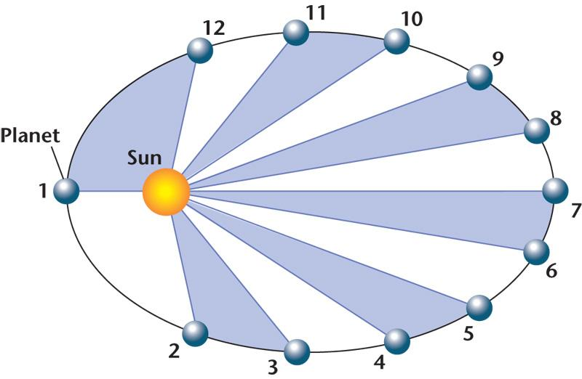

Kepler’s Second Law
- Kepler’s second law states that because a planet moves fastest when close to the Sun and slowest when far from the Sun, equal areas _________________________ are swept out in equal amount of time.

Kepler’s Third Law
- Kepler also found that the square _________ of the orbital period (P) equals the cube __________ of the semimajor axis of the orbital ellipse (a).
- Kepler’s third law states P2 = A3 ______________, where P is a unit of time measured in Earth years, and a is a unit of length measured in astronomical units.
- Italian scientist Galaleo Galale ________________proved, by discovering four moons orbiting the planet Jupiter that not all celestial bodies orbit Earth, and therefore, Earth is not necessarily the center of the solar system.

Gravity and Orbits
- Through observations, Newton realized that any two bodies attract each other with a force that depends on their masses ______________ and the distance between the two bodies.
- The force grows stronger _____________ in proportion to the product of the two masses, but diminishes ______________ as the square of the distance between them increases.
The Sun-Earth-Moon System
- The relationships between the Sun, Moon, and Earth are important to us in many ways.
- The Sun provides light ______ and warmth __________, and it is the source of most of the energy that fuels our society.
- The moon ______ raises tides in our oceans and illuminates our sky with its monthly cycle of phases.
- Every society from ancient times to the present has based its calendar and its timekeeping system on the apparent motions of the Sun and Moon.

Daily Motions - Earth’s Rotation
- The length of a day as we observe it is a little longer than the time it takes Earth to rotate once ____ on its axis.
- Our timekeeping system is based on the solar ______ day, which is the time period from one sunrise or sunset to the next.

Why does the Earth spin?
- The Earth spins because it was made out of _____________________.
- It continues spinning because mass maintains its state of motion unless acted on by a force.
- This property is called __________!

Annual Motions
- The annual changes in length of days and temperature are the result of revolving orbital motion _____________ about the Sun.
- The ecliptic ________is the plane which Earth orbits about the Sun.

The Effects of Earth’s Tilt
- Earth’s axis is tilted relative to the ecliptic at approximately 23.5 ____°.
- As Earth orbits the Sun, the orientation of Earth’s axis remains fixed _____ in space.
- At one point, the northern hemisphere of Earth is tilted ________ the Sun, while six months later it is tipped ______ from the Sun.
- As a result of the tilt of Earth’s axis and Earth’s motion around the Sun, the Sun is at a ______ altitude in the sky during _____________________________.
- _Altitude ________ is measured in degrees from the observer’s horizon to the object. There are 90 degrees from the horizon to the point directly overhead, called the __________ of the observer.

Seasons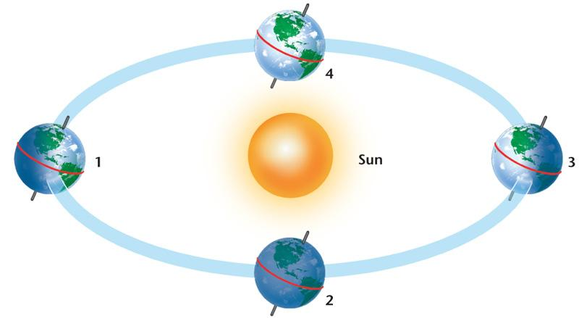
- Annual Motion – Solstices
  - As Earth moves from position 1, through position 2, to position 3, the altitude of the Sun decreases in the northern hemisphere.
  - Once Earth is at position 3, the Sun’s altitude starts to increase as Earth moves through position 4 and back to position 1.
  - Summer Solstice
    - The Summer Solstice __________________ occurs around June 21st ___ each year when the Sun is directly overhead at the Tropic of Cancer, which is at 23.5° N.
    - The summer solstice corresponds to the Sun’s maximum _________ altitude in the sky in the ___________ hemisphere.
  - Winter Solstice
    - The Winter Solstice _____________ occurs around December __________ 21 each year when the Sun is directly overhead at the Tropic of Capricorn which is at 23.5° S.
    - The winter solstice corresponds to the Sun’s minimum ________ altitude in the sky in the ______________ hemisphere.
  - Equinoxes
    - When the Sun is directly overhead ___________ at the equator, both hemispheres receive equal ________ amounts of sunlight.
    - The autumnal equinox occurs around October __________, halfway between the summer and the winter solstices when the Sun is directly over the equator.
    - The _________________ occurs around March 21, halfway between the winter and the summer solstices when the Sun is directly over the equator.
    - For an observer at the Tropic of Cancer or Tropic of Capricorn, the Sun is 23.5° from the point directly overhead during the equinoxes.
    - For a person standing at the x at 23.5º N, the Sun would appear in these positions on the winter solstice, the vernal equinox, and the summer solstice. On the autumnal equinox, the Sun would be at the same altitude as on the vernal equinox.
1.1.1e-h Why do things move like they do?
1.1.1e | Explain Precession—change in direction of the axis, but without any change in tilt—this changes the stars near (or not near) the Pole, but does not affect the seasons (as long as the angle of 23.5 degrees stays the same)
1.1.1f | Explain nutation—wobbling around the precessional axis (This is a change in the angle—½ degree one way or the other. This occurs over an 18 year period and is due to the Moon exclusively. This would very slightly increase or decrease the amount of seasonal effects.)
1.1.1g | Explain barycenter- the point between two objects where they balance each other (For example, it it the center of mass where two or more celestial bodies orbit each other. When a moon orbits a planet, or a planet orbits a star, both bodies are actually orbiting around a point that lies outside the center of the primary (the larger body). For example, the moon does not orbit the exact center of the Earth, but a point on a line between the Earth and the Moon approximately 1,710 km below the surface of the Earth, where their respective masses balance. This is the point about which the Earth and Moon orbit as they travel around the Sun.
1.1.1h | Summarize that the Sun is not stationary in our solar system. It actually moves as the planets tug on it, causing it to orbit the solar system's barycenter. The Sun never strays too far from the solar system barycenter.

Precession
- Perception`__________ was the third-discovered motion of Earth, after the far more obvious daily rotation and annual revolution.
- ________ precession is the movement of the rotational axis of an astronomical body, whereby the axis slowly traces out a ______.
- In the case of Earth, this type of precession is also known as the __________________________.
- Earth goes through one such complete precessional cycle in a period of approximately ______ years or 1° every 72 years, during which the positions of stars will slowly change in both equatorial coordinates and ecliptic longitude.
- Over this cycle, Earth's _______________ moves from where it is now, within 1° of Polaris, in a circle around the ecliptic pole, with an angular radius of about 23.5 degrees.

Precession vs. Nutation
- Precession is the _________________________________ Earth, with a period of about 26,000 years.
- Nutation "to nod" superimposes a small _____________ upon this great slow movement.

Nutation
- The cause of nutation lies chiefly in the fact that the plane of the Moon's orbit around the Earth is tilted by about _____ from the plane of the Earth's orbit around the Sun.
- The Moon's orbital plane precesses around the Earth's in _____ years, and the effect of the Moon on the precession of the equinoxes varies with this same period. The British astronomer James Bradley announced his discovery of nutation in 1748.
- The nutation of a planet happens because of ____________________ of other bodies that cause the precession of the equinoxes to vary over time so that the speed of precession is not constant.
- Nutation makes a _______ change to the _______ at which the Earth tilts with respect to the Sun, thereby moving the location of the _______________, the most northerly latitude which the Sun can reach directly overhead.

What does this mean?
- The position of the _________ in its orbit around the Sun at the solstices, equinoxes, or other time defined relative to the seasons, ____________.
- For example, suppose that the Earth's orbital position is marked at the ________ solstice, when the Earth's axial tilt is pointing directly towards the ____.
- One full orbit later, when the ____ has returned to the ______ apparent position relative to the background stars, the Earth's ____________ is not now directly towards the Sun: because of the effects of precession, it is a little way "beyond" this.
- In other words, the solstice occurred a little _________ in the orbit.

What is barycenter?
- The Moon as well as the Earth orbit the _______________ between the two celestial bodies.

The _____ is not stationary!
- Although it is convenient to think of the Sun as the ______________ of our solar system, it actually moves as the planets tug on it, causing it to orbit the solar system's barycenter.
- The Sun never strays too far from the _____________________ barycenter.

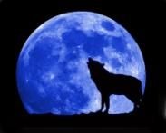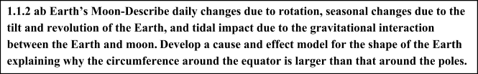

The moon revolves around the earth with a period of about __________ days ~ one month!

Facts about the Moon…
- Unlike the stars, Moon can also be seen during the _________________.
- We also see that the Moon is always involved in eclipses, and its position seems to be well correlated with the __________________________ of the ocean.
- Understanding the ____________________________ of the Moon with respect to the Sun and the Earth will explain these phenomena.

Origin and Properties of the Moon
Scientists think the moon formed after a large __________, about the size of a planet, hit Earth.
Describe what happened in each picture:
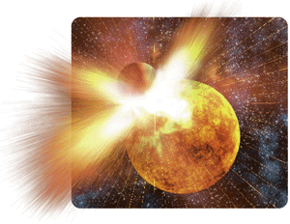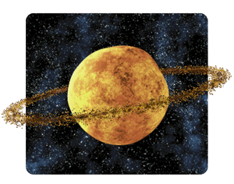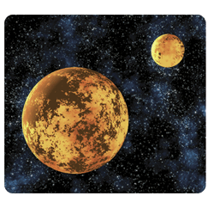

- This theory is consistent with:
1.) _______________ of lunar rocks, which is similar to the composition of the crust of the earth;
2.) ______________________ that the moon had a molten surface for ___________ million years;
3.) the lack of ____________________________________________ for the moon, which together with its low density implies it has very little iron in its core.

The Moon’s Motions
The moon’s orbit is tilted __________ degrees relative to the plane of Earth’s orbit. The moon’s movement around Earth causes it to ________________ later each day and to go through phases.
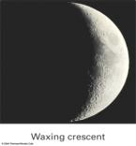
Sunlight illuminates _____________ of the Moon.

This causes the “________________” of the Moon
________________ Moon – increasing from day to day
________________ Moon – decreasing from day to day
Draw the following moon phases:
Waxing Crescent | Waxing Crescent | 1st Quarter | Waxing Gibbous
Full Moon | Waning Gibbous | 3rd Quarter | Waning Crescent

New Moon - The Moon is on the ________________ part of the sky as the Sun and rises and sets with the Sun
Full Moon - The Moon is in the __________________ side of the sky as the Sun and rises when the Sun sets and sets when the Sun rises
The Phase of the Moon - The phase of the Moon depends on the __________ position between the _________________, the _____________, and the ____________…

Moonrise/Moonset
- The time the Moon rises and sets is correlated to its phase
Phase of the Moon | Rise | Zenith | Set
New Moon | 6am |  | 6pm
Waxing Half Moon |  | 6pm | Midnight
Full Moon |  | Midnight
Waning Full Moon | Midnight
New Moon |  | Noon | 6pm

- Why do we Always See the Same Side of the Moon? It’s due to _______________________

Tidal Locking
A tidally locked body takes just as long to rotate around its own axis as it does to revolve around its partner. This ____________________ rotation causes one ________________ constantly to face the partner body. The Moons orbital period is ___________ days. It also rotates once on its axis in ____________ days (synchronous rotation) resulting in Tidal Locking.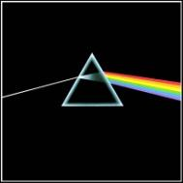

“Dark Side” of the Moon

The Moon ______________________ have a “dark side”
Everywhere on the Moon, the ________ rises and sets _________ per month
It has a side which faces away from us -during a New Moon, the _____ side is completely illuminated

The Moon’s Motions
A __________________ eclipse occurs when Earth passes between the sun and the moon, and the moon is within Earth’s ________________.
A __________________ eclipse occurs when the moon passes between the sun and Earth, and the moon’s ____________________ falls on Earth.
Eclipses occur when the Sun, the Earth and the Moon all lie along a ____________________. Draw the planetary bodies involved in a solar eclipse: 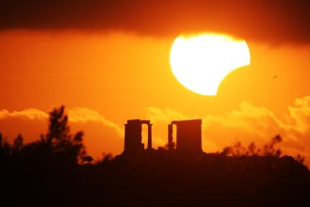
- The Moon’s orbit is tilted ______º with respect to the ecliptic, so there are only _____ times a year when the paths overlap.

Eclipses: Summary
Motion of the Moon around Earth:

_________ day revolution of the Moon around the Sun
Tilt (~5º) of the lunar orbit (around the Earth) w.r.t. the ____________ plane.

The precession of the lunar orbit w.r.t. Earth-Sun direction
The ___________ and ____________ of the Moon need to be just right for us to see total eclipse.

THE MOVING OF THE OCEANS - Tides
The ________________-daily rise and fall of Earth’s oceans— known as the tide—is a result of _______________________ pulls from the moon and the _________________.
- Tides reach different levels depending on Earth’s location in relation to the moon and sun.
• High tides are _________ and low tides are ________ when the moon, sun, and Earth are aligned.
- __________ Tides - The gravitational affects the moon and sun _________ to influence the flow of the oceans on Earth.
- __________ Tides - The gravitational affects of the moon and sun __________ each other with their influence on the flow of the oceans on Earth.
Perigee: The point ____________ to Earth in the moon’s ____________.
Apogee: The point ____________ to Earth in the moon’s ____________. 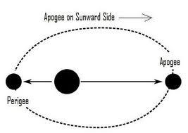
TIDES & CONSEQUENCES 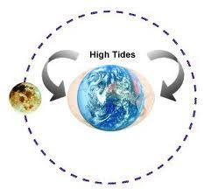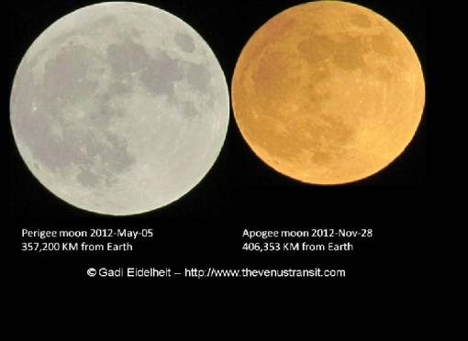
This little tidal behavior goes both ways! The Earth ___________ tides on the Moon.
The Earth "__________" the Moon's rotation AND the braking is complete!
We see a permanent "____________" and "_______________ side" of the Moon.
Moon also brakes the _______________________________
The length of the "day" is _________________________!
- Day is increasing about ___________________ seconds/century

Moon's orbit is _____________________ because of all of this interaction
Therefore, the day is getting __________, Moon looks _________________, and tides are ____________________________.
 | Fission | Fusion
Definition | of a large atom into two or more smaller ones | of two or more lighter atoms into a larger one
Natural Processes |  | Occurs in like the
Byproducts
Conditions | Critical mass of the substance and high-speed neutrons are required  (Think “ ” uranium) | High , high _ environment
Energy requirements | Takes energy to split two atoms | Extremely is required to bring two or more close enough that nuclear forces overcome _____________________________
Energy released | A million times greater than the energy released in _____________ reactions | _____times greater than the energy released by fission.
Nuclear weapons | ____________ bomb, aka ______________ bomb or ____________ bomb | __________________ bomb, which uses a fission reaction to “trigger” a fusion reaction.
Energy Produced by the Sun
What is an Electromagnetic Wave?
- Electromagnetic waves can transfer energy a medium
- An electromagnetic wave consists of

Producing Electromagnetic Waves
- Electromagnetic waves are produced by
- Every charged particle has an surrounding it
- The electric field produces electric that can push or pull on other particles
- When a charged particle moves it produces a
  - A can exert magnetic forces that can act on certain materials
- When a charged particle changes its motion, its magnetic field changes
  - The changing magnetic field causes the to change
  - When one field , so does the other
- **The two fields constantly cause each other to and this produces an **

Energy
- _ is the energy that is transferred through space by electromagnetic waves
- Electromagnetic waves transfer energy through a , or
  - Example: You can see the stars and sun because their light reaches the Earth through the vacuum of space
- Radiation
  - It includes light, infrared and ultraviolet radiation, waves, microwaves, X rays, and rays.
- Speed
  - All electromagnetic waves travel at the same speed in a vacuum =
  - This speed is called the
    - At this speed, light from the sun takes about to travel to the Earth (150,000,000Km away)
    - Light waves travel more slowly in
- Models of Electromagnetic Waves
  - Many properties of electromagnetic waves can be explained by a
  - Some properties are best explained by a model
  - Both a wave model and a particle model are needed to explain all of the light
- Wave Model of Light
  - Light acts as a wave when it passes through a
  - Ordinary light has waves that in all directions- ↔ ↕ and at all other
  - A filter acts as though it has tiny that are aligned in one direction
    - Only some light waves through a polarizing filter.
    - Light that passes through and vibrates in only one direction is called
    - No light passes through two polarizing filters that are placed at right angles to each other 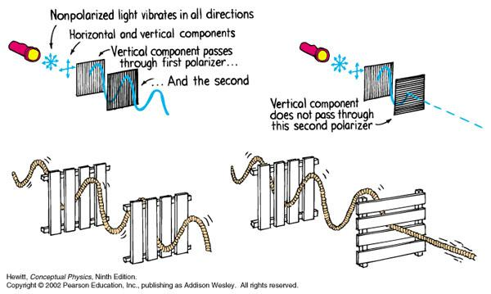

Particle Model of Light
- Sometimes light behaves like a
- When a beam of light shines on some substances it causes tiny called to move
  - The movement of causes an electric current to flow
- Sometimes light can even cause an electron to move so much that it is of the substance
  - This process is called the
- The photoelectric effect can be explained only by thinking of light as a stream of tiny , or of energy
  - Each packet of light energy is called a

Photosynthesis
- The key cellular process involved with energy in plants is .
- Chlorophyll is a that absorbs sunlight. When chlorophyll absorbs light energy, much of that energy is transferred to the _ in the chlorophyll molecule. These - electrons are what make photosynthesis work.
- In the process of photosynthesis, plants use energy from to convert and into high-energy and . The equation looks like this:
_ + _ + light → _ +
carbon dioxide + water + light energy → glucose + oxygen
- In plants, photosynthesis occurs in the .
- The reactions of photosynthesis are split into two parts: the reactions and the light-independent reactions.
- Many factors affect the rate of photosynthesis.
  - A shortage of can slow or stop photosynthesis.
    - No water = no photosynthesis
  - _ is also a factor since photosynthesis depends on enzymes that work best at temperatures above freezing.
    - Cold temperatures = less photosynthesis,
    - Warm temperatures = more photosynthesis
  - The amount of also affects the rate of photosynthesis
    - More light means it happens , less light and it occurs

How is the sun harmful to humans?

Sun produces _____________ radiation, which causes __________ and skin cancer
What protects us from UV radiation?

Is UV radiation the only danger that the sun poses to life on Earth?
_____! The sun produces other harmful radiation besides UV. Some examples are:
1
2
3
4

Solar Wind
- Consists of __________ particles that stream off of the Sun in all ____________ at speeds of about 400 kilometers per second ( about 1 million miles per hour).

Solar Flare
Occurs when ____________ has built up in the solar atmosphere and then is suddenly released.
Energy ________is the equivalent of 100-megaton hydrogen bombs exploding at the same time.

How are we protected from the bombardment of solar particles and radiation?

Earth’s _____________________

How does Earth produce a magnetic field?
Its produced because of the _________outer core, as the Earth rotates it causes the _______ core to move around which generates _________ around the __________core

