NABS Notes – July 2021

“If your dream is a big dream, and you want your life to work on the high level you say you do, there’s no way around ding the work it takes to get you there.” -Joyce Chapman
Welcome to the July edition of our NABS Notes! It’s hard to believe another National Convention has already come and gone and school is looming large in the not-so-distant future. Before things get too crazy busy, we hope you’ll take some time to catch up on all things new with NABS. Read on to learn more about our newly elected board and updates on committees. In this edition you will find:

•Meet the 2021-2022 NABS Board!
•An Introduction to NABS Committees
•Stay Connected | NABS Social Media

Meet the 2021-2022 NABS Board!

President | Trisha Kulkarni, She/Her
Trisha is both humbled and honored to be entering the second year of her term as the President of NABS! Originally from Dayton, Ohio, she venture out from the Midwest to California, where she is currently a senior at Stanford University, studying Computer Science with a minor in Creative Writing. In her free time, you can find Trisha working out at the gym, taking a deep dive into her Spotify recommendations, or getting boba with her friends and family. Given the experience of losing her vision unexpectedly before the start of high school and finding the National Federation of the Blind as a 2018 national scholarship recipient, Trisha is firmly rooted in the philosophy that gaining independence and refining oneself are both ongoing journeys, unique to each person. Yet, she wholeheartedly believes that the magic of our student division is for everyone! Trisha is inspired daily by the power of collective knowledge in this organization, and she welcomes any student or ally to reach out with any questions, concerns, or ideas about the work that we do.

1st Vice President | Mausam Mehta, She/Her
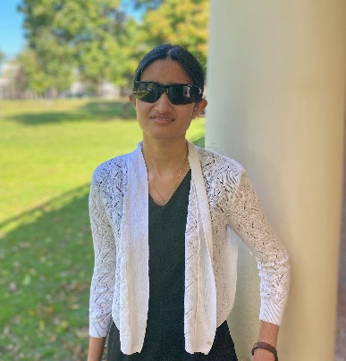
Although she is far from new to the NABS family, Mausam is ecstatic to serve in this new-to-her position over the coming year! Born and raised in Virginia, she remained in-state for college, and she wears the University of Virginia colors louder and prouder than just about anyone you’ll ever meet. Academically, Mausam’s interests are widespread, but she devotes herself fully to whatever she puts her mind to. Currently, her mind is set to studying, specifically the fields of Commerce, IT, and Management. If she can manage to find free time, she chooses to spend it hiking, crafting, or reading. One of her favorites, of course, is Harry Potter. She possesses a fierce sense of loyalty that may trick some into thinking she belongs to a different house, but she is Gryffindor to the death!

2nd Vice President | Justin Salisbury, He/Him
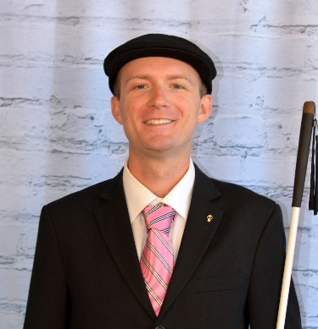
While he has served in many roles over the years, Justin loves filling his latest position on the NABS Board. The wisdom he has accumulated throughout his life comes from a variety of people and places, and Justin is excited to return to his home state of Vermont to pursue a doctoral degree in the field of Educational Leadership and Policy Studies. The outdoors have a special place in Justin’s heart, so he loves spending time fishing, kayaking, and hiking. Luckily, Justin has had the opportunity to live in almost a dozen states so far, each of which contributes uniquely to his identity, so he has been able to participate in some of his favorite hobbies in tons of new and exciting places.

Secretary | Nina Marranca, She/Her
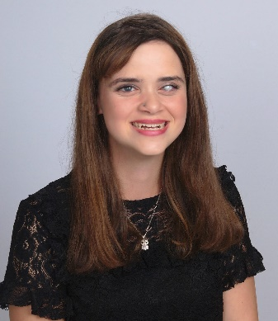
Nina is thrilled to move into a new position on the NABS Board after serving in a different capacity over the last year. You may recognize her as the host of the NABS Now Podcast, which just so happens to be one of her favorite initiatives to work on. In her everyday life, Nina works and attends school in her home state of New York. She is pursuing degrees in both Psychology and Criminal Justice. If Nina ever slows down long enough to take a break, she manages to fill the time by working out, cooking delicious food, or reading lots and lots of books. Her literary mind also extends into writing as she dabbles in spoken word for fun every now and again.

Treasurer | Elizabeth Rouse, She/Her
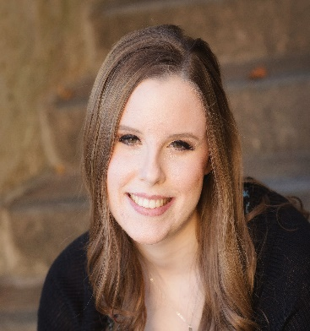
With a passion for details and an ever-growing adoration for spreadsheets, Elizabeth loves keeping up with the business of NABS finances. Originally from Iowa, Elizabeth snuck down south to attend the Louisiana Center for the Blind in January of 2021 after completing undergraduate degrees in English and Theatre. During the months of April through October, you’ll be hard pressed to pull Elizabeth away from a radio broadcast of Chicago Cubs baseball, which she loves listening to, preferably while buried under lots of blankets and snuggled up with her cat, Wrigley. If it happens to be the off season, she can be found binge watching Grey’s Anatomy or going for a run, striving to win her latest Apple Watch competition.

Board Member 1 | Logan Stenzel, He/Him
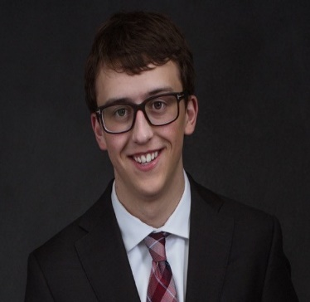
It’s hard to believe that Logan has only belonged to NABS nation for just over a year, but both his optimism and work ethic have been proven invaluable in that short time! A rising sophomore at the University of Minnesota, Logan is double majoring in Computer Science and Finance, and he can often be found researching investment strategies or working on programming projects while ingesting copious amounts of coffee. Since those pastimes seem a bit too much like work, he sometimes manages to take breaks, either choosing to binge watch new and old shows alike with a bowl of ice cream or walk around town with friends. Logan hopes that his work on the board will allow NABS to shine brightly in the lives of students nation wide as it did for him during both the COVID-19 pandemic and his transition into college.

Board Member 2 | Robert Parsons, He/Him
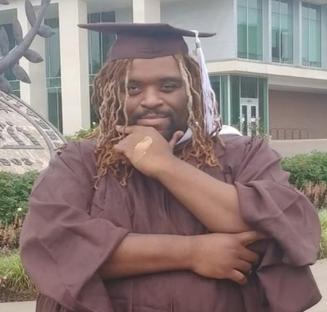
Robert has been a leader in NABS for quite some time, serving on too many seminar planning squads and leadership committees to count. Currently a PhD student at Western Michigan University, pursuing research in Counselor Education and Supervision, he originally hails from New York City. Robert is not only an avid traveler and reader, but he also serves as our resident expert on all things food. Hit him up if you’re looking for some great opportunities to tantalize your tastebuds. As a board member of the NFB of Michigan, Robert enjoys facilitating connections between student divisions and their affiliate presidents. He has made a goal for himself this year to work diligently in NABS regarding innovative ways to both increase membership and inclusivity.

Board Member 3 | Kinshuk Tella, He/Him
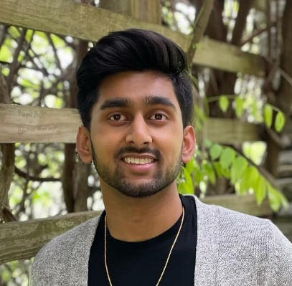
While he has been one of our Zoom masters for more than a hot minute, Kinshuk is joining the NABS Board with tons of great ideas, helpful suggestions, and deeply rooted dedication this year for the first time. After spending the summer of 2021 in California for an academic internship, Kinshuk plans to return to his home state of Ohio to continue his studies in Environmental Science and Geology. In spite of his relatively central location in the country, Kinshuk loves keeping tropical plants. At one point, he had over 30 different species to attend to. When he isn’t watering his personal vegetation collection, Kinshuk enjoys keeping up with men’s fashion, working out, and performing on one of the many instruments he plays.

Board Member 4 | Gene Kim, He/Him
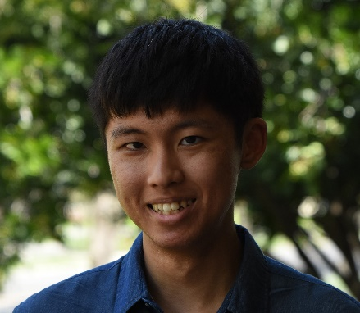
Gene is proud to begin serving on the NABS Board although he has been one of the masterminds behind our website throughout the past year. He is a second-year student at Stanford University, studying Symbolic Systems and/or Mechanical Engineering with interests in human-computer interaction, artificial intelligence, and mechatronics. Having been born and raised in the same 30 square mile radius in California his entire life, Gene enjoys traveling and looks forward to experiencing many new cultures in the post-COVID-19 world. His most exciting trip in recent years was to Japan in 2019, where he had the opportunity to meet Princess Takamado and the First Lady. This trip was awarded to the top performing teams in the 2019 National Japan Bowl competition, in which Gene placed third. Some of his other hobbies include cooking, playing guitar, and solving puzzles. He loves getting to know people and having good conversations, so don’t hesitate to reach out!

An Introduction to NABS Committees

The NABS Outreach Committee
The Outreach Committee is responsible for many of the communication methods used to spread the latest NABS News both inside and outside of the Federation. This group works primarily on The Student Slate blog post, the NABS Now Podcast, and monthly editions of NABS Notes.

The NABS Fundraising Committee
The Fundraising Committee works hard to fund our movement through various initiatives throughout the year. This group has been immensely successful with projects such as Fantasy Football, NABS merchandise, and our annual NABS Walk-A-Thon. The funds raised throughout the year send students to national and regional events, sponsor seminar speakers and expenses, and allow for NABS Representatives to attend state conventions across the country.

The NABS Legislative and Self-Advocacy Committee
The LSAC Committee is responsible for ensuring student voices are heard, which includes training students to use their voices in every realm of life. This group helps our members understand the power of speaking up, develop awareness surrounding rights students possess in and out of the classroom, and prepare for an influential student presence at the National Federation of the Blind’s Washington seminar, which takes place each winter.

The NABS Diversity, Equity, and Inclusion Committee
The DEI Committee works toward ensuring that every individual feels as if they belong in our NABS spaces, including committees, virtual programs, and in-person events. This group hosts conversations, feedback sessions, and seminars that encourage the fostering of an environment in which our diverse membership body is not only welcome and represented but also included.

Connect with Us | NABS Social Media
Follow us on:
Twitter, Instagram, like us on Facebook, join our Facebook group, & join the NABS email listserv.

