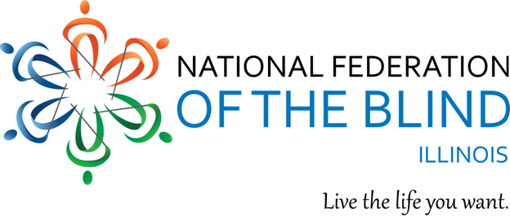
Illinois Association of Blind Students
Virtual Cooking Course
May 15, 2022.

Interested in attending a cooking class? You can give the class as a gift, or take it yourself. The Illinois Association of Blind Students will be administering a virtual cooking course via the Zoom platform on May 15, 2022, from 5-7 P.M. central standard time. This course offers people the opportunity to learn basic cooking skills as they prepare three Mexican dishes. Course objectives and dishes to be covered during this course can be found below:

COURSE OBJECTIVES:
✓ Learn how to determine doneness of boiled chicken
✓ Demonstrate basic knife skills while chopping vegetables
✓ Prepare a sweet tomato salsa (sweet means not spicy, so it won’t include hot peppers)
✓ Use the blender (or food processor) in a safe way, while blending hot or warm liquids
✓ Safely use the oven to finish cooking a dish
✓ Cooking and seasoning Mexican food

DISHES TO BE COVERED:

Torta Azteca:
This is a classic, but not so common dish which is the equivalent to a Mexican lasagna. It is made with corn tortillas, tomato sauce, chicken and cheese. It is optional to top it with sour cream, hot pepper salsa and guacamole.

Refried Beans:
These beans can accompany many Mexican dishes, and are rather simple and easy to prepare. Because of the length of the class, we won’t be cooking the beans, but rather using canned beans for practical purposes.

Guacamole:
This will not be the classic guac recipe, but it might be the best one you ever had. The classic recipe may only incorporate 4 ingredients, but this one will be enriched to be extra creamy and to hold better and longer, without the avocado turning dark.

REGISTRATION:
People who wish to participate in the IABS Virtual Cooking Course will be expected to pay an admission fee of $30, as well as purchase materials and ingredients that will be utilized during the course. A full list of materials and ingredients will be sent to all students by May 8, 2022. Spots for the IABS Virtual Cooking course are limited, and only the first eight people who register will be accepted. To register for this course, please reach out to Glenn Moore at gmoore3rd@gmail.com for more information regarding registration and payment for the course.

