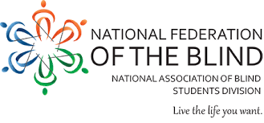

2022 Atlantic Student Seminar
Reflect, Reequip, Reimagine: Raising the Bar for Blind Students!

The National Association of Blind Students (NABS) and the National Federation of the Blind of Maryland invite you to the annual Atlantic regional seminar, a fun-filled weekend brimming with opportunities for professional growth, confidence building, and mentorship!

Friday, August 12 (6:00 PM) – Sunday, August 14 (12:00 PM)
Delta Hotels Baltimore Hunt Valley by Marriott
245 Shawan Rd
Hunt Valley, MD 21031

Register here and pay your $100 registration fee to participate!

Please direct questions to Logan Stenzel (stenzellogan@gmail.com)

The past years have challenged blind students in a variety of ways, but we will emerge stronger than ever. Join the National Association of Blind Students for an engaging weekend of growth. Through enlightening presentations, spectacular guest speakers, exhilarating activities, and thought-provoking discussions, we will reflect on the past, prepare in the present, and reimagine our future. Together we can raise the bar for blind students!

