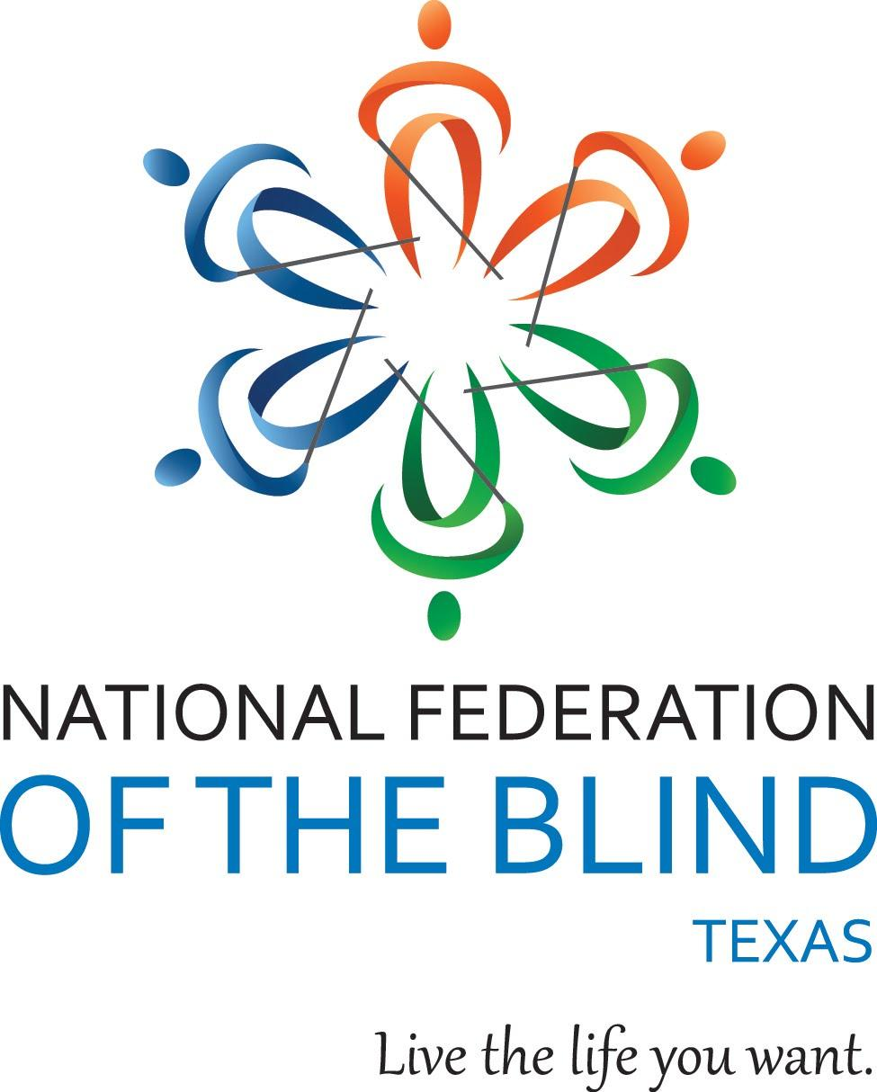**Texas Association of Blind Students presents**

**2023 Student Summit**

Date: Friday, August 11, 2023-Sunday, August 13, 2023

Location: Holiday Inn Downtown Market Square

318 W. Cesar E. Chavez Blvd

San Antonio, Texas 78205

(210)-225-3211

*Are you a blind/VI student?*

*Are you wondering about your college, career options and developing a stable foundation for your life?*

Join members of the National Federation of the Blind and Texas Association of Blind Students to learn about resources and strategies that can help you thrive in school, work, and life!

Conference highlights include:

* Interactive demonstrations of adaptive sports
* Meet blind professionals working in a variety of vocations
* Learn the keys to success from other blind students
* Plenty of time to network and make new friends

**Students, teachers, parents, and everyone welcome!**

Conference registration is $75 and room rates are $89 per night plus taxes. Make sure to ask for the NFB room rate when booking your stay.

[Register online now](https://forms.gle/CTstR5dUXtYoV7wVA) or call our office at 281-968-7733. Registration should be completed by August 1, 2023.

Qualifying Texas residents will be registered for the free NFB-NEWSLINE® electronic information service.