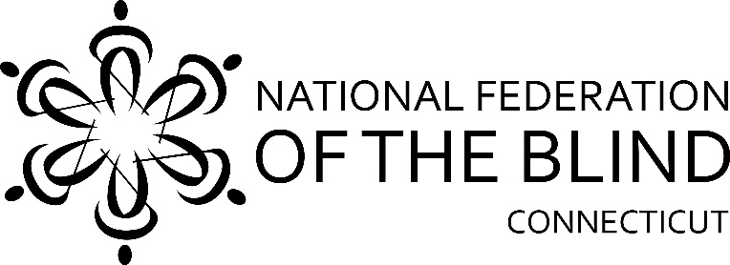

**52nd Annual State Convention!!**

**November 3, 4 & 5, 2023**

**The National Federation of the Blind of Connecticut will hold our 52nd Annual State Convention on Friday, Saturday, and Sunday, November 3, 4 & 5, 2023** at the **Holiday Inn, 35 Governor Winthrop Boulevard, New London**. Rooms will be available for Friday and Saturday nights for a convention discounted rate of $102.80 including tax, per night. **To reserve a room, call the Holiday Inn at 860-443-7000 and use our group code FTB to receive our discounted rates.** **The deadline for reserving a room for the convention is October 2, 2023**

Friday night dinner will be on your own this year. An excellent option is the hotel’s restaurant, La Luna, which is an Italian restaurant that serves very good food at reasonable rates. The hotel will have firepits on their outdoor patio in time for our convention. We will be holding our Vendor Fair on Friday evening from 7:00pm to 10:00pm.

On Saturday morning, a full breakfast buffet will be served at 8:00am followed by our general session which starts promptly at 9:00am. We will hear from Affiliate President Maryanne Melley, our National Representative Gary Wunder, and a variety of innovative speakers.

Lunch will be served from 12pm-1:00pm. Speakers will continue after lunch. We will also hold open discussion sessions, including one regarding Uber and Lyft usage. The CT Association of Blind Students meeting will be held from 2:00pm to 3:00pm and the CT Association of Guide Dog Users meeting will be held from 3:30pm to 4:30pm.

Our Banquet will begin at 6:00pm. National Representative Gary Wunder will address our convention during the banquet Saturday evening. Also, we will present Academic Scholarship Awards.

We will, of course, have our 50/50 and basket raffles!

On Sunday morning at 8:00am, a full breakfast buffet will be served before our 9:00am Annual Business Meeting. We will elect two board positions.

**The National Federation of the Blind of Connecticut acknowledges**

**with gratitude our convention sponsors listed below:**

**Silver Sponsor:** Retina Consultants, Manchester, CT 06040

**Registration Form**

Attendees who register at the door will be charged an additional $10. Please note that online registrations will be available at [www.nfbct.org](http://www.nfbct.org), following the link to State Convention information.

**Name**: ______________________________________________________

**Address**: _____________________________________________________

**Phone**: ______________________________________________________

**E-mail**: ______________________________________________________

**Indicate how many will be attending the following:**

**Division meetings Saturday Afternoon**

_____ CT Association of Guide Dog Users; _____ CT Association of Blind Students

_____ **State Convention Registration Fee: $20 per person**

**Meals:**

_____ Full convention package, $95 per person. This includes Saturday and

Sunday breakfasts, Saturday lunch and banquet dinner. This includes the

registration fee and represents a $10 discount per person.

_____ Saturday Morning Full Breakfast Buffet, $15

_____Saturday Lunch Choices: ____Roast Beef Wrap, $15; ____Turkey Wrap,

$15; ___Ham Wrap $15; ____Tuna Wrap, $15

_____ Saturday Night Banquet Meal Choices: ____Chicken Parmigiana, $40;

____Eggplant Parmigiana, $40

______Sunday Morning Full Breakfast Buffet, $15

**Total payment (registration fee and meals): $______**

**______ No, I cannot attend the 2023 state convention, but I am sending a donation to the NFB of CT.**

**Registration deadline is October 15th.** Send your check payable to the NFB of CT with your registration form to:

**NFB of CT, 111 Sheldon Road, Unit 420, Manchester, CT 06045**