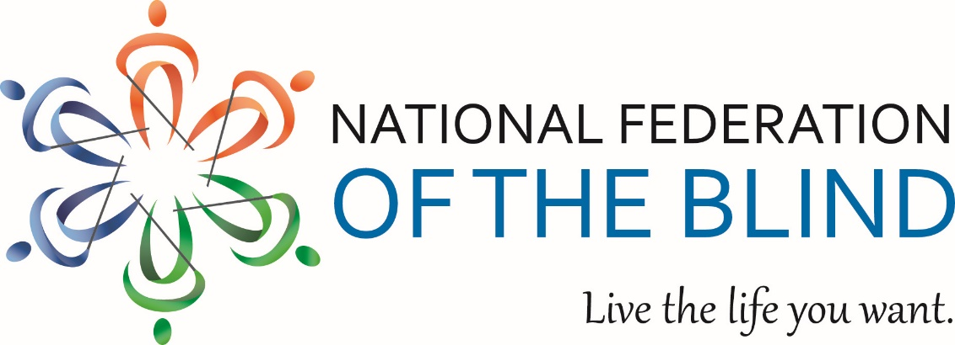

**Welcome to the Great Western Guide Dog Show and Seminar**

Saturday, May 13th

9 a.m. to 3 p.m.

Colorado Center for the Blind

2233 W Sheppard Ave Littleton Colorado 80120

<https://cocenter.org/>

Secessions available on Zoom will be noted on the agenda items below. <https://zoom.us/j/7206208007>

Your Colorado Association of Guide Dog Users, a division of The National Federation of the Blind of Colorado welcomes each and every one of you to this powerful day.

Sponsored by: The Michael Hingson Group, The Animal Law Firm, and Worley Enterprises.

A special thanks to all of the trainer experts from this nation’s leading guide dog schools.

Guiding Eyes for the Blind, Guide Dog Foundation, Guide Dogs for the Blind, The Seeing Eye, and Canines and Canes

Gold Sponsor: The Animal Law Firm

The Animal Law Firm is America’s premier animal law firm specializing in service animal representation, pet custody disputes, dog bite defense, veterinary malpractice, and more! We fight for the Underdog. Now serving 3 states: Colorado, Pennsylvania, and New Jersey. Cerridwyn Nordstrom, iamcerridwyn@gmail.com

Gold Sponsor: The Michael Hingson Group

Michael Hingson, author of the #1 NY Times Bestselling book *Thunder Dog*, the story of a blind man, his guide dog, and the triumph of trust at Ground Zero; member of the NFB for 51 years; is using his eighth guide dog, Alamo; Internationally acclaimed keynote and public speaker; chief vision officer for accessiBe. info@michaelhingson.com

Gold Sponsor: Worley Enterprises

The WE team, we build opportunity through service.

kevanworley@worleyenterprises.com

**9:00 a.m.**

REGISTRATION

Front Lobby

(suggested donation $20) Light breakfast snacks

**9:30 a.m.**

OPENING CEREMONY

Large Conference Room (available on Zoom)

Maryann Migliorelli, President, Boulder Chapter, and longtime guide dog handler

**9:45 a.m.**

REMARKS FROM OUR NFBCO PRESIDENT AND PRADA HANDLER JESSICA BEECHAM

Large Conference Room (available on Zoom)

**9:55 a.m.**

KEYNOTE SPEAKER, MIKE HINGSON

Large Conference Room (available on Zoom)

Mike is the author of *Running with Roselle* and New York Times bestseller *Thunder Dog.*

**10:30 a.m.**

BREAK FOR HUMANS AND DOGS

**10:45 a.m.**

FEATURING THE STORIES OF A BLIND AUTHOR AND GUIDE DOG HANDLER

Large Conference Room (available on Zoom)

Jo Elizabeth Pinto

**11:00 a.m.**

CAN YOU ACTUALLY TRAIN YOUR OWN GUIDE DOG?

Large Conference Room (available on Zoom)

Julie Johnson, owner of On The Go Dog Gear

**11:15 a.m.**

WE ARE FIRST-CLASS CITIZENS WHO HAPPEN TO TRAVEL WITH GUIDE DOGS

Large Conference Room (available on Zoom)

A report on advocacy. The twin roadblocks from transportation network companies and the airline industry presented by Raul Gallegos, President, NAGDU, and Paul Sandoval, Vice President, NAGDU

**11:45 a.m.**

LUNCH

Outside or Lunchroom

**12:20 p.m.**

A PRESENTATION FROM THE ANIMAL LAW FIRM

Large Conference Room (available on Zoom)

Cerridwyn Nordstrom, Attorney at Law**,** member, National Federation of the Blind

**12:30 p.m.**

SO YOU WANT A GUIDE DOG, DO YA?

Large Conference Room (available on Zoom)

A panel of guide dog handlers and trainers have the answers. Should you? Or shouldn’t you? You decide.

Facilitator Kevan Worley

**1:00 p.m. to 3:00 p.m.**

EXHIBITS

Lunchroom

Enjoy the opportunity to peruse exhibits from schools, products, services, and On the Go Dog Gear.

**1:15 p.m.**

POWER SESSION 1

Senior Resource Room

Tips and tricks from trainers and handlers, dog distraction, targeting, etc.

Tami Gomes and Kristen Lake

(This session will be repeated at 2:15 p.m.)

POWER SESSION 2

Small Conference Room

Put your best paw forward. Getting Fido’s groom on, time to get Fido’s nails trimmed. Ideas for making your beast look its best.

Melissa Smith and Jane Flower

(This session will be repeated at 2:15 p.m.)

POWER SESSION 3

North Hall/Outside

The Juno walk experience.

Bill Porter and Ellie Carlson

(This session will be repeated at 2:15 p.m.)

**2:15 p.m.**

POWER SESSION 1

Senior Resource Room

Tips and tricks from trainers and handlers, dog distraction, targeting, etc.

Ellie Carlson and Tami Gomes

POWER SESSION 2

Small Conference Room

Put your best paw forward. Getting Fido’s groom on, time to get Fido’s nails trimmed and get ideas for making your beast look its best.

Kristen Lake and Chelsea White

POWER SESSION 3

North Hall/Outside

The Juno Walk Experience

Megan Dameron and Bill Porter

POWER SESSION 4

Large Conference Room

DOG FOOD FOR THOUGHT: A special presentation on alternative dogs’ nutrition, presented by Melissa Smith, trainer, and advocate.

**2:50 p.m.**

THAT’S A WRAP

Large Conference Room

Final thoughts and adjournment.

**3:00 p.m.**

IT’S TIME TO LEAVE THE BUILDING

Parking Lot

Join us in the lobby for pictures