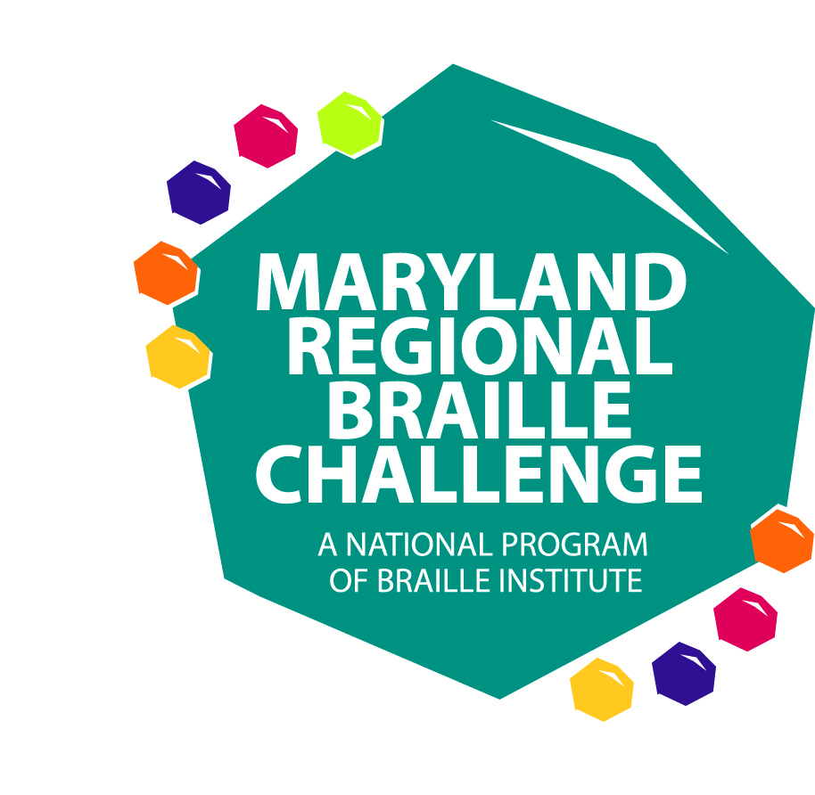
THE MARYLAND REGIONAL BRAILLE CHALLENGE
FEBRUARY 7, 2015
PARENT/STUDENT REGISTRATION PACKET

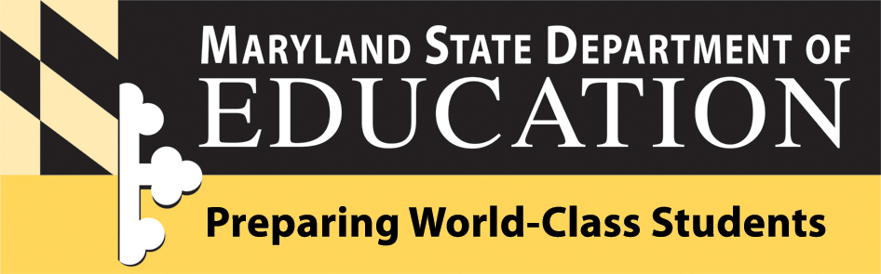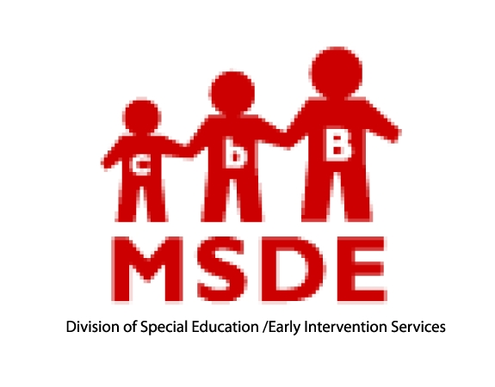
The Maryland State Department of Education and
The Maryland School for the Blind
will be hosting the Maryland 2015 Regional Braille Challenge on
Saturday, February 7, 2015

Braille is an important key to literacy! It allows for the enjoyment of reading, leads to school success, and opens the doors to future employment. Come celebrate braille literacy with a day filled with fun, competition, learning, prizes, and enjoyment! In addition, bring in Braille books you no longer read for our first ever Braille book exchange!

Students who read braille in grades Prekindergarten through Grade 12 are invited to participate in the Maryland Regional Braille Challenge reading and writing contests. Parents are invited to participate in workshops while students are taking the tests. Teachers and school staff are invited to assist with test proctoring and scoring and helping to facilitate the day.

WHEN: Saturday, February 7, 2015 (Snow date: February 21, 2015)

COST: FREE

TIME: 8:30 AM to 4:00 PM (Lunch will be provided)

WHERE: The Maryland School for the Blind
3501 Taylor Avenue
Baltimore, MD 21236

THANK YOU TO THE GENEROUS SUPPORT OF OUR NATIONAL SPONSORS!!!
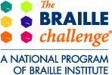
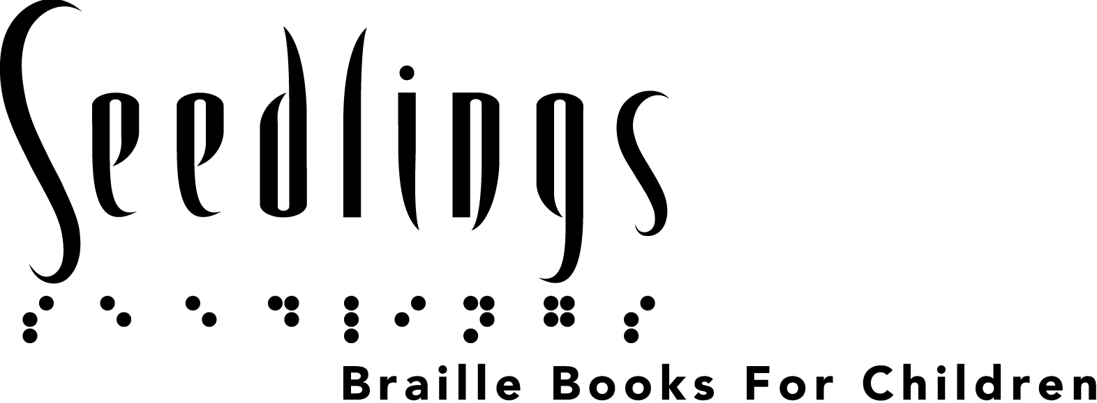

Maryland 2015 Regional Braille Challenge
Agenda

8:30-9:00 Registration (Russo Alcove)
9:00-9:30 Opening Ceremony (Russo)
- Welcome and Introductions
- Group Formation
9:45-10:45 Session 1
    - Students in PreK-12 Testing
    - Parents attend workshops
11:00-12:00 Session 2
    - Students in PreK-12 Testing
    - Parents attend workshops
12:00-12:45 Lunch (Dining Hall)
1:00-2:00 Session 3
    - Students in Grades 1-12 Testing
    - Parents attend workshops and students in Pre-K and K attend activity
2:00-3:15 Session 4
    - Students in Grades 5-12 Testing
    - Vendor Fair: Parents and students Pre-K through Grade 4 and older students as they complete testing (Russo)
3:15-4:00 Awards (Russo)
Maryland 2015 Regional Braille Challenge
Contest Categories

Novice (Prekindergarten and Kindergarten) Students in this level only compete in the Maryland Regional contest. This is not a national contest for this grade group.
- Reading (Letters and contractions are read orally and student locates and marks the correct letter/contractions on the line).
- Writing (Student writes dictated letters and contractions)
Apprentice (grades 1-2) and Freshman (grades 3-4)
- Reading Comprehension (Students read a passage in braille and answer multiple choice questions about it)
- Spelling (The proctor will dictate words orally and the student will write the words on a braillewriter in both contracted and uncontracted form)
- Proofreading (Students will read sentences in Braille and answer multiple choice questions regarding errors in spelling, punctuation, or grammar)
Sophomore (grades 5-6), Junior Varsity (grades 7-9), Varsity (grades 10-12)
- Reading Comprehension (Students read a passage in braille and answer multiple choice questions about it)
- Proofreading (Students will read sentences in Braille and answer multiple choice questions regarding errors in spelling, punctuation, or grammar)
- Speed and Accuracy (Students use a Victor Reader Stream or a BookPort Plus to listen to an audio passage and write the passage on braillewriter with speed and accuracy)
- Chart and Graph Reading (Students read and interpret charts and graphs and answer multiple choice questions about them)

All students who participate and remain all day for the Maryland Regional Braille Challenge will be recognized. For those students who are reading below grade level, they may participate in the contest in a younger grade group. Parents need to keep in mind that students who compete in a below grade level group for their age will be grouped with students younger than their child and their contests will not be eligible for the national competition.

Maryland 2015 Regional Braille Challenge
Student Registration and Permission

Student’s Last Name: First Name:
Date of Birth: Grade in School:
Address:
Parent Cell Phone: Parent’s Email:
Name of Teacher of the Visually Impaired:
Contest level you would like your child to participate: (NOTE: Only students in Grades 1-12 who compete at age/grade level will have their entries submitted for the national contest.)
PreK Kindergarten Grade 1 Grade 2 Grade 3 Grade 4 Grade 5 Grade 6 Grade 7 Grade 8 Grade 9 Grade 10 Grade 11 Grade 12
T-Shirt Size: Child: Small Medium Large Adult: Small Medium Large X-Large
Lunch Options: Italian cold cut Tuna on croissant Peanut butter and jelly sandwich
Chicken Caesar Salad Caesar Salad (with no chicken)
For Students in Grade 5-12 Only: Students may bring their own or school system Victor Reader Stream and headphones to use for the “Speed and Accuracy” contest. If they cannot bring one, a Bookport Plus will be provided for use. Please check one box.
I will bring a Victor Reader Stream OR I know how to use a BookPort Plus
Parent Signature
Contest Release
I hereby give permission to the Maryland State Department of Education, the Maryland School for the Blind, and Braille Institute for my child to participate in The Braille Challenge preliminary contest. I understand that if my child qualifies, he or she is eligible to attend The Braille Challenge final contest in Los Angeles, CA on June 20-21, 2014.
Photographic Release
I hereby authorize Braille Institute of America, Inc. (BIA), the Maryland State Department of Education (MSDE), and the Maryland School for the Blind (MSB) to photograph, videotape, or otherwise record by visual, audio, electronic or manual means, the visual likeness and/or voice or other sounds created by the above named contestant (collectively "Reproductions"). BIA,MSDE or MSB may use or permit to be used the reproductions in any CD, DVD, exhibition, display, publication, solicitation or promotional or educational material or on any website including without limitation agency websites, Facebook, or YouTube without compensation to the contestant, the contestant's heirs, successors or assigns.
Parent Name (printed): _________________________________________________________________

Parent Signature: ________________________________________________________________________
THIS FORM MUST BE SIGNED and SENT TO VICTORIA WATT BY JANUARY 16, 2015
FAX 410-319-5708 or Email @ victoriaw@mdschblind.org
Maryland 2015 Regional Braille Challenge
Parent Registration

Braille Challenge Participant’s Name: ___________________________________
Name of Parents/Guardians Attending:
__________________________________ __________________________________
Lunch Options (please select 1 for each parent attending):
Italian cold cut Tuna on croissant Peanut butter and jelly sandwich
Chicken Caesar Salad Caesar Salad (with no chicken)

Accommodations to be provided upon request. Please specify.
Large Print Braille Electronic
Yes, I would like to bring books to exchange at the Braille book exchange. I will bring approximately ____ books (count each volume as a separate book please, this is to help with planning).
*Is your child a member of the Maryland State Library for the Blind and Physically Handicapped? If not, visit www.lbph.lib.md.us to download and application.*
Workshops will be provided throughout the day for parents.
Workshop names and descriptions will be sent to parents following registration.
NOTE: At least one parent must attend and remain on site throughout the day while their child is present and competing. Parents are not allowed in the testing rooms with their child. You are encouraged to participate in the workshops provided. Your children will be escorted and supervised by teachers and staff from the Local School Systems and the Maryland School for the Blind.
If students from the Maryland School for the Blind need transportation, please contact Ruth Ann Hynson to discuss.
THIS FORM MUST BE SIGNED and SENT TO VICTORIA WATT BY JANUARY 16, 2015
FAX 410-319-5708 or Email @ victoriaw@mdschblind.org

