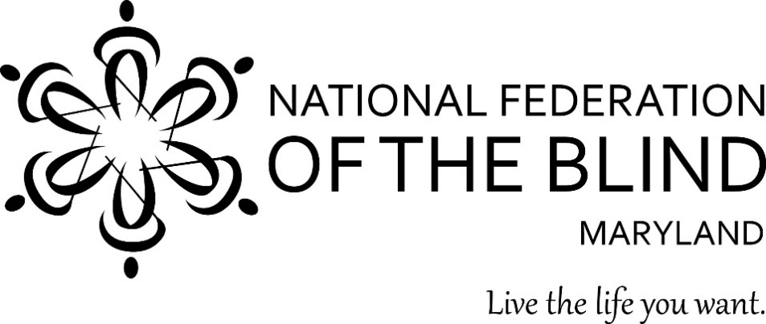

Subject: Appropriation for the Center of Excellence in Nonvisual Access (CENA) to Education, Public Information, and Commerce
To: Members of the Maryland General Assembly
From: Members of the National Federation of the Blind of Maryland
Contact: Sharon Maneki, Director of Legislation and Advocacy
National Federation of the Blind of Maryland
9013 Nelson Way
Columbia, MD 21045
Phone: 410-715-9596
Email: nfbmdsm@gmail.com

Date: January 2021

PROPOSED ACTION
The Maryland General Assembly should keep the $250,000 appropriation in the Governor’s Budget for the CENA to Education, Public Information, and Commerce.

BACKGROUND
In 2014, the National Federation of the Blind (NFB) founded the NFB Center of Excellence in Nonvisual Access (CENA). The CENA is a center of expertise, best practices, and resources that enables business, government, and educational institutions to more effectively provide accessible information and services to blind citizens. The State of Maryland, through the Maryland Department of Disabilities (MDOD), partners with the CENA to support a series of projects under the Nonvisual Accessibility Initiative (NVAI) with an aim to establish Maryland as a leader in nonvisual accessibility.

The public-private partnership between MDOD and the NFB has improved the standard of accessibility throughout the state. Through the development and implementation of a variety of projects within the following six focus areas, we will continue to build a more accessible Maryland.

- Enhancing Access to Education Technology and Strategies
Inaccessible instructional materials prevent blind and low-vision students from accessing the fundamental tools of education, leaving them woefully unprepared for their futures. Under the NVAI the NFB will continue to address the lack of accessible digital publications and instructional materials by conducting trainings on tools, strategies, and best practices in the creation and dissemination of materials that are “born accessible.” Through our continued partnership with the Maryland Open Source Textbook initiative, the HathiTrust, the DAISY Consortium, major publishing companies, and education technology developers, the NFB will continue to assist in the development and implementation of innovative accessible technologies and strategies.

- Enhance Access to Employment-Related Tools and Services
The Workforce Innovation and Opportunity Act (WIOA) sought to create system change to address the significant unemployment of people with disabilities by defining the relationship between state Departments of Labor and Division of Rehabilitation Services. Yet, there remains a 70 percent unemployment/underemployment rate for blind people in this country. One of the contributing factors is that many employers are using online applications, training tools, as well as workplace technology that is inaccessible and makes it impossible for a blind or low-vision job seeker to obtain, retain, or advance in employment. Under the NVAI, the NFB will collaborate with the Maryland Department of Labor and the Maryland Division of Rehabilitation Services, ensuring greater access to the American Job Centers in an effort to improve access to employment systems and services. In addition, the NFB will conduct outreach to employers in an effort to provide them with the training and support required to eliminate the employment barriers faced by blind and low-vision Maryland citizens.

- Offering Accessibility Boutiques and Other Training Seminars
The CENA will host informal accessibility-specific Accessibility Boutiques and other training seminars. The Accessibility Boutiques are usually one or two hours long, and are free and open to the public, and are designed to create public awareness about accessibility and provide a brief orientation about specific accessibility tools and strategies. Other larger trainings will offer a more substantive exposure and training experience to the participants and address major issues related to nonvisual accessibility.

- Maintaining the Accessibility Switchboard and Community of Practice
The NFB will continue to develop and market the Accessibility Switchboard, a dynamic online portal consisting of an accessibility information resource for consumers and a compliance information portal for organizations. This work will be informed by the Accessibility Community of Practice, a volunteer group of accessibility experts from educational institutions, corporations, and the public sector.

- Assisting with the Integration of Smart Technologies for Accessible Cities
In order to facilitate the integration of innovative technologies and strategies toward the creation of an accessible city that will provide the opportunity for blind people to have equal access to essential information, resources, and services, the NFB will:
- Continue to participate in partnerships with technology developers and city planners in the evaluation and implementation of various transportation and wayfinding strategies. We will host quarterly meetings with our partners in order to share information across disciplines.
- Continue to investigate and evaluate the various tools being used for wayfinding and the strategies for creating accessible public spaces. A summit will highlight the work being done to create more accessible public and private programs and services by bringing representatives from academic, public, and private organizations together to share best practices and network.

- Coordinating the Accessibility Inclusion Fellowship Program
The “Final Report of the Study on Accessibility Concepts in Computer Science, Information Systems and Information Technology Programs in Higher Education” recommended that three annual fellowships be awarded to help instructors begin to include accessibility concepts contained within the minimum areas of instruction in at least one course offering in their institution. The CENA will continue to recruit and support these fellows in the coming year.

CONCLUSION
Access to information remains one of the greatest barriers faced by blind persons. To reduce these barriers the National Federation of the Blind established the CENA to provide information about best practices and to develop innovative techniques for achieving nonvisual access. The Maryland General Assembly should allow this state-of-the-art program to continue by approving the $250,000 appropriation in the Governor’s Budget under the Maryland Department of Disabilities.

