Bernard F. Turner, III
Live the Life You Want Award Application
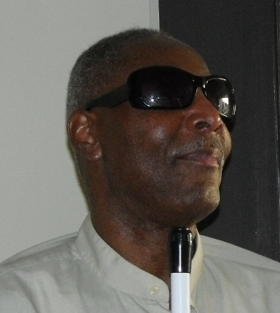

Photo of Bernard F. Turner, III

Bernard F. Turner lost his sight at age 40. He learned the skills of blindness and went on to live the life he wanted. He went back to work and retired as an Instructional Technology Supervisor from the Arnold & Porter Law Firm.
Last Name______________________________ First Name____________________ MI_____
Address_______________________________________________________ Zip Code________
Date of Birth ________________________ Home phone #_______________________
Cell phone #___________________________
On a separate page write a brief essay, not longer than two or three paragraphs explaining how this award will help you to live the life you want and achieve greater independence. Be sure to include when you lost your sight, how you handle blindness, and how you will use the award.
Attach copy(s) of documents supporting the need for award funds (bill for technology, tuition, etc.) to this application. If you don’t have an actual bill, send a description and price.

Applicant’s Signature ___________________________________________________________

Eligibility & Guidelines
- This award is open to blind people who lost their sight between the ages of 18-60.

- Applicants must demonstrate the need for the award through a brief narrative and supporting documentation.

- One application per person.

- The National Federation of the Blind of Maryland (NFBMD) will advertise and encourage people to apply for this award. The winner is expected to attend the annual NFBMD convention, November 12-14, which will be in-person at the Holiday Inn, 105 W. Fayette St, Baltimore, MD 21201. The final decision on the winner will be made by the Turner family.

- Applications will be accepted from September 1, 2021 through October 11, 2021.

- The Turner family will notify the winner by November 1. The $200 award will be presented November 13 at the NFBMD convention banquet.

- Submit your application electronically to Ellen Ringlein at Convention@nfbmd.org including proof that you have preregistered for the State Convention. We will make sure that the Turner family receives it.

