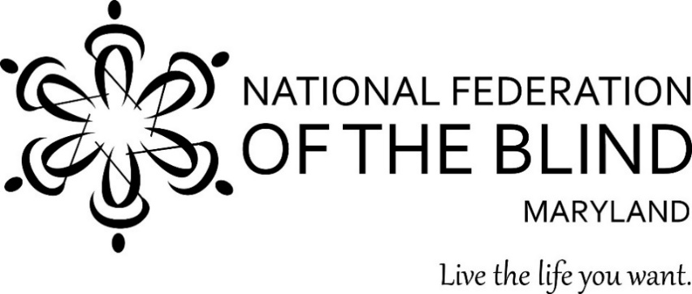

Subject: Appropriation for the Center of Excellence in Nonvisual Access (CENA)
to Education, Public Information, and Commerce
To: Members of the Maryland General Assembly
From: Members of the National Federation of the Blind of Maryland
Contact: Sharon Maneki, Director of Legislation and Advocacy
National Federation of the Blind of Maryland
9013 Nelson Way
Columbia, MD 21045
Phone: 410-715-9596
Email: nfbmdsm@gmail.com

Date: January 2022

Proposed Action: The Maryland General Assembly should keep the $250,000 appropriation in the Governor’s Budget for the CENA to Education, Public Information, and Commerce.

Background: In 2014, the National Federation of the Blind (NFB) founded the NFB Center of Excellence in Nonvisual Access (CENA). The CENA is a center of expertise, best practices, and resources that enables business, government, and educational institutions to more effectively provide accessible information and services to blind citizens. The State of Maryland, through the Maryland Department of Disabilities (MDOD), partners with the CENA to support a series of projects under the Nonvisual Accessibility Initiative (NVAI) maintaining the State of Maryland as an ongoing leader in nonvisual accessibility.

The public-private partnership between the NFB CENA and MDOD (CENA/MDOD) has improved the standard of accessibility throughout the state, and through the development and implementation of a variety of projects within the following six focus areas, we will continue to build a more accessible Maryland.

- Enhancing Access to Education Technology and Strategies
Inaccessible instructional materials prevent blind and low-vision students from accessing the fundamental tools of education, leaving them woefully unprepared for their futures. The problem with the lack of accessibility to education technology has been exacerbated during the COVID crisis and created significant problems in the provision of effective virtual instruction to Maryland’s blind and low-vision students. Under the NVAI the CENA/MDOD has worked diligently to identify accessible education technology, while seeking to work with developers to make other education technologies nonvisually accessible. In the coming year, through the NVAI, the NFB will continue to address the lack of accessible education technology, digital publications, and instructional materials by conducting trainings on tools, strategies, and best practices in the creation and dissemination of tools that are “born accessible.”

- Enhance Access to Employment-Related Tools and Services
The unemployment/underemployment rate for blind people in this country continues to exceed 70 percent, and the need to utilize more online, digital, and virtual means of providing employment services and supports has created both problems and opportunities. Under the NVAI, the CENA/MDOD will continue to work in coordination with the Maryland state Department of Labor and Division of Rehabilitation Services to develop and implement the training and tools that will enhance access to the network of employment systems and services available through the American Job Centers. In addition, the NFB will conduct outreach to employers in an effort to provide them with the training and support required to eliminate the employment barriers faced by blind and low-vision Maryland citizens.

- Offering Accessibility Boutiques and Other Training Seminars
Accessibility Boutiques are one- to two-hour basic overviews/trainings designed to create public awareness about accessible software, products, services, and strategies. Quarterly Trainings are half-day trainings that offer a more substantive training experience to the participants and address major issues related to nonvisual accessibility. The CENA/MDOD will continue to offer Accessibility Boutiques and Quarterly Trainings, at no cost to Maryland citizens, on topics that assist both laymen and professionals to remain knowledgeable of the evolving tools, strategies, and best practices to build a more accessible Maryland.

- Maintaining the Accessibility Switchboard and Community of Practice
The NFB will continue to develop and market the Accessibility Switchboard, a dynamic online portal consisting of an accessibility information resource for consumers and a compliance information portal for organizations. This work will be informed by the Accessibility Community of Practice, a volunteer group of accessibility experts from educational institutions, corporations, and the public sector.

- Assisting with the Integration of Smart Technologies for Accessible Cities
The development and implementation of accessible, safe, affordable, efficient transportation allows blind and low-vision Maryland citizens to independently travel throughout their communities. In addition, emerging nonvisual access navigation or wayfinding technologies facilitate independent access to a variety of public and commercial venues, including college campuses, public and commercial buildings, and other environments. In order to promote the integration of innovative technologies and strategies toward the creation of accessible cities, the CENA/MDOD will continue to participate in meetings and establish partnerships with technology developers and city planners in the evaluation and implementation of various transportation and wayfinding strategies. Our active involvement will assist in the integration of accessibility features throughout public spaces that are seamless and esthetically pleasing.

- Coordinating the Accessibility Inclusion Fellowship Program
The “Final Report of the Study on Accessibility Concepts in Computer Science, Information Systems and Information Technology Programs in Higher Education” recommended that three annual fellowships be awarded to help instructors begin to include accessibility concepts contained within the minimum areas of instruction in at least one course offering in their institution. The CENA/MDOD has offered these fellowships for three years, and will continue to recruit and support an additional cohort in the coming year.

Conclusion
Access to information remains one of the greatest barriers faced by blind persons. The public-private partnership between the NFB CENA and MDOD (CENA/MDOD) has proven to be an effective method of removing these barriers by providing information about best practices and developing innovative techniques for achieving nonvisual access. The Maryland General Assembly should allow this state-of-the-art program to continue by approving the $250,000 appropriation in the Governor’s Budget under the Maryland Department of Disabilities.

