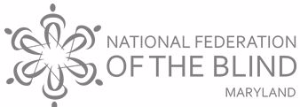
10 Year Annual National Harbor Chapter County Resource Day

Come join the National Harbor Chapter -National Federation of the Blind of Maryland’s (NHC-NFBMD) 10th year hosting in Prince George’s County!
This event educates the community about Blind Equality Achievements
To share resources for the Blind/Low -vision ,persons with changing vision and their families and friends in the following areas: Health, independent living ,employment , technology ,quality of life /recreation and transportation and more .

Theme: Make A Difference ; Make It Count!
Date : Friday, October 20, 2023
Time: 2-6pm

Location: Community Center and Town Hall of Colmar Manor 3701 Lawrance Street Colmar Manor 20722
Admission: Free
Register :
1.( Online: https://www.brownpapertickets.com/event/6142266
2) Telephone: Chairperson /President Amber Woods 301-978-6686 or Board Member Joyce Brooks 301-529-8218

Thank you for helping the NHC-NFBMD “Changing What It Means To Be Blind In Prince George’s County and Beyond!”

