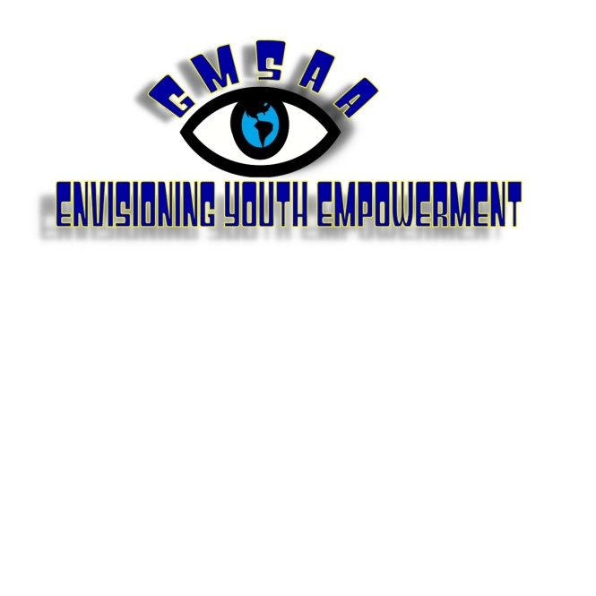

President: Ricky Scott Treasurer: Fred McEachern
Vice President: Tim Snyder Secretary: Alan Chase

BASIC INFORMATION:
Who: Any youth with a visual impairment 16 years of age or older
What: Envisioning Youth Empowerment Retreat (EYE Retreat)
When: Wednesday, August 3rd to Saturday, August 6th
Where: The Governor Morehead School in Raleigh, NC
Why: To provide an opportunity for youth with visual impairments to experience attending college, starting their own business, and exploring their surroundings using public transit and audio description.
How: There is no cost for housing or food. Transportation, liens, and personal hygiene items are the applicant’s responsibility. At this time, we are only able to accept applications for approximately thirty youth.

PERSONAL INFORMATION: (all information is confidential)
Name: Age:
Address:
City: State: Zip:
Day Phone: Evening Phone:
I am currently: High School College
Graduate School Working
I am: Blind Legally Blind Visually Impaired

ACCOMMODATIONS: (check all that apply)
I use: Braille Large Print Regular Print
I have special dietary needs. Explain:
I have allergies or a medical condition. Explain:
Other:

ACTIVITIES: (please check all that you wish to participate)
The following is a list of possible activities for this summer. Note that there may be extra costs for some events and you may be required to ride public transportation with a sighted guide and/or an O&M specialist. Parent or guardian permission may also be required for those under 18. The final schedule will include both required and optional activities.
Speak to faculty and students at NC State University
Trip to a Durham Bulls Game ($15.00)
Learn more about access to leisure reading materials
Attend an audio described museum tour
Experience an audio described movie
A talent show: (explain your talent)
Explore public transportation
Learn about your legal rights
Learn to play beep ball
Learn how to start your own business
Design your own board game
Check out new assistive technology
Other ideas: (please explain)

PERSONAL STATEMENT:
Please use this space to tell us why you want to attend this retreat or something interesting about you!

EMERGENCTY CONTACT:
Name:
Address:
City: State: Zip:
Day Phone: Evening Phone:
Relationship to you:

CONTACT:
Please submit this application to Alan Chase, Retreat Coordinator, via e-mail at achase11@nc.rr.com or by mail to 1217 Manassas Court, Unit C, Raleigh, NC 27609. The deadline for all applications is Friday, July 1st, 2011 at 5pm.

If you have questions or suggestions you may contact Alan Chase via phone at 910-612-2220 or e-mail at achase11@nc.rr.com.

SIGNATURE: (I agree that all information is true and accurate)

Applicant Signature: Date:
Parent/Guardian (if under 18): Date:

