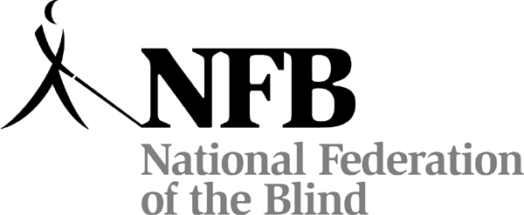

30 SCHOLARSHIPS
For Blind High School Seniors through Grad School Students
in the United States or Puerto Rico.

The $12,000 Kenneth Jernigan Scholarship
1 Scholarship for $10,000
2 Scholarships for $7,000 each
4 Scholarships for $5,000 each
22 Scholarships for $3,000 each

PLUS a trip to the NFB Annual Convention
and other gifts to scholarship winners!

ARE YOU A LEGALLY BLIND STUDENT?
Go to:
www.nfb.org/scholarships

NATIONAL FEDERATION OF THE BLIND
2012 SCHOLARSHIP PROGRAM

To apply: Read the rules of eligibility, the timeline, the Submission Checklist, and the Scholarship FAQ, then fill in the online Scholarship Application Form. Supply the required documents and complete one telephone interview with our representative.

Deadline: March 31, 2012
All documentation and the interview request must be received by the deadline.

E-mail: Scholarships@nfb.org
NFB Scholarship Program: (410) 659 -9314, extension 2415 (8 a.m. - 5 p.m. ET)
NFB at Jernigan Place, 200 East Wells Street, Baltimore, MD 21230

