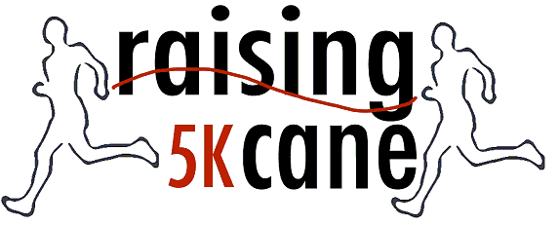
Raising Cane and Camp Abilities NC ∞ PO Box 12911, Raleigh, NC 27606
We CAN-C the POSSIBILITIES

CAMP ABILITIES IS COMING TO NORTH CAROLINA!

What is Camp Abilities North Carolina?

Camp Abilities North Carolina (CANC) is a new sports camp designed to meet the unique needs of children with visual impairments.

CANC is committed to helping youth with visual impairments explore and learn individual and group sports to optimize their potential to improve and sustain health and wellbeing throughout their lives. CANC focuses on teaching Sports and Healthy Living Habits to students with visual impairments, ages 11-17, and is modeled on Dr. Lauren Lieberman’s Camp Abilities in Brockport (NY).

CANC is a part of Raising Cane, Inc., a private 501c 3 non-profit dedicated to encouraging and providing sport activities for the visually impaired in North Carolina. www.RaisingCane.org

CANC has partnered with the North Carolina Lion’s Camp Dogwood, a camp serving the visually impaired/blind community of North Carolina since 1967, to bring this event to NC.

When is Camp Abilities North Carolina?
July 10-13, 2013

Where is CANC?
Camp Dogwood for the Blind & Visually Impaired is located on the shores of Lake Norman in Sherrills Ford, North Carolina.

Sports Topics
United States Association of Blind Athletes, Self-Determination, Sport and Recreation Accessibility Accommodations,

Healthy Living Topics
Nutrition, Exercise, Community Resources, for Home

Specially designed sports for people with visual impairments
Sample activities/sports: Goal Ball, Beep Kickball, track and field, swimming, waterskiing, tubing, yoga

Cost: $150.00

Staff:
Includes Certified Teachers of the Visually Impaired, Certified Orientation and Mobility Specialists, Certified Physical Education Teachers, Adapted Physical Education Teachers, Physical Education Interns from North Carolina University Programs, licensed nurse, and certified lifeguards.

Location:
Camp Dogwood for the Blind & Visually Impaired is located on Lake Norman in Catawba County. The campus, on 65 wooded and rural acres, was started in 1967. It is owned and operated by the North Carolina Lions, Inc. The campus is designed to provide easy mobility and comfort for blind and visually impaired guests. The NC Lions also provide a summer recreation program for blind/VI adults. For more information on Camp Dogwood www.nclionscampdogwood.com.

