NATIONAL FEDERATION OF THE BLIND OF NORTH CAROLINA

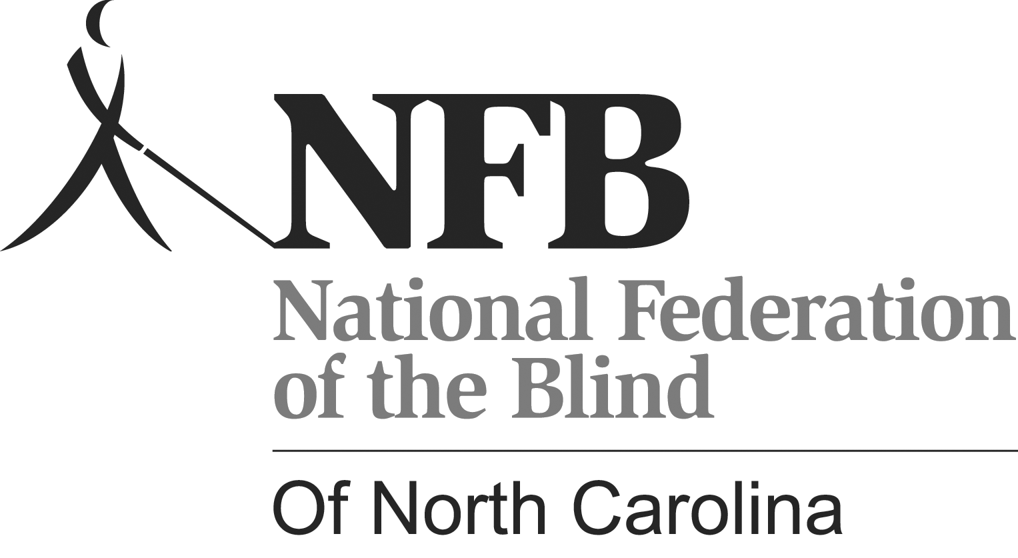

2013 STATE CONVENTION

Funding the Movement
Changing What It Means To Be Blind In NC

September 12 - 15, 2013

Holiday Inn Bordeaux, 1707 Owen Drive
Fayetteville, North Carolina

In memory of Hazel Staley
Convention sponsor: Harnett County Chapter
NFB Declaration

The National Federation of the Blind of NC is a North Carolina 501 (c) 3 consumer organization comprised of blind and sighted people committed to changing what it means to be blind. Though blindness is still all too often a tragedy to those who face it, we know from our personal experience that with training and opportunity it can be reduced to the level of a physical nuisance. We work to see that blind people receive the services and training to which they are entitled and that parents of blind children receive the advice and support they need to help their youngsters grow up to be happy, productive adults. We believe that first-class citizenship means that people have both rights and responsibilities, and we are determined to see that blind people become first-class citizens of these United States, enjoying their rights and fulfilling their responsibilities.
The most serious problems we face have less to do with our lack of vision than with discrimination based on the public’s ignorance and misinformation about blindness. Join us in educating North Carolinians about the abilities and aspirations of North Carolina blind citizens.
The NFB of North Carolina has 14 local chapters around the state and one division for students.

Thursday, September 12, 2013

5:00 - 8:00 PM Hospitality in Napoleons
7:00 - 9:00 PM Registration in Lobby

Friday, September 13, 2013

7:00 – 9:00 AM Hospitality in Napoleons

8:00 - 11:00 AM Registration in Lobby

9:00 AM - Noon | Leadership Seminar by Ron Brown in Chanel | TBA
Noon – 1:30 PM | Hospitality in Napoleons
1:30 – 2:30 PM | Advocacy and Legislation by Ron Brown in Chanel |  | Envision America Dave Bode in Lemans
2:30 – 2:45 PM | Break |  | Break
2:45 – 3:45 PM | How Your Affiliate Works by Ron Brown and Gary Ray in Chanel |  | Humanware  Jack Mitchell in Lemans
3:00 – 6:00 PM | Registration in Lobby
3:45 – 4:00M | Break |  | Break
4:00 – 5:00 PM | NFB of NC Secretary’s Session by Sharon Weddington and Gary Ray in Chanel |  | Low Cost A.T. Alternatives to Windows  Doug Smith in Lemans
5:00 – 7:00 PM | Hospitality in Napoleons
7:30 – 8:30 PM | NFB of NC Treasurer’s Session with Boyce Locklear in Chanel
7:00 – 10:00 PM | Vendor Hall in Chateau
7:00 PM – Until | Dance in Napoleons

The 2013 NFB of NC State Convention is hosted and sponsored by the Harnett County Chapter.

Programs & braille compliments of the NC Library for the Blind & the Friends of the NCLBPH.

Thanks go to the Wilson County Chapter for handling door prizes.

Saturday, September 14, 2013

7:00 – 8:30 AM  8:00 – 9:00 AM | Hospitality in Napoleons  Registration in Lobby
Saturday General Sessions in Wellingtons

9:00 – 9:05 AM | Call to Order by President Gary Ray
9:05 – 9:10 AM | Invocation by Tommy W. Thomas, Sr. Shekinah Glory Missionary Baptist Church
9:10 – 9:20 AM | Welcome by Harnett County Chapter
9:20 – 9:30 AM | Welcome by Anthony G. Chavonne, Mayor of Fayetteville
9:30 – 10:00 AM | Political Speakers (To Be Announced)
10:00 – 10:20 AM | President’s Report by Gary Ray
10:20 – 11:00 AM | National Update by Ron Brown, National Board Member
11:00 - 11:25 AM | Report from Library for the Blind by Carl Keehn, regional librarian
11:25 – 11:45 AM | Update from North Carolina Central University Master’s Program by Dr. Beth Harris
11:45– Noon | Report on Students Division by Alan Chase
Noon – 12:45 PM Registration in Lobby
Noon - 1:30 PM Hospitality in Napoleons
Noon – 5:00 PM Students in Chanel

2:00 - 2:30 PM | Update from Division of Services for the Blind by Eddie Weaver, Director
2:30 - 3:00 PM | BELL Report
3:00 – 3:30 PM | Update from the Governor Morehead School by Barbria Bacon, Director
3:30 – 4:00 PM | Update from the MIRA Foundation by Bob Baillie
4:00 – 4:20 PM | Update from the Vision Resource Center
4:20 - 4:30 PM | SUN Program Update by Al Sanchez, NC SUN Chair
4:30 - 4:45 PM | Reading of amendments to state constitution
4:45 - 5:00 PM | Nominations by Tim Jones
5:00 PM | Adjourn

Saturday Night Banquet in the Expo

6:30 PM | Welcome by President Gary Ray
6:35 PM | Invocation and Blessing by Susan Lee, Harnett County Chapter Chaplain
6:40 PM | Introduction of Head Table by First Vice President Tim Jones
6:55 PM | Announcement of Drawing winners by Tim Jones and Randy Vickers
7:20 PM | Award of Robert & Hazel Staley Scholarships by Julius Locklear
7:40 PM | Keynote Speaker – Ron Brown, National Board Member
8:40 PM | Pledging Our Way to Success by Ron Brown
TBA | Hospitality in Napoleons

Join the Legacy Society

Help build a future full of opportunity for the blind by becoming a member of the Jacobus tenBroek Legacy Society. Your legacy gift to the National Federation of the Blind can be made in the form of a will or living trust, an income-generating gift, or by naming the NFB as a beneficiary of a retirement plan or life insurance policy. You can also become a member of the Jacobus tenBroek Legacy Society by making a legacy gift to your state affiliate.

By committing to support an NFB affiliate, your gift will benefit both local and national programs as all bequests made to affiliates are split evenly with the NFB national treasury. In addition to having the satisfaction of contributing to the future success of the NFB's mission, tenBroek legacy society members will also receive a specially designed thank you gift and other benefits.

For additional information about the Jacobus tenBroek Legacy Society, please contact Lou Ann Blake at the NFB Jernigan Institute by e-mail at lblake@nfb.org, or by telephone at 410-659-9314, extension 2221.

Sunday, September 15, 2013
All Sunday Sessions Will Be Held in Wellingtons
7:00 – 8:30 AM | Hospitality in Napoleons
8:00 – 8:45 AM | Worship Service by the Reverend Robert Parrish
NFB of NC Business Meeting
9:00 AM | Call to Order by President Gary Ray
 | Invocation by Joy Scott
 | Hazel Staley Memorial
 | Secretary’s Report by Sharon Weddington
 | Treasurer’s Report by Boyce Locklear
 | Membership Report by Sharon Weddington
 | Fund Raising Report by Tim Jones
 | Chapter Reports by Chapter Representatives
 | Old Business
 | New Business
 | Constitutional Amendments
 | Elections
Noon | Adjournment

SPECIAL THANKS GO TO:

Western Harnett Lions Club
Cumberland County Chapter of the NFB of NC

