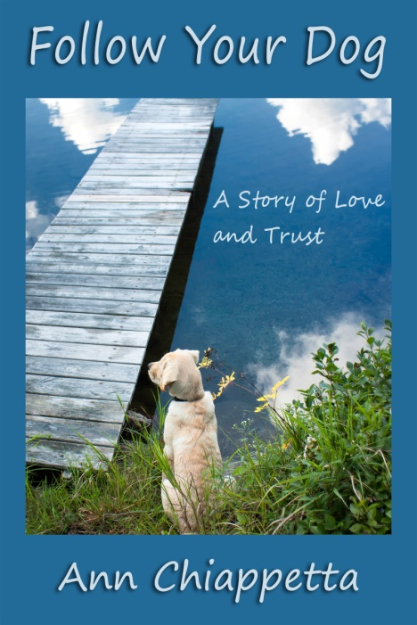

**Follow Your Dog**

**A Story of Love and Trust**

© 2017

by Ann Chiappetta

In e-book ($3.99) and print ($11.95) from Amazon and multiple other online booksellers.

Full details: http://www.dldbooks.com/annchiappetta/

What, exactly, does it mean to share one’s life with a guide dog?

While there is practical merit to the human-canine bond, which developed over a period of 70,000 years, it’s not akin to any other human-animal relationship. It is unique.

The person and guide dog are interdependent, and the bond of mutual trust is what makes the partnership successful and fulfilling for both. Ask yourself how many people you would trust with your life, and after answering, ask yourself if you would trust an animal with your life. Unless you are bonded to and live with a working dog, you might hesitate in answering the second question.

To be sure, guide dogs have performed many heroic tasks and have saved handlers from innumerable dangers. However, there are smaller and subtler things that can mean so very much: the feel of your dog’s head on a foot while riding the bus, the whimpers and doggie dreaming, the way you and the dog move in sync when walking down the street, and countless other tokens of trust and affection.

With this book, I hope to take the reader on a journey of understanding: learning what it’s like to overcome the darker side of disability by walking the path of independence with a canine partner.

—Ann Chiappetta

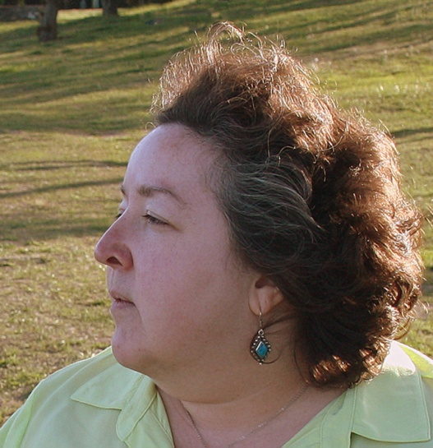

**About the Author**

Ann Chiappetta, M.S., lives in New Rochelle, NY with her husband, daughter, and assorted pets. She works as a readjustment counseling therapist for the Department of Veterans Affairs. Her poems, articles, and short fiction have appeared in numerous online and print publications. Her first book was *Upwelling: Poems* © 2016.

**Contact Information**Book website: http://www.dldbooks.com/annchiappetta/Personal website: http://www.annchiappetta.com/ Blog: www.thought-wheel.com

E-mail: anniecms64@gmail.com

Telephone: (914) 636-2393