SPRING 2019

The Sounding Board

The Publication of the National Federation of the Blind of New Jersey

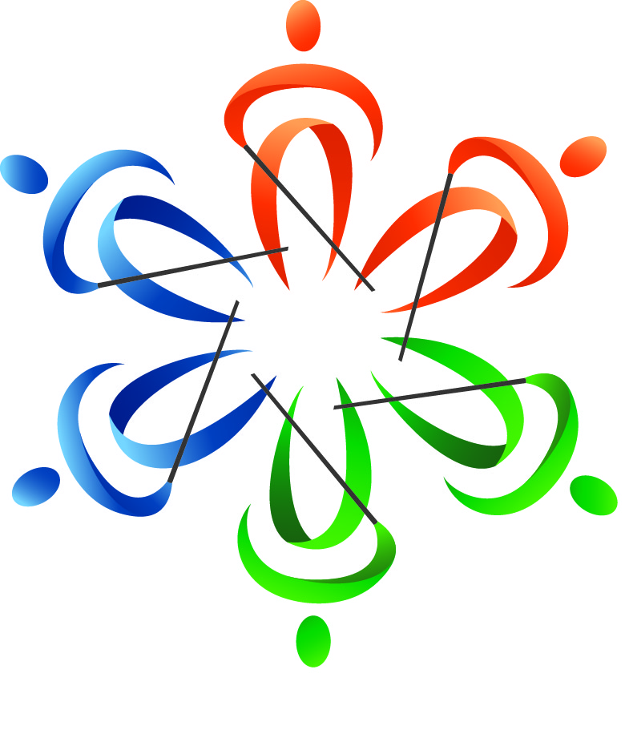
In This Issue

Annemarie Cooke
& Ryan Stevens
Share news and reflections of the Washington Seminar

Joe Ruffalo
Introduces the new NFBNJ Board

Maurice Peret
Describes the NFB Career Mentoring Program

Rose Santiago
Is hosting a book signing April 12 in Lyndhurst

NJ Students Natasha Ishaq, Sami Ishaq & Ethan Morrobel
Reflect on the 2018 NFB EQ Program

Live the Life You Want
THE SOUNDING BOARD
Spring 2019

Katherine Gabry, Editor
Annemarie Cooke, Mary Jo Partyka & Barbara Shalit, Co-editors
Mark Gasaway, Guest Editor
Barbara Shalit, Advertising Manager

Published by e-mail and on the Web through Newsline by
The National Federation of the Blind of New Jersey
www.nfbnj.org

Joseph Ruffalo, President
State Affiliate Office 254 Spruce Street Bloomfield, NJ 07003
Email: nfbnj1@verizon.net

All articles should be submitted to the State Affiliate Office at nfbnj1@verizon.net and specialk38@aol.com. Advertising rates are $25 for a half page and $40 for a full page. Ads should be sent to barbart@tullensound.com. The editorial staff reserves the right to edit all articles and advertising for space and/or clarity considerations.

Please Note: The deadline for the Fall issue is September 15, 2019.

Donations should be made payable to the
National Federation of the Blind of New Jersey
and sent to the State affiliate office.

To subscribe via Newsline: Jane Degenshein 973-736-5785 or Jdegen16@comcast.net

DREAM MAKERS CIRCLE
Help build a future full of opportunity for the blind by becoming a member of the Dream Makers Circle. Your legacy gift to the National Federation of the Blind can be made in the form of a will or a living trust, an income-generating gift, or by naming the NFB as a beneficiary of a retirement plan or life insurance policy. You can also become a member of the Dream Makers Circle by making a legacy gift to your state affiliate. By committing to support an NFB affiliate, your gift will benefit both local and national programs, since all bequests made to affiliates are split evenly with the NFB national treasury. In addition to having the satisfaction of contributing to the future success of the NFB's mission, Dream Makers Circle members also receive a specially designed thank you gift and other benefits. For additional information, please contact Patti Chang at the NFB Jernigan Institute by email at pchang@nfb.org, or by telephone at 410-659-9314, extension 2221.
Mission Statement
The National Federation of the Blind of New Jersey, Inc. is an organization of blind and interested sighted people who plan and carry out programs; work to improve the quality of life of the blind; provide a means of collective action for parents of blind children; promote the vocational, cultural and social advancement of the blind; achieve the integration of the blind into society on a basis of equality with the sighted; and take action that will improve the overall condition and standard of living of the blind.

The National Federation of the Blind knows that blindness is not the characteristic that defines you or your future. Every day we raise the expectations of blind people because low expectations create obstacles between blind people and our dreams. You can live the life you want; blindness is not what holds you back.

The National Federation of the Blind Pledge
I pledge to participate actively in the efforts of the National Federation of the Blind to achieve equality, opportunity and security for the blind; to support the programs and policies of the Federation; and to abide by its constitution.

The Sounding Board
The Sounding Board is the magazine of the National Federation of the Blind of New Jersey. It is published twice a year. Our hope is that through The Sounding Board, we aspire to provide a source of hope, inspiration, pride and camaraderie through the personal stories in our publication.
Hundreds of readers receive our publication via email and Newsline. The Sounding Board is also available for download in its entirety from our website at www.nfbnj.org. We encourage our readers to share The Sounding Board with family members, teachers, professionals, neighbors, friends and any other interested parties. We estimate our circulation to be in the thousands, as readers from across the country regularly report that The Sounding Board influences their lives.
Twenty-six people contributed to this issue by sharing stories, editing, interviewing and proofreading. It is truly a collaborative effort. We hope you enjoy the fruits of our labor.

TABLE OF CONTENTS

Comedy & Musical Entertainment Night Fundraiser 1
Presidential Message, by Joe Ruffalo 2
From the Editor’s Desk: Why am I an NFB member for all these years?? by Katherine Gabry 3
Washington Seminar: The Big Picture, by Annemarie Cooke 4
The 2019 Washington Seminar Issues: Updates and New Pursuits, by Ryan Stevens 5
Reflections from First-Timers at the Washington Seminar, compiled by Annemarie Cooke 7
Pursuing Equal Rights for Blind Parents, by Ryan Stevens 9
The Agnes Allen Distinguished Service Award, by Carol Castellano 10
Raising Expectations Award: Congratulations Brian Mackey! 12
Introducing the New Members of the NFBNJ Board, by Katherine Gabry 13
Building on NJ’s Trailblazing Legacy for the Blind & Visually Impaired, by Dr. Bernice Davis 16
Why get involved? by Rose Santiago 18
NFB Career Mentoring Program: Looking for Mentors & Mentees, by Maurice Peret 19
Rose Santiago to Host Book Signing for Live Your True Essence April 12 20
From Seed to Harvest, by Gerald Moreno 21
BELLS Ready to Ring for a Sixth Summer 23
NFBNJ Scholarship Winners Announced at 2018 State Convention 24
Reflections from the 2018 NFB Engineering Quotient Program, by Natasha Ishaq, Sami Ishaq & Ethan Morrobel 25
SSPNJ and iCanConnect/NJ (advertisement) 27
Sports & Recreation Line Up, by Linda Melendez 28
Live Your True Essence (advertisement) 29
NFBNJ Contact Info 30
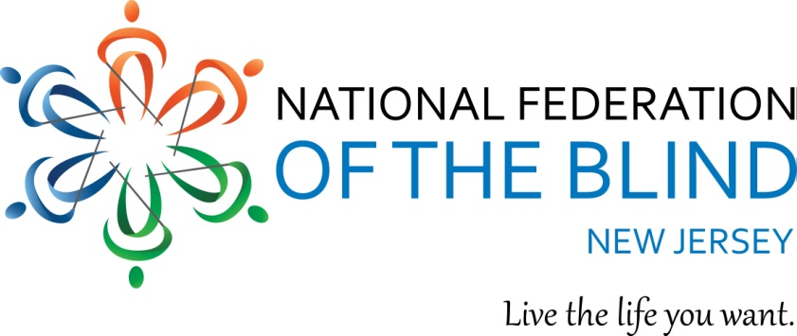
NATIONAL FEDERATION of the BLIND of NEW JERSEY
and
BLOOMFIELD UNICO
announce
COMEDY and MUSICAL ENTERTAINMENT NIGHT
Saturday, April 13, 2019
7:00 to 11:00 p.m.
Belleville Knights of Columbus
94 Bridge Street, Belleville, NJ

Buffet Dinner, Desserts, Soda, Cash Bar
Entertainment, Auction & Raffle
Enjoy our local talent
The comedy of Robert Ruffalo of Cedar Grove
& musical entertainment from
Richard Fox of Bloomfield on keyboard
Jane Ruffalo Degenshein of West Orange on flute
Joe Baccan of Mahwah, vocalist

Proceeds will benefit each organization’s Joe and Rose Ruffalo Scholarship Fund, supporting deserving blind and sighted students. Joe and Rose were loyal supporters of Bloomfield UNICO and NFBNJ. Pay via PayPal or credit card at www.nfbnj.org/Comedy-Musical-Night/registration or make your check payable to NFBNJ and mail to NFBNJ, 254 Spruce Street, Bloomfield, NJ 07003. Please write NFBNJ/UNICO in the memo. You also can reserve a table of eight. If you are unable to attend, please consider making a donation. For additional information, call NFBNJ President Joe Ruffalo at 973-743-0075.

PRESIDENTIAL MESSAGE

Dear Fellow Federationists,
The songs of birds, the planting of flowers and the fresh air of spring bring renewed and continued growth to us as individuals and to the National Federation of the Blind of New Jersey as an organization. Since the last issue of The Sounding Board, the organization has continued to provide the philosophy and expectations to live the lives we want. The New Jersey State Convention continues to nourish the seeds of our rising expectations, while the chapter and division meetings provide growth in each member, the activities and outreach programs provide the gift of the Federation to others, and the scholarships awarded provide financial support to the next generation of leaders. Congratulations to our newly elected affiliate board members and huge thanks to those who have served on the affiliate board. A well-deserved shout out goes to Ellen Sullivan and to all who have contributed their time and resources to make our fundraising efforts successful. Whether you helped out on a grant application, or on the opportunities at Boscov’s Department Stores, Barnes & Noble or at a grocery store, please know that your efforts are appreciated, and that they ultimately support the programs and projects of the NFB and the NFBNJ.
The affiliate’s 10th Annual After the Holidays party was held in January with music, dancing, great fellowship and terrific food. On April 13, together with the Bloomfield UNICO, we will host a comedy and musical entertainment fun- and fund-raiser at the Knights of Columbus in Belleville to benefit the Joe and Rose Ruffalo Memorial Scholarship Fund. All the details can be found on the state website at www.nfbnj.org.
On a special note, I want to personally thank all who conspired behind my back to honor me at the State Convention for my 25 years as your state president. I was touched by your presentation of the joke book in large print, Braille and also on a thumb drive. The proceeds – which have exceeded $2,300 – are earmarked for the Joe and Rose Memorial Scholarship Fund. To purchase a copy, please contact Linda Melendez at 732-421-7063 or by email at lindamelendez220@gmail.com.
I was once again reminded that life is a never-ending learning process, as Judy and I represented the NFB at the Tennessee State Convention in March. While on the plane, I reflected that this convention would be my 94th national, inter-state convention or state convention sharing – and learning – how I continue to live the life I want.
I hope you enjoy this issue of our publication. Thanks to all who have shared their stories – you inspire our faith and appreciation in each other. Please share the magazine with others you know so that they, too, will see that although we may have lost, or are losing, our eyesight, we will never lose our vision.

Sincerely,
Joe Ruffalo, President
National Federation of the Blind of New Jersey
FROM THE EDITOR’S DESK:
WHY AM I AN NFB MEMBER FOR ALL THESE YEARS??
By Katherine Gabry

Recently, people have been asking me why I’ve been involved with the National Federation of the Blind for so long. It has been a long time – 27 years this spring. Nonetheless, these queries have given me cause to reflect on what it is about the NFB that I find meaningful.
As editor of this publication for more than 15 years, almost every time I ask members why they’re involved with the NFB, the reply is the same: The camaraderie, finding others in the same situation. The connections are euphoric, life changing, a revelation.
I’ve not yet met anyone in the NFB who travels in shoes similar to mine. My life is in the DeafBlind community, not an area of expertise for the NFB. And long-ago hopes that my son would find people like himself through the NFB haven’t panned out. Even at national conventions, the number of profoundly deaf, ASL-using, braille-reading attendees is in the low single digits.
So, what’s the attraction for me? In 1992, my son was transitioning from early intervention to the school system. At that time, I was introduced to Carol Castellano, mom of a young daughter born fully blind. I had never heard of the NFB, so Carol introduced me and willingly shared her NFB knowledge, contacts and information. While our children were very different, Carol and I were kindred spirits, believing that all children deserve the opportunity for an education, that our expectations for them should be high, that thinking “outside of the box” works, and that we had every right to be respected members of the IEP team. Carol was an understanding friend and educated advisor as my son and I navigated many difficult educational situations.
Reflecting now, the Federation gave credence to my requests for necessary educational accommodations that created a level playing field for my son. Everything I was asking for was completely within his legal rights. That confidence booster was invaluable and life changing. By high school, he was able to advocate for himself, requesting accommodations and understanding how the law protected him. As he graduates from college this spring, I believe that in these ways, the NFB has shaped his self-image and understanding of his place as a deserving and productive member of a larger community.
Thus, in my view, the great service the Federation performs has been to alert its members and Congress to legal inequities in providing services for the blind and visually impaired, and to rectify those inequities. Through the annual Washington Seminar, hundreds of NFB members share their personal stories, insights and concerns with their representatives in Congress, an essential stepping stone in getting laws passed or changed. If your child has the chance to read in his preferred medium, if you’ve been a college student who used accessible textbooks, if you’ve been able to vote with an accessible voting machine, then the NFB has made a mark on your life. The NFB continues to work toward basic, equal civil rights for those who are blind and visually impaired. Legislative action based on equal opportunity regardless of the ability to see changes life for the better for thousands of blind Americans. That’s why I have maintained my long, and much appreciated, affiliation with the NFB.
WASHINGTON SEMINAR: THE BIG PICTURE
By Annemarie Cooke

Editor’s Note: Annemarie is an active long-time member of the NJ Affiliate, having recently been elected to the state board, and serving as vice president of the Sports and Recreation Division, board member of the Garden State Chapter and the Technology Division, and a member of the At-Large Chapter and the Scholarship and Sounding Board committees. She also enjoys her role as a mentor and cooking coach with students in the EDGE program. Her hobbies include international and domestic travel.

Ever wonder why an accessible voting machine must, by law, be at every polling place? Or how the National Library Service for the Blind and Physically Handicapped made it to fast-track distribution of digital content and playback machines after decades of vinyl discs and audiotape?
Those are just two major results of the National Federation of the Blind’s lobbying efforts, particularly through the Washington Seminar, an annual event since the 1970s, according to John Pare, the NFB’s executive director for advocacy and policy.
This past January, some 600 Federationists – 16 of them from New Jersey – came together in Washington, DC to visit their Congressional representatives in both Houses and advocate for three issues: the Access Technology Affordability Act, GAIN and DEA. The specifics on these issues are in the next article, The 2019 Washington Seminar Issues: Updates and New Pursuits, by Ryan Stevens, NFBNJ Legislative Director.
The NFB’s advocacy efforts take place all year round on the national, state and local levels. But, says Pare, there is a unique power created when teams of blind people, with white canes or service dogs, and dressed in business attire, fan out over Capitol Hill to visit their own elected officials. And it’s the personal story shared by the visiting Federationists that makes the occasion memorable and eventually, in many cases, effective.
There is a strategy in the scheduling of the Washington Seminar during the last week of January. According to Pare, by this time, freshmen legislators have been sworn in and are getting settled in their offices, and the House and the year’s first Senate sessions have just gotten underway, so there is a window of opportunity for NFB’s personal advocacy.
At this year’s Great Gathering-In, the kickoff on Monday afternoon of Washington Seminar week, there was special drama and excitement. President Mark Riccobono took the microphone to announce that the Marrakesh Treaty was in the final stages leading to approval. The treaty, in negotiation for more than a decade, is the product of a global agreement that facilitates distribution and use of books in alternative formats by blind people and others with print-related disabilities all over the world. The NFB has been instrumental in bringing this treaty to fruition.
Ryan Stevens, who has been attending the Washington Seminar for decades, recalls another major success of the NFB’s efforts: Braille became the default format for blind and visually impaired school children who expressed a desire to learn it. The student’s Individualized Education Plan (IEP) must provide for instruction in Braille unless two adults on the IEP team (such as a school psychologist and parent) decide that such instruction is not appropriate, Stevens said.
And of course, there were efforts by the NFB and its members to get the Help America Vote Act on the books more than a decade ago so that blind voters could have an accessible machine in which to cast ballots. In addition, the NFB also lobbied hard for funding for the NLS to launch its digital conversion in relatively short time.
The 2019 Washington Seminar marked the 25th for Stevens, who attended his first in 1995 as president of the Keystone Chapter in Pennsylvania. “I fell in love with the process, and I’ve been coming ever since,” he says. “Being able to present myself in a calm, professional manner to a member of Congress or a legislative aide, and knowing there is real importance in what I was saying, is really powerful.”

THE 2019 WASHINGTON SEMINAR ISSUES: Updates and New Pursuits
By Ryan Stevens, NFBNJ Legislative Director

Greetings, fellow New Jersey Federationists! From January 28 – 31, the NFB held another successful Washington Seminar in our nation’s capital. Over 600 members from around the country, including 16 from our own affiliate, went to Capitol Hill to talk about the most pressing legislation concerning the blind with our Congressional representatives. This time, we addressed three issues: One is carried over from last year, and the other two are revamped ideas on concerns we have had for some time. While we were in DC, we received two pieces of good news which I will detail after the rundown of what we discussed with our legislators.
The legislative issue from 2018 which we again brought to the attention of Congress this year is the Access Technology Affordability Act. Access technology enables blind people to participate in today’s connected world and to perform tasks that they were once unable to accomplish themselves. Today, the blind most often acquire this technology through their state blindness agency or through their employer as a reasonable accommodation. The problem with going through the state agency is the length of time it takes to receive the equipment. The drawback of receiving it from an employer is that such requests can make the company wary of hiring blind people because of the expense. Unfortunately, the cost of access technology also prevents most blind people from purchasing it themselves. The Access Technology Affordability Act helps to alleviate this burden by providing a tax credit to the blind person when he or she purchases equipment. We have changed the elements of the bill we are asking to have introduced. This new version would set the tax credit at $2,000, which is usable over a 3-year period. We have also agreed to allow the legislation to expire after five years. As of March 15, Bill S815 has been introduced in the Senate.
The second issue we brought to the attention of Congress is the Greater Access and Independence through Nonvisual Technology (GAIN) Act. The rapid proliferation of advanced technology is undeniable. Most new stoves, glucose monitors and treadmills now require that consumers interact with digital displays, flat panels, and other user interfaces which are inaccessible to blind individuals. Inaccessibility is not a mere inconvenience; it can threaten the safety, health and independence of blind Americans. Advancements in technology have the potential to transform how people live in a society, but are designed for those with no functional limitations. Nonvisual access is achievable, as demonstrated by a number of mainstream products, such as Apple's iPhone and iPad with VoiceOver. Virtually all ATMs and voting machines are also accessible, using simple fixes. Although the Americans with Disabilities Act and other laws require physical accessibility for people with disabilities (for example, wheelchair ramps and Braille signage in public buildings), no laws protect blind consumers’ right to access technology. The GAIN Act would call on the Access Board, an independent federal agency and leading source of information on accessible design, to conduct a nonvisual access standard review, and issue a report with findings and recommendations for a minimum nonvisual access standard for home-use medical devices, home appliances and fitness equipment. The Federal Drug Administration and the Federal Trade Commission would then be tasked with enforcing the rules established by the Access Board. There is no bill in either the House or Senate at this time.
Our third topic was the Disabled Employment (DEA) Act. The Javits-Wagner-O’Day Act (JWOD), originally enacted in 1938 and expanded in 1971, is a well-intentioned but obsolete law intended to provide employment for people with disabilities through specialized government contracts. However, the work experience provided by the recipients of these contracts, such as the AbilityOne Program, does not utilize or teach the skills required for today’s fast-paced digital work environment. Many workers with disabilities employed under AbilityOne are assigned menial, repetitive tasks, which do nothing to equip them with the skills needed to succeed and advance in a 21st century workplace. As a result, many of these individuals find themselves trapped in these jobs for years, if not decades, with no real hope of advancement or finding new employment opportunities elsewhere. These workers are also segregated and paid subminimum wages. The DEA will allow for-profit as well as nonprofit entities to bid on contracts through a newly created commission, will ensure that workers earn at least the prevailing wage, will equip employers with the necessary tools and supports to integrate workers with disabilities, and will establish an Employment Integration Trust Fund to assist employers in meeting reasonable accommodation requirements under Title I of the Americans with Disabilities Act. While this legislative goal is still in its infancy, there is some good news on the workers with disabilities front.
At the Great Gathering-In Meeting held the evening prior to going to Capitol Hill, President Riccobono announced the introduction of the Transformation to Competitive Employment Act. It follows the model set by the Transitioning to Integrated and Meaningful Employment (TIME) Act of the past two Congressional terms. Over a 6-year period, it would phase out the special wage certificates that allow disabled workers to be paid subminimum wages. The bill numbers are HR873 in the House and S260 in the Senate. We have been encouraging all of you to contact Senators Corey Booker and Robert Menendez, as well as your individual member of Congress to ask them to support these bills. The way to do that is explained at the end of this article.
The best news of all that came out of the 2019 Washington Seminar is the ratification of the Marrakesh Treaty and signing of its implementation legislation by President Trump. The treaty was also transmitted to the World Intellectual Property Organization (WIPO) in Geneva, Switzerland on February 8. Once WIPO’s 90-day review period is complete, blind and print disabled people throughout the world can get textbooks and other printed materials in accessible formats directly from other countries, including works in other languages. It took almost six years of hard work and advocacy by us, the National Federation of the Blind to have this come to fruition, but indeed it has!
For more details and the full fact sheets for each of the issues we are pursuing, go to https://nfb.org/washington-seminar
As I have said in the past, while going to DC and addressing these important issues directly with our elected officials is vital, it is only the beginning of our legislative agenda. Also, there will be other concerns that will arise during the year. We cannot ignore any of these until next January. All of us need to make an effort to help all blind Americans live the lives we want, and I appreciate the work you have done.
To contact your member in the House of Representatives or the US Senators from New Jersey, call the Capitol Switchboard at 202-224-3121. To find your House member, contact your local public library or go to www.house.gov and enter your zip code.

REFLECTIONS FROM FIRST-TIMERS AT THE WASHINGTON SEMINAR
Compiled by Annemarie Cooke

Editor’s Note: For Northern Chapter members Joanna Mallard of Jersey City and Connor Mullin, a graduate student at Louisiana Tech, attending the Washington Seminar was a first-time experience. Here are snapshots of their DC visit:

Joanna Mallard
I felt anxious! I felt nervous! I felt excited! Actually, I Never Felt Better!!!! During the Great Gathering-In on Monday afternoon, in a ballroom filled with several hundred fellow Federationists, my anxiety and nervousness began to fade, and a feeling of empowerment began to seal the cracks within my foundation. I was proud to know that I am one of many to make a difference in the world for blind Americans.
The next day visiting our New Jersey congressmen and senators, presenting the issues at hand became very personal for me. I can only speak from my own life experiences, and that’s what was given. Hope begins to build! Faith began to increase knowing that my children, your children and the children to come won’t have to feel “less than” because they are blind or have a visual impairment. We told our stories to our representatives in Congress. We can live lives we dream! I am a member of the NFB, and we can’t be stopped!

Connor Mullin
My first legislative appointment was with Representative Bill Pascrell's office. We spoke with one of his legislative aides, Alex. My job was to tell him about the Access Technology and Affordability Act (ATAA). As I described the bill, he listened politely, but when I brought in my personal story of why access technology was so important to my college success, his demeanor changed. It seemed to reach him in a genuine way, as he broke his relative silence to say that he could only imagine how not being able to afford this kind of technology would make the already challenging endeavor of college so much more daunting.
I think Alex was listening from start to finish, but I think he understood after I made our proposal real through my experience. This is why it is so important that we have the Washington Seminar each year. Although it is true that year-round relationship management is probably the most crucial piece that drives our legislative agenda, blind people presenting our initiatives with real-life accounts at this event every year reaches lawmakers and their staff in a way that statistics, facts and footnotes cannot. Put simply, therefore, to contribute to this critical component is why I show up.

Editor’s Note: The New Jersey Affiliate provided the cost of airfare to DC for Connor; here is his note of thanks:

I wanted to write to thank each and every one of you for helping to make it possible for me to attend this year's Washington Seminar. It was truly amazing to be able to travel to DC and advocate for our policies on the Hill. As someone who got their undergraduate degree in political science, being at the Capitol was a thrill, but it was equally empowering to know that we were changing the attitudes of some of the nation's most important people (and that includes the legislative staff) about what blind people can do.
Thank you all so much once again. I hope to repay you through my involvement in the NFB and work as a future rehab professional.
PURSUING EQUAL RIGHTS FOR BLIND PARENTS
By Ryan Stevens, Chair of the NFBNJ Resolutions Committee

Hello, fellow New Jersey Federationists. Ordinarily, I would be providing you with an overview of the resolutions passed at our most recent State convention. This time, however, I will be highlighting the actions that members of the affiliate are taking to bring the goal of one of them to fruition. What we are hoping to accomplish is so important, this resolution was the only one presented last November in Woodbridge.
During the past few years, a number of state affiliates throughout NFB have been introducing bills into their legislatures which would give equal rights to parents and guardians who are blind in adoption, foster parenting and custody disputes. It has been a long-held and mistaken belief in society and in law that blindness prevents a person from properly caring for children. Blind people throughout time have shown their ability to be caregivers who are as competent as sighted persons, yet have had their children taken away without their capabilities even being considered. To date, 10 of these bills have been passed and signed into law, with four others currently working their way through state houses.
The National Federation of the Blind of New Jersey is putting in significant effort to join this growing list of states. At the 2018 State Convention, one of our speakers was Assemblywoman Yvonne Lopez from the 19th Legislative District. At the end of her presentation, we discussed parental rights with her at the podium, and provided her with a copy of the resolution. She offered to support our endeavor in any way she could. Since then, our Parental Rights Committee, led by Chairperson Joanna Mallard, President Joe Ruffalo and First Vice President Linda Melendez, have met with her and her staff on multiple occasions. At the last meeting in early February, they brought copies of the 10 bills signed into law. The Assemblywoman is using these to make a template for what she hopes to bring to the New Jersey Assembly floor. There may be some changes to her proposed bill, and it will be reviewed by the Parental Rights Committee and by the NFB National Center. Once there is consensus that the language is correct, Assemblywoman Lopez will present it to her colleagues. We are also seeking an advocate in the State Senate.
The timetable for all of this is obviously uncertain, but this vital pursuit is moving forward. President Ruffalo and I will keep you posted on the progress of this bill. As it begins its journey through the legislative halls in Trenton, we will be counting on your voices to turn it into law so that blind parents and guardians are afforded the same level of respect and protection as all others. To read the resolution from the 2018 State Convention, go to www.nfbnj.org.

The Agnes Allen Distinguished Service Award
Presented at the 2018 NFBNJ State Convention
By Carol Castellano

The Agnes Allen Distinguished Service Award is presented to organizations or individuals who are not members of our organization, who have made substantial contributions to improve the quality of life for the blind of New Jersey. It is the highest honor that we give as an affiliate, and we regard the recipients of this award as true friends of the blind, instrumental in championing programs that will benefit the blind community and dedicated to initiatives that will generate hope and promise in innumerable ways.
This award honors the life and work of Agnes Allen who was born in 1924 and who continues to be an independent, confident, capable and optimistic blind woman with a life-long love of learning and education, and a commitment to living a life of service.
In her career, Agnes instructed blind and DeafBlind students, and encouraged them to tackle any obstacle that stood in the way of achieving independence. Her commitment to Braille literacy is evidenced by the fact that she was still tutoring blind students in Braille after her 90th birthday.
A long-standing and active member of the National Federation of the Blind, Agnes served as an officer of both the New Jersey and Connecticut affiliates, helped to found chapters, participated in state and national conventions, and was a long-time volunteer in our Braille mentoring program.
Her example of generosity, love of neighbor and joyful, positive attitude has been a great blessing to her family, friends and colleagues. She is deeply respected and dearly loved, and we are very happy to give an award in her honor.
The recipient of this year’s Agnes Allen Distinguished Service Award is: The Middle Atlantic Blind Golf Association.
The story of the Middle Atlantic Blind Golf Association—or MABGA—begins in 1948, when Robert Allman, blind since age 4, created a plan to share the joys of golf with blind friends and to organize a competitive blind golf program in the local blind community and beyond. I imagine Bob was a fine organizer—he had already excelled in many areas of life, including as a wrestling champion and Phi Beta Kappa recipient at the University of Pennsylvania, a husband in a successful marriage, a father of four sons and the principle of a busy law practice.
Over the past 70 years, the organization has grown and thrived due to the enthusiasm of its many volunteer coaches, and the cooperation and generosity of the many golf clubs that sponsor outings. The coaches, so generous with their time and talents, say that they enjoy seeing their blind golfer hit a good shot more than hitting one themselves.
In 1993, MABGA, along with the Philadelphia Section of the PGA and many local golf professionals, launched its Junior Golf Program for blind and visually impaired boys and girls ages 5 – 21. Each young golfer receives individual lessons and equipment, not to mention pizza and soft drinks at each event. This program is the first known joint effort between a PGA Section and a regional blind golf association. MABGA’s goal is to extend this program to blind children across the entire country. Events are held at the pitch and putt course and practice green at the Overbrook School for the Blind in Philadelphia, spearheaded by our friend Norman Kritz. Norman unfortunately could not be with us tonight.
Today, MABGA has almost 200 blind junior and senior golfers and volunteer coaches. The Junior Golf program has expanded to North Jersey, and additional sites in Georgia and New York.
So it is with great pleasure that we bestow the Agnes Allen Distinguished Service award to the Middle Atlantic Blind Golf Association. Accepting on behalf of the organization is Mario Tobia. The plaque reads:

The National Federation of the Blind of New Jersey
Presents the
Agnes Allen Distinguished Service Award
to the
Middle Atlantic Blind Golf Association

In Recognition of Invaluable Contributions to the Quality of Life of the Blind of NJ
Through the efforts and dedication of volunteers over the past 70 years,
MABGA has enabled blind children and adults
To learn the skills of golf, experience the pleasure of the sport,
And enjoy one more opportunity to be included in the mainstream of society.
This award recognizes MABGA’s efforts to raise expectations, increase opportunity and Facilitate integration of the blind into society on the basis of equality.
Together with love, hope and determination, we transform dreams into reality.
November 3, 2018
From the grateful members of the NFBNJ
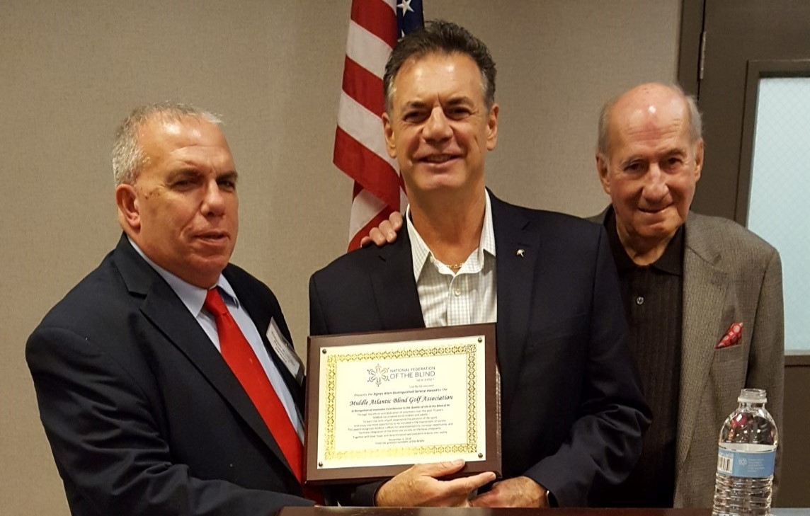

Joe Ruffalo, left, presents the Agnes Allen Distinguished Service Award to Mario Tobia and Marty Jensen, from the Middle Atlantic Blind Golfers Association.

RAISING EXPECTATIONS AWARD 2018: CONGRATULATIONS BRIAN MACKEY!

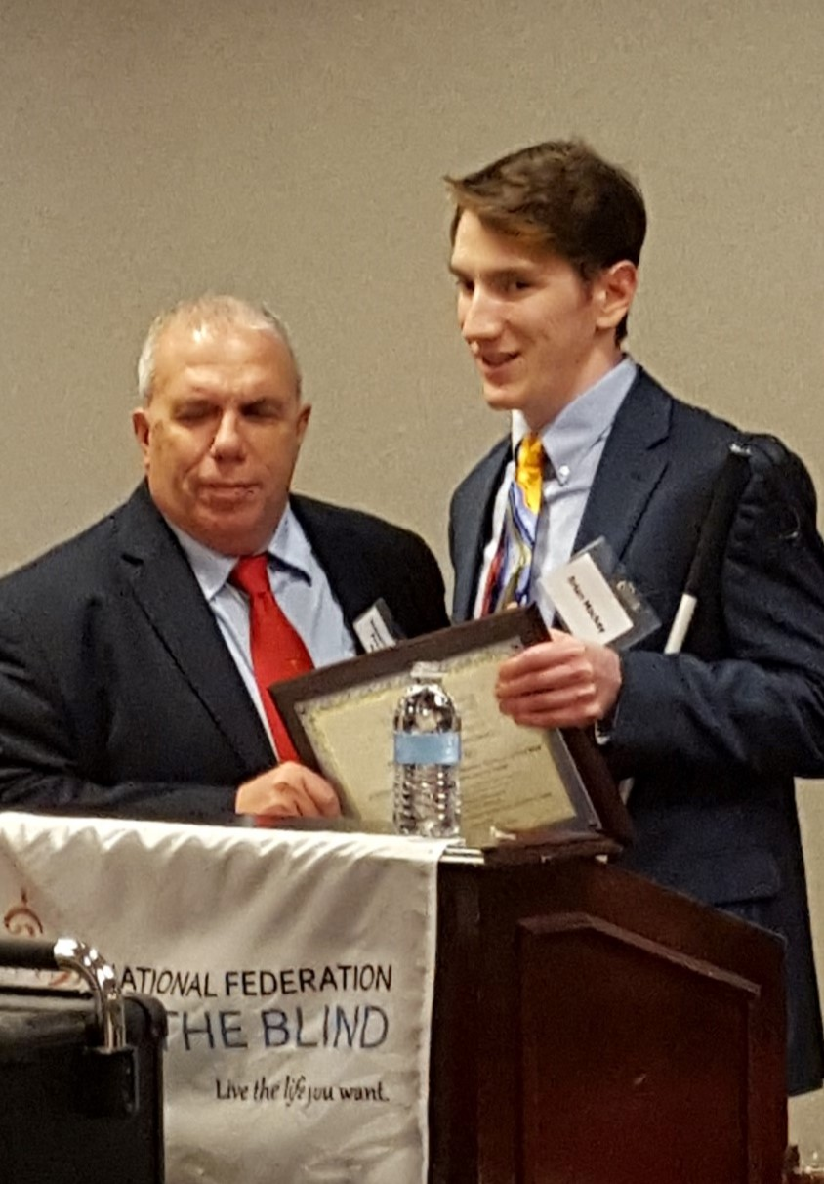
NFBNJ President Joe Ruffalo presented the Raising Expectations Award to Brian Mackey at the 2018 New Jersey State Convention in November (see picture at left). Brian began his NFB life as a POBC kid. As the years went on and he grew up, he took his own place in the Federation and began his years of service to the affiliate. Many adjectives can be used to describe Brian—he is dedicated and reliable, spending many hours working on affiliate projects, researching things for us, and finding out the answers to questions. He keeps us all on the straight and narrow, sending out reminder messages whenever we need them. He also has the fastest fingers in the East—just as you’re hanging up the phone, his reply is in your email box!
Brian serves as the webmaster for NFBNJ and also for other affiliates. He has held positions on the chapter, division and affiliate levels, most recently serving as affiliate Secretary and then Treasurer. Outside his many NFB activities, Brian enjoys golf and karate, and he’s participated in the surfing adventures.
Brian was presented with a plaque that read:

National Federation of the Blind of New Jersey

Presents the RAISING EXPECTATIONS AWARD to

Brian Mackey

In Recognition of Your Commitment, Dedication and Hours of Hard Work
on Behalf of the Blind of NJ and the Nation

Your invaluable contributions have enhanced each of our lives.
Whenever we have asked, you have answered.
We call you our colleague with respect.
We call you our friend with love.
Together, with love, hope and determination we transform dreams into reality.

November 3, 2018
From the grateful members of the NFBNJ

INTRODUCING THE NEW MEMBERS OF THE NFBNJ BOARD
By Katherine Gabry

NFBNJ President Joe Ruffalo and members of the National Federation of the Blind of New Jersey have welcomed a new State Board, voted into office at the State convention in November. New board members are: Linda Melendez, 1st Vice President; Ellen Sullivan, Secretary; Andrew Rees, Treasurer; and board members Annemarie Cooke and Zoraida Krell.
We’re grateful for the combined 25 years of service of our retirees – Brian Mackey, Alice Eaddy and Dan Facchini – and wish them well in their future endeavors. Brian served as Secretary for two years and Treasurer for six years; Alice was a board member for four years and Secretary for two years; and Dan was a board member for 10 years and one year as 2nd Vice President.
And now, please meet the new members of the State Board of the NFBNJ:

Linda Melendez, 1st Vice President
A native of Brooklyn, New York, Linda now lives in Keyport, along the northern New Jersey coast. She describes herself as confident, strong and goal oriented. She has worked as a secretary, word processor, IT technician and a coordinator of new hire training for major corporations.
Linda brings commitment, dedication, determination and time, as well as a passion for the members of the NFBNJ, to her service on the board. “I want to see the success of the NFBNJ’s chapters, divisions, programs and projects continue, and to be a part of the continued growth of our affiliate,” she states. Further, she believes that moving out of one’s comfort zone can provide a sense of accomplishment and empowerment.
Linda has attended New Jersey State Conventions regularly since 2015, at which time she made a decision to not just attend, but to commit to the NFBNJ with her ideas, energy and time. This decision also motivated her to attend a national convention, and in 2016, she was a recipient of the Jernigan First Timers Scholarship Award at that convention. In 2018, she had the privilege of being the NFBNJ Alternate Delegate.
Linda is passionate about getting to the gym at least three times a week. She also enjoys spending time in the kitchen making homemade chocolate lollipops, and chocolate covered pretzels, Oreos and walnuts. She used to make the sweet treats for the children in her son’s classes, as well as for the holidays and parties. “Now that I’m going to be a grandmother,” she says, “I am coming out of retirement and will be making them for my grandbaby and NFBNJ auction baskets.”

Ellen Sullivan, Secretary
Ellen lives in Maplewood (Essex County). She grew up in Washington Township, NJ, in Bergen County. She describes herself as energetic, enthusiastic and persistent.
Ellen was a pharmacologist and worked in the pharmaceutical industry for almost 18 years. She has also done volunteer work since she was 12 years old, including working with children, seniors, children with disabilities, fundraising, peer support and the National Federation of the Blind (both in Delaware and New Jersey).
When asked what she brings to the NFBNJ board and why she wants to serve, Ellen replied, “I think I compliment this very energizing organization by a willingness to help my fellow colleagues any way I can. I have good listening skills (needed for a secretary) and am very goal oriented. I like the NFBNJ leadership and enjoy working with them. It is a pleasure to have the opportunity to work with so many gifted individuals.”
Ellen has attended one New Jersey State Convention and two national conventions. The conventions have been life changing for her because she no longer sees blindness as a limitation. “I’ve enjoyed many new friendships and have learned innumerable ways to manage my life to make it meaningful to me and those around me,” she says.
Some of Ellen’s favorite pastimes include reading, walking and exploring with her cane, walking dogs with her sister, and the treadmill.

ANDREW REES, TREASURER
A native of Long Island, NY, Andrew and his family moved to Somerset (Somerset County), New Jersey more than 40 years ago. He describes himself as diligent, detail oriented and committed. He has a master’s degree in social work, and has worked at the Office on Aging and Disability Services for more than 16 years.
“I am honored to be on the NFBNJ board and am devoted to doing my very best,” Andrew says. He has been a member of NFBNJ for 20 years, and brings both a commitment and a passion to serve the members of the affiliate. He finds, “The power of this movement on national and global levels is felt after attending both state and national conventions.” He’s attended six or seven state conventions and two national conventions.
On a personal note, Andrew likes sports, mostly baseball, and he’s an “avid Yankees fan.” He also listens to a lot of music, with classic rock as a favorite, although his tastes range from classical to heavy metal, and include jazz. He also enjoys a variety of ethnic foods.

Annemarie Cooke, BOARD MEMBER
Annemarie has lived in Southampton, in the South Jersey Pinelands, since her semi-retirement in 2015. She was born in Elizabeth and spent 45 years in the New Brunswick area going to school and working. She describes herself as compassionate, curious and a wordsmith.
Annemarie was a reporter for a daily newspaper for 17 years, and then became the “public face” of Recording for the Blind, where she also spent 17 years. On the conference circuit for that organization, she first became involved with the organized blind community, which allowed her to attend, altogether, more than 50 national and state conventions. Through these conventions, she’s met fellow Federationists with whom she feels a strong desire to work on NFB activities and projects.
After Recording for the Blind, she worked for a small assistive technology company, attended culinary school, worked for the Commission for the Blind under a short-term government program and is now completing her third year as a mentor to blind/VI high school students in the EDGE program.
When asked what she brings to the NFBNJ board, Annemarie replied, “Organizational skills; the ability to write clearly, concisely and under deadline; an intense belief in the abilities of blind people; a sense of adventure; and the consideration of how to find a way to accomplish just about anything I want to do and the desire to help other blind folks gain the confidence and competence to do the same.” As a semi-retiree, she also now has the time to devote to the NFBNJ, making phone calls, writing letters, advocating, or lending an ear or a helping hand whenever needed.
Annemarie classifies herself as a lifelong learner and someone with a wide range of interests. She enjoys exploring the world around her, traveling, reading, taking classes and cooking.

ZORAIDA KRELL, BOARD MEMBER
Zoraida has been a resident of Bergen County all her life. She currently resides in Bergenfield with her husband of 23 years, Brian. She grew up in New Milford. She describes herself as caring, kind and honest.
Zoraida is the senior executive director of franchise development at Brain Balance Achievement Centers, which educate children with different learning abilities. She describes her work as a wonderful mix of education and business.
Zoraida is the secretary of the NFBNJ’s Northeast Chapter, and believes that the insights she’s gained from this membership will serve her well as a board member. She believes that serving on the state board will provide her with a broader understanding and appreciation of the needs of those who are blind and visually impaired throughout the state, and the opportunity to serve NFB members in a more personal way. She also cites Northeast Chapter President Dan Facchini as a model example of service.
The November 2018 state convention was Zoraida’s first NFB-related convention. She enjoyed the camaraderie of those she met, and found meaning in their shared stories, meals, meetings and fun. She also appreciated not being the only “blind person in the room,” and the trust and caring from fellow Northeast Chapter members who made it a point to keep track of each other.
Zoraida cites music, concerts and plays, and meeting up with friends, as among her favorite pastimes. She also says that she doesn’t mind housework, with the main goal of keeping her home neat, in consideration of safety issues. She also knits and crochets, and is looking forward to learning how to use a hand loom.
BUILDING ON NJ’S TRAILBLAZING LEGACY FOR THE BLIND & VISUALLY IMPAIRED
By Dr. Bernice Davis, Executive Director
New Jersey Commission for the Blind and Visually Impaired

In 1908, a then 27-year-old Helen Keller and her teacher Anne Sullivan visited the home of Montclair resident Sarah Churchill, a philanthropist and music teacher who was also blind. Churchill had invited several community leaders and elected officials to her home, including Governor Franklin Fort, to talk about the need for New Jersey to have a state agency dedicated to addressing the needs of blind children and adults. Following that meeting, Keller was invited to give testimony before the State Legislature, and in April 1910, with New Jersey ranking third in the nation for population density, the Commission for the Blind began providing education and training for blind residents under the leadership of its first Executive Director, Lydia Hayes Young.
It’s now my honor to have been named the eighth executive director of CBVI. In this role, I’m responsible for the administration and operations of the single state authority charged with providing education, vocational rehabilitation, independent living, eye-health services and assistive technology for the 300,000 residents of New Jersey who are blind, visually impaired or deafblind.
For nearly 110 years, the Commission has been at the forefront of the blindness services movement and continues to strive for the realization of new levels of achievement for consumers of all ages. We will expand upon this rich history by facilitating opportunities for people living in New Jersey who are blind, visually impaired and deafblind.
I am a doctor of psychology and have more than 20 years of administrative experience, having held several leadership roles in both the private and public sectors. Since joining the Commission’s staff 13 years ago, I’ve been very fortunate to have had the opportunity to augment that experience with vital information and experiences shared with me by colleagues and many consumers – all individuals willing to invest in CBVI’s success in meeting the current and future needs of the people we serve.
Our community stakeholders also serve as a valued resource that enables us to maintain awareness of the expectations of our consumers and the importance of the Commission’s fulfillment of the same.
Upon reflecting on my tenure at the Commission, I’ve witnessed many advancements in the field of blindness services. The tremendous strides in technology alone have achieved great gains in facilitating independence and an environment of inclusion, but most importantly it has been the dedicated work of CBVI staff, consumers, advocates and other partners to promote positive attitudes about people who live with blindness and vision impairments that have made the greatest impact.
NFBNJ has, for many years, been instrumental in conveying the needs and concerns of blind, visually impaired and deafblind persons across New Jersey. Please know that ensuring that individuals who are blind and visually impaired have access to opportunity is among the top priorities of Governor Murphy and everyone that works in his administration. This – in no small part – is the result of your effective advocacy, done not only for your members, but also on behalf of all blind and visually impaired residents.
I wholeheartedly agree that together we can make a difference, and I look forward to working with the leadership of the NFBNJ on our shared commitment to ensure that people who are blind, visually impaired and deafblind have the chance to live the life they want.
We’ve been busy, and I would like to share a few highlights from the past 12 months:
- We celebrated with two groups of age 55+ consumers and their companions upon their completion of the Senior Hands-On Retreat Experience (SHORE) program. The program participants received training and resource information with the goal of enabling them to acquire the necessary skills and confidence to maintain independence with vision loss.
- We held a ceremony to mark the launching of the Library Equal Access Program (LEAP) at the Newark Public Library with Lieutenant Governor Sheila Oliver, Department of Human Services Commissioner Carole Johnson, and Newark City Council President and CBVI retiree Mildred Crump. LEAP provides assistive technology training for people 55 years of age and older.
- More than 60 high school students participated in a CBVI-sponsored summer transitional services program geared towards preparing them for life after high school and adulthood.
- Our Project BEST provided eye screenings to nearly 35,000 people. Of that number, nearly 4,000 people were referred for further medical eye care.
- The Commission is also focused on jobs. Last year, it provided pre-employment transition services, transition services and vocational rehabilitation services to 921 students in secondary or post-secondary education. It also helped 373 Individuals pursue post-secondary education, while 204 Individuals exited the vocational rehabilitation system after successfully obtaining, maintaining or advancing in their careers in competitive integrated employment.

We are also implementing strategies to significantly expand our community education and outreach with the goals of making sure that people who need CBVI services are aware of what we do and for the general public to gain a greater awareness of the abilities and potential of people who are blind, visually impaired and deafblind.
We have more to come, and I look forward to working in partnership with NFBNJ on our shared priorities. I understand the trust that’s been placed in our agency and take it seriously. Please be assured that the Commission for the Blind and Visually Impaired will continue to build upon its trailblazing legacy.
WHY GET INVOLVED?
By Rose Santiago

Editor’s Note: Rose is a board member of the Northeast Chapter and chair of the Spanish Committee, as well as a volunteer in the Braille Enrichment through Literacy and Learning (BELL) program. She is a business owner of Mariposa Essence and the author of Live Your True Essence and Organic Recipes for Your Personal and Spiritual Pleasure.

Comments from NFBNJ President Joe Ruffalo: I’ve known Rose for several years. She’s a friend, colleague and role model. She’s also someone who identifies a goal, outlines the steps and works her plan to achieve her goal. Once she achieves her goal and crosses the finish line, the finish line becomes her next starting line. It is rewarding for me to witness the ways she transforms her dreams into reality!

Here is Rose’s story:

The most outstanding accomplishment in my life has been to be the proud mother of my son, Gabriel. Raising him as a single mom, while also managing a business and taking care of my own home and personal responsibilities, was often quite challenging. Nonetheless, during those years, I endeavored to care for my son and established a housekeeping business for 14 years, which allowed me to support my child and secure a home for the both of us. Throughout my life, I have always believed that having a positive mindset and knowing that everything would work out fine despite setbacks was the determining factor in growing as a person and business owner who was blind since birth. I always felt that I could do more, thus I decided to become an author and start a new business, Mariposa Essence. The opportunity to help others break through their limiting beliefs and disempowering thoughts that inevitably lead to living a life of pain and discontentment is what led me to write the book, Live Your True Essence, http://www.LiveYourTrueEssence.com.
In March 2016, I became a member of the National Federation of the Blind. Here, I discovered that there were other blind individuals who had also traversed seemingly insurmountable barriers as I had, and yet were able to become a powerful force in motivating others and demonstrating through life experiences that they, too, could live the life they wanted. “What a coup!” I thought with relief. I knew I would fit right in. A year later, I became chair of the Spanish Committee, and in January of 2018, I was elected board member of the Northeast Chapter. In all, I am extremely grateful and proud of the woman I am today. To serve in any capacity where I can make a difference in someone else’s life is what absolutely brings me true joy and satisfaction.

NFB CAREER MENTORING PROGRAM: LOOKING FOR MENTORS & MENTEES
By Maurice Peret

Editor’s Note: Maurice Peret is the coordinator of career mentoring programs for the National Federation of the Blind, a national program that provides pre-employment transition services to blind and low-vision students. Before joining the NFB staff, Mr. Peret, among other things, worked with, trained, and educated blind youth and adults as a lead O&M instructor and rehabilitation projects coordinator and, before that, as a rehabilitation outreach coordinator for Blind Industries and Services of Maryland Rehabilitation Department. He is National Orientation & Mobility Certified (NOMC) and is a member of the National Orientation and Mobility Certification Training Committee under the direction of the National Blindness Professional Certification Board. He also serves as a peer reviewer for the Journal of Blindness Innovation and Research. In addition, Mr. Peret served as NFB’s base camp communications manager for the 2001 NFB/Allegra Mt. Everest expedition which featured Erik Weihenmayer, the world’s first blind mountaineer to summit the highest peak on Earth. Along with his wife, Lou Ann Blake, Mr. Peret has hiked the Maryland portion of the Appalachian Trail, part of which was done during their honeymoon.

In 2014, President Barack Obama signed into law the Workforce Innovation and Opportunity Act which mandated that state agencies serving blind and low vision consumers allocate at least 15 percent of their Federal funds to transition age youth, a historically underserved population. The NFB Career Mentoring Program is an innovative program that makes available a nationwide network of successful blind professionals in as many careers and personal interests as can be imagined by young blind people hoping someday to live the lives they want. The program centers around five essential elements of success. They include:
- the notion that it is okay to be blind;
- that mastery of the alternative skills of blindness leads to greater confidence and independence;
- dealing gracefully yet assuredly with public attitudes about blindness helps dispel outdated myths about blindness;
- that blending in adds up to fuller integration and inclusion in the best that society has to offer, and
- that giving back is the full measure of success as a blind person.

Without the competitive advantage of shared experiences of blind men and women who have negotiated the labyrinth of educational, vocational and employment systems, youth who are blind or have low vision can become discouraged by the low expectations held by society. A matrix mentoring model insures that mentees in the NFB Career Mentoring Program are matched with not just one, but in many cases two or even three successful blind mentors. The program includes monthly interactions between mentors and mentees, regularly scheduled monthly teleconferences to gauge and measure progress in the program, and quarterly mentoring retreats focusing on essential aspects of career exploration, work-based learning experiences, enrollment in postsecondary education and training, job readiness skills and self-advocacy.
Currently, the NFB is under agreements with three state agencies – Maryland, Mississippi and Nebraska – to provide career mentoring-based, pre-employment transition services. If you are a young person not looking to reinvent the wheel, you are encouraged to sign up to become a mentee by completing the online application at: https://nfb.org/menteeapplication. If you are a successful blind working adult or student, perhaps your talents can be put to work helping the next generation of successful blind people. If so, please complete the online mentor application at: https://nfb.org/mentorapplication.
Remember that blindness is not the characteristic that defines you or your future. Every day we raise the expectations of blind people because low expectations create obstacles between blind people and our dreams. You can live the life you want; blindness is not what holds you back!
For further information, please contact Maurice Peret, Coordinator of Career Mentoring Programs, 200 East Wells Street, Baltimore, MD 21230, (410) 659-9314, extension 2350, or by email at: MPeret@nfb.org

Rose Santiago TO HOST BOOK SIGNING FOR LIVE YOUR TRUE ESSENCE APRIL 12

Join NFBNJ member and author Rose Santiago in an evening of great conversation and a chance to own your personal copy of her recently published book, Live Your True Essence: Learn 12 Secrets That Will Empower Your Mind, Balance Your Body and Enlighten Your Spirit. The event will take place Friday, April 12, at 7 p.m., at the Trattoria Il Cafone Italian restaurant, 7 Ridge Road, in Lyndhurst.
Rose has studied and practiced essential oils that support holistic healing for almost 20 years. In addition, for over two decades, she has researched and studied business, philosophy and the connection between scientific study and spiritual enlightenment. Throughout her journey, she has uncovered a spiritual path based on a higher way of thinking, using practical principles to help others live their authentic and divine essence.
Her online business, Mariposa Essence, provides organic and natural products that assist in bringing overall balance and well-being to the mind, body and spirit. Rose volunteers her time with the NFB and the Lion's Club, organizations that open doors to a life of independence for many. Rose’s passion for helping others to master a lifestyle that reflects their true essence is the driving force behind what she writes about.
Rose enjoys reading, relaxing at the beach, and cooking healthful dishes. You can learn more about all that Rose offers at her website: www.RoseSantiago.com.
FROM SEED TO HARVEST
By Gerald Moreno

Editor’s Note: In his long tenure as a member of the NFBNJ, Jerry served as affiliate secretary, board member and chapter president. He now resides in North Carolina with his wife of nearly 46 years, Madeline. Jerry was recently elected chapter president in North Carolina, and the members “down yonder” enjoy his New Jersey accent. His essay below was written in February 1997; he revised it in January 2019. Its meaning today is as relevant as it was in 1997.

WHY NOT WORK? This question is asked by many blind people. However, some other blind folk ask … WHY work? They ask this question because of a lack of understanding, for if they only realized that inside themselves is the potential to succeed – that the possibility already exists within them – they would not even think of failure.
Consider a tomato seed. It has all the potential, given the proper set of conditions, to become a fruit-bearing plant. All that is necessary to become a tomato is already in the seed. Contemplate that for a while. Think of yourself as a seed. Are you planted in fertile ground, or are you on the shelf? A seed on a shelf is useless. It cannot produce anything. Until planted, it will never bear fruit. However, with the proper set of conditions – prepared soil, sufficient water and nutrients, sunlight and heat, and a weed- and obstacle-free environment – the seed can grow and flourish.
Like that seed, what you need to succeed is already within you, and you, too, need the proper conditions to grow and flourish. Seeds need prepared ground so that the seedlings can pierce the top soil, and the roots can absorb sufficient water or nutrients. Without water and nutrients, the plant will shrivel up and die. Likewise, your mind must be prepared; you must understand and believe in yourself, that you can make it. If you don’t have this belief in yourself, you will never rise above your own expectations. You’ll exist, but you won’t prosper. Believing that you can begins the process of growth. Break up the hard ground in your mind and allow your victory to grow!
Once the ground is prepared, the seed can be planted. Roots actively seek the life-sustaining forces of water and nutrients at this level of growth. You, too, must vigorously explore your “water and nutrients”: Education and training to strengthen your abilities and allow you to grow into the marketable employee that is inherent in you. After you receive sufficient education and training, you can enter the job market knowing that you have something to offer, a fruit worthy of harvest!
Sunlight and heat to a plant are like networking and camaraderie to us. The sun's rays shed light on the plant, thus enabling it to produce fruit. Networking's illuminating effect sheds light on available services, training and assistive technology, and leads to job opportunities. As a sprouting leaf gravitates toward the sun and turns toward it, you also must seek out those who are presently employed and learn from them. The only way you can find out about these things is by taking the initiative. Without networking, you run the risk of no harvest, that is, no job! To learn about job opportunities, you must be in contact with those who know. Turn to people who already are working and ask them how they got their jobs. Associating with successfully employed people will lift up your attitude; it’s always better to identify with positive people than negative. Do not allow yourself to be dragged down.
Throughout the United States, there are meetings of chapters of the NFB that you can attend, as well as conventions and events. Email jobs@nfbnet.org to join the NFB’s Jobs listserv. The warmth of camaraderie will nurture you and give you companionship. Knowing that there are others who have already traveled the road you are about to take may alleviate your fears.
Weeds can choke a plant to death. There are those in society who have hindered the opportunities of blind people to succeed. Most are unintentional, due to a lack of education or information; nonetheless, the result is the same. The choking effect of misconception and ignorance needs to be pulled up, as a weed from the root, and destroyed. Given a weed-free environment, the blind can be just as fruitful as their sighted peers.
Some obstacles to plant growth may have nothing to do with soil or climatic conditions. Improperly planted seeds may become food for the birds. Shallow planted seeds will not survive. If you are not prepared for employment, or even greater, for life, you run the risk of being devoured while on your path.
To be fruitful, you must first learn what the obstacles are and then how to avoid or remove them. Knowledge and wisdom help to expose and extract any obstacle in your way. Maintain perception of your situation; what seems at first to be a Mount Everest in your path may in fact be just an anthill. The rich history of the NFB is replete with examples of dislodged Mount Everests. Floyd Matson's “Walking Alone and Marching Together” chronicles many a mountain turned anthill. It’s essential reading for all blind persons.
Do not be weighted down with excess baggage. Life has enough of its own. Learn efficient travel from those who are or have been on the path.
The position in which a seed is planted has no effect on the harvest; it is the proper preparation and care of the field that ensures a harvest worth the labor involved. Like the seed, no matter what position you find yourself in, you have the potential to be fruitful. It might take some effort on your part, but it can be done. If you give up and stay at home, like a seed on a shelf, you will not be fruitful.
Some time must elapse between the sowing of the seed and the time you enjoy the fruit of your labor. Yet, some people who have planted themselves in the employment field lose hope when they do not see instantaneous results. Just like there is a growing season for tomato plants, there is a growing season for you. If you do not realize this, you can become discouraged and quit. Quitting interrupts the growth cycle and never leads to fruit.
A farmer would never dig up a seed to see if it is growing! Knowing that he has done all that he could, he has enough confidence in the idea of seedtime and harvest to wait with anticipation. If you have been diligent and set the growth process into motion, you can wait patiently and with expectation. The farmer looks at his planted field and pictures the prospective harvest. Do the same for yourself. Picture yourself employed and successful. Be just as expectant of success as that farmer is of a bountiful crop.
Why not work? The choice is yours. You decide whether there will be an employment harvest. It starts with a decision. Make the right choice and the growth process is set in motion. Remember: A seed on the shelf bears no fruit. By following the aforementioned principles, you can learn to overcome any obstacles. Plant yourself and produce a plentiful harvest!
BELLS READY TO RING FOR A SIXTH SUMMER!

The BELLs will be ringing again as the NFBNJ sponsors its sixth Braille Enrichment through Literacy and Learning (BELL) Academy weekdays, 9 a.m. to 3 p.m., July 22 – August 2, 2019, at the Puerto Rican Association for Human Development (PRAHD) in Perth Amboy. Parents must transport their children to and from the facility each day, and provide them with lunch, unless otherwise specified. There is no cost or registration fee for children to attend this program.
The BELL Academy helps blind and low-vision children ages 4 – 12 develop the literacy skills that will empower them to achieve their academic goals and live the lives they want. The NFBNJ is especially grateful to the Allergan Foundation for their generous grant this year. Also, this year, with the assistance of our Wells Fargo partners, we will provide opportunities for students to imagine, create, and touch their future and dreams not only through Braille instruction, but also by nurturing their development of tactile arts and graphics. Through the generous support of the American Action Fund for Blind Children and Adults, each student participant in the 2019 NFB BELL Academies will be provided with an inTACT Sketchpad.
The NFB provides an overview of the program at https://nfb.org/bell-academy. The Frequently Asked Questions brochure for New Jersey is available at https://nfb.org/bellacademy-faqs-affiliate/nj. For additional information, please contact Mary Jo Partyka, NJ BELL coordinator, at choirnfb@gmail.com or by phone at 609-888-5459.

From Ice Cream to T-Shirts, Braille Paper to Pizza
YOU CAN HELP SPONSOR THIS SUMMER’S BELL ACADEMY

The following sponsorship opportunities are available for the BELL Academy this summer:
$200 T-shirts for all participants $100 Games: Twister, Bingo $20 Dark-lined paper
$200 Arts and crafts supplies $50 Ice cream at the beach $15 20/20 pens
$150 Christmas party in July $30 Mid-week pizza party $10 Daily snacks
$100 Louis Braille birthday party $30 Braille paper $5 Water each day

Sponsorship for Tactile Graphics Products
- 4 or more Sensational Graphics Blackboards at $49.95
- 3D Doodler Pens, $100 each with ink strands. Extra ink strands, $12 for a 25-pack
- InTact Sketch Pad electric eraser, $150
- InTact Sketch Pad paper: 100 sheets for $24

Make your check payable to NFBNJ and send it to Joe Ruffalo, NFBNJ President, 254 Spruce Street, Bloomfield, NJ 07003. In the memo, please write “BELL.” Sponsorship in any amount is appreciated. Thank you for your interest and support in driving the BELL Academy vehicle along the road to literacy and learning for blind children.
NFBNJ SCHOLARSHIP WINNERS ANNOUNCED AT 2018 STATE CONVENTION

Mary Fernandez, chair of the State Scholarship Committee, has announced the winners of the 2018 NFBNJ State Scholarships. Congratulations to each of the following:

Jonathan Zobek: Tom & Gail Ferry Memorial Scholarship
This scholarship will go a long way in helping offset my college education expenses. I am currently studying communications at The College of New Jersey, and one day hope to give back to the blindness community, either as a certified rehabilitation counselor or orientation and mobility instructor. Either way, I am so thankful for your generous contribution to my future. Thank you for believing in me and investing in my education and future employment. I will continue to try my best and maintain academic success.

Connor Mullin: Louise & Pete Facchini Scholarship
Editor’s Note: Connor wrote the following letter to Louise and Pete’s son, Dan Facchini:
I am writing to express my sincere gratitude for selecting me as the recipient of the 2018 Louise and Pete Facchini Memorial Scholarship. After getting back involved in the NFB in 2017, you have been a wonderful mentor and friend to me, and I consider your friendship a major reason why I have remained as engaged as I have been. With the financial support that this scholarship will provide, I intend to continue to be an active member in the National Federation of the Blind, to become a competent, confident travel instructor, and to keep your friendship close to my heart. Thank you once again for believing in me and being a tremendous friend.

Alba Milla: Klaus & Michelle Zechner STEM Scholarship Award
I would like to thank you for awarding me this scholarship. It means a lot to me that there are people like you in this world who are generous and are willing to lend a helping hand to those who need it. My journey is not easy, being a single mother and a full-time college student. People as kind as you make it possible for people like me to continue to strive and put our best foot forward every single day. Please know that this scholarship is very much appreciated and will be put to good use.

Lauryn Boyle: Tara Carty Memorial Scholarship
It was such an honor to receive this special scholarship in memory of Tara Carty, and I will do my best to live up to her legacy, sharing my smile and my music with the world! I am grateful to receive this generous scholarship because it gives me the ability to continue studying vocal performance at James Madison University. My dream is to perform on Broadway or at The Metropolitan Opera in New York City, or perhaps even in Germany. After my performing experiences, I hope to open an art school to include music, dance, theater and music therapy so that all children, including those who are differently abled, can come to learn and experience the beauty of the arts.
Before the NFBNJ State Convention, I knew only one other person who was visually impaired, aside from my brother. It was comforting to meet others, especially some my own age, and this helped me to feel less alone knowing that there are many others who are similar to me, who are also confident and successful. The attendees and speakers at the convention taught me that everyone has gone through plenty of struggles, but are still able to triumph. I learned that people may lose their eyesight, but no one will ever truly lose their vision for success. Each and every person at the NFBNJ was extremely warm, welcoming, supportive and positive. Thank you for awarding me this scholarship and I look forward to attending more NFBNJ events in the future! If you would like to hear me sing, you can go to my YouTube channel LMB Vocalist.

Deryn Hespos: Annemarie Cooke & Douglas McCray Scholarship
The NFB is a great organization that provides support to blind and visually impaired people across the United States. I am honored to be one of the recipients of NFB’s assistance. This scholarship will be immensely helpful in enabling me to complete my schooling to become a future educator of the blind and visually impaired. I have not had very much involvement with the NFB prior to being awarded this scholarship, but I enjoyed the state convention and am looking forward to continuing to be a part of the NFB, hopefully as a Student Division member. One last gigantic thank you to Joe Ruffalo and all the NFBNJ members, board members and Scholarship Committee members, and everyone else involved in selecting and awarding me this great honor. I can’t wait to see and work with you all more in the future!

REFLECTIONS FROM THE 2018 NFB ENGINEERING QUOTIENT PROGRAM
By Natasha Ishaq, Sami Ishaq & Ethan Morrobel

Editor’s Note: Both Natasha and Sami are AP and honors students at Franklin High School in Somerset County. Natasha, a senior, is a high-ranking cadet in the Junior Reserve Officers Training Corps, and a member of the National Honor Society, the Hispanic Honor Society and Amnesty International. During the past two summers she has interned with the NJCBVI. She has volunteered for the Family Resource Network and the Holy Cross Church Thrift Store in North Plainfield. Additionally, she takes piano and vocal lessons. Sami, a junior, has recently explored the programs and experiences the NFB has to offer. He’s a member of the school’s Robotics Team, where he was recently elected finance manager, and the Thespians. Sami has mentored blind and visually impaired students through the SHARP program in Freehold. Both Natasha and Sami plan to continue their studies on the college level. Here is what Natasha and Sami had to say about the program:

The NFB Engineering Quotient (EQ) program was an experience that we will never forget. NFB EQ is a week-long summer engineering program for blind and low-vision teens from across the United States. Our week in Baltimore consisted of daily classes focused primarily on the science and math involved in structural engineering, group discussions, and evening activities and outings. Our exposure to tactile learning tools and resources allowed us to complete tasks that otherwise would have been challenging due to visual barriers. The program instilled a sense of understanding as to how it is possible for blind individuals to obtain careers in the STEM – science, technology, engineering and math – fields. By communicating with blind engineers who work for large corporations or government organizations and agencies, such as the FBI, we learned that there already are a number of blind and visually impaired individuals defying the odds. Not only did the program instill in us the belief that it is possible for blind and visually impaired engineers to prosper, but it also provided us with the opportunity to represent ourselves. There was staff on hand when we needed, yet the program encouraged us to be independent in our daily routines. For instance, we were presented with the responsibility to be at certain places at certain times. We were trusted with our own mobility skills and were required to use a white cane or guide dog as tools of mobility in order to ensure independent travel.
Not only did we acquire knowledge pertaining to various skill sets, but we also were presented with the opportunity to meet and socialize with blind and visually impaired students in our age group from all around the country. It was truly inspiring hearing the experiences of students who may live so far from us who have overcome similar adversity.
The NFB EQ program presented an amazing opportunity to construct career goals, practice daily living skills and meet some truly extraordinary individuals. The program reinforced that it is always possible to live the life you want and transform your dreams into reality.

Editor’s Note: Ethan, a junior at Scotch Plains Fanwood High School, is on the school’s cross country and swim teams, as well as the Lightening Wheels Paralympic Club swim team. In 2018, he was inducted into the school’s National Honor Society. He is a member of the Civil Air Patrol and has been a junior counselor for his town’s Annual Leadership Training Conference for four years. Ethan enjoys flying airplanes, golfing and participating in leadership camps/activities. He is a lifeguard at a local gym.

Attending the NFB Engineering Quotient engineering program was a great experience for me. I enjoyed making friends, learning about engineering and learning more about the blind community. Meeting blind engineers and architects inspired me to be at peace with the fact that one day I may lose all my sight. The staff and students were friendly and engaging, and I thoroughly enjoyed my stay at the National Center in Baltimore. The field trips to the Old Mill Farm Museum and to a river where we went swimming were especially memorable. In our classes, we learned about the STEM fields and participated in a number of practical hands-on activities. The week’s experiences have led me to consider a future career in architecture or engineering, specifically, aerospace engineering. I wish to thank everyone who contributed to the success of this program.

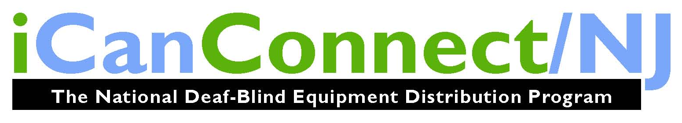
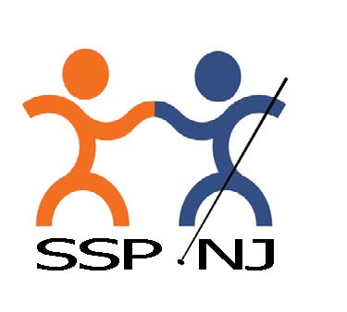

Support Service Providers of NJ
(SSPNJ)
&
iCanConnect (iCCNJ)
serve individuals throughout the State of New Jersey
with combined hearing and vision loss.

Do you have trouble with
your hearing and vision?
Or know someone who does?

SEE IF YOU QUALIFY
SSPNJ: Kathleen Spata 609-771-2795
iCCNJ: Carly Fredericks 609-771-2711

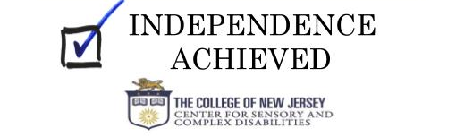
SPORTS & RECREATION LINE UP
By Linda Melendez

Editor’s Note: Linda currently serves as the affiliate’s 1st Vice President, as well as president of the NFBNJ’s Sports & Recreation Division, and a member of the At Large Chapter, and the Senior and Technology divisions.

As we enter our second year as a thriving division, here’s what’s happening in 2019:

- Winter Challenge: Participants were encouraged to download and complete BlindAlive podcasts. Blind Alive has created dozens of audio described exercise videos for all levels of personal fitness geared for the blind and visually impaired.
- Spring Personal Challenge: Push yourself to obtain a personal goal.
- Walking: Join us at mall and park walks, as well as summer Boardwalk Beach Days.
- Bowling League: In North Jersey, our bowling league meets in Belleville for an 8-week commitment.
- Third Annual Step Challenge: Participants are encouraged to walk at least 7,500 steps a day throughout the month of October. All must register before October 1 and complete a survey at the end of the challenge.
- NFBNJ Book Club: This club meets quarterly by conference call. The goal is to learn about the Federation and our members through reading and sharing. The books are chosen by moderator Janie Degenshein. This quarter’s book was “Outside Myself,” written by past NFB National and NFBNJ State Scholarship winner Kristen Witucki. Participants must register online, and all discussions are held on the NFBNJ technology conference call line.

All are welcome to join our monthly conference calls; call in information is available at www.nfbnj.org under Chapters and Divisions. For our exciting events, activities and challenges, use the direct link www.nfbnj.org/sports-and-recreation-calendar.
Special thanks to each member for your participation and engagement. You are the reason the Sports & Recreation Division is so successful. Congratulations to Vee Gaspa, newly elected division secretary, and Trish Ebel, newly elected board member.
Be on the lookout for more exciting events, activities, challenges and a possible autumn state event from the NFBNJ Sports and Recreation Division! Please remember that New Jersey is a big state when using paratransit or public transportation. Our members and friends organize events directed to participants in a specific region of the state so that we spend less time travelling and more time enjoying the event.

Live Your True Essence
Learn 12 Secrets That Will Empower Your Mind, Balance Your Body and Enlighten Your Spirit
A Book by Rose Santiago

BOOK SIGNING: April 12 Trattoria Il Cafone, Lyndhurst 7 PM

Rose’s incredible journey takes us along the winding roads and uneven plains
of the life experiences and physical challenges she overcame
to discover the true essence of who she is in mind, body and spirit.

After more than 20 years of research and education in spirituality, and nearly two decades of study and practice in the world of essential oils and aromatherapy, Rose has created an extraordinary and unique essence that inspired her to write this book. Her passion for knowledge, and her wish to help others who struggle with disempowering thoughts, limiting beliefs and health imbalances has moved her to share her personal stories, ideas and philosophies with the world.

Step into the divine essence that makes you you!
In Live Your True Essence, you’ll learn to:
- Tap into the higher part of yourself that can create limitless possibilities
- Develop behaviors and beliefs that can serve you instead of limit you from being, doing, having and giving more of yourself.
- Understand how to have a positive mindset, learn the value of appreciation, discover the powerful and transformative qualities you hold within your grasp, and learn ways you can grow and expand in thought, despite setbacks so you can live a purpose driven life.
- Learn the harmful effects toxic chemicals can reap on your body and begin to explore the world of essential oils and aromatherapy, as well as plant ingredients to enhance your mood, manage pain and discomfort, and improve physical, emotional, mental, and spiritual imbalances.
- Discover how to express your most authentic and powerful true essence, which you will master with practiced tools such as meditations, affirmations and visualizations to create magic in your life.

Find Live Your Essence at Amazon.com, barnesandnoble.com and Goodreads.com

NFBNJ CONTACT INFORMATION

National Federation of the Blind National Office
President Mark Riccobono 410-659-9314 officeofthepresident@nfb.org
NFB State Affiliate
President Joseph Ruffalo 973-743-0075 nfbnj1@verizon.net
1st Vice President Linda Melendez 732-421-7063 lindamelendez220@gmail.com

2nd Vice President Mary Jo Partyka 609-888-5459 choirnfb@gmail.com
Secretary Ellen Sullivan 302-658-2268 ems553@comcast.net
Treasurer Andrew Rees 732-659-6002 amrees567@gmail.com
Board Members Annemarie Cooke 609-859-4084 aec732@gmail.com
Linda DeBerardinis 856-735-5559 ljdeber3@comcast.net
Jane Degenshein 973-736-5785 jdegen16@comcast.net Mary Fernandez 732-857-7004 mary.fernandez@duke.edu
Veronica Gaspa 434-989-1868 Veronica.gaspa@student.shu.edu
Zoraida Krell 201-439-0120 krellbz@gmail.com

NFBNJ Chapters – Meeting dates, times & available at www.nfbnj.org
At Large Joe Ruffalo 973-743-0075 Nfbnj1@verizon.net
Capital Mary Jo Partyka 609-888-5459 choirnfb@gmail.com
Central Jersey Mac Biggers 801-916-9753 macbiggers@yahoo.com
Garden State Ryan Stevens 856-240-1497 RYSteve@comcast.net
Northeast Dan Facchini 201-906-8655 danfb@verizon.net
Northern Rick Fox 973-743-6107 richardfox1@comcast.net
South Jersey Shore Phil Harrison 609-788-0890 pbharrison39@comcast.net
NFBNJ Divisions
Blind Students Jonathan Zobek 609-216-0181 jrzobek@gmail.com
Parents of Blind Children Carol Castellano 973-377-0976 blindchildren@verizon.net
Senior Blind Jane Degenshein 973-736-5785 Jdegen16@comcast.net
Sports & Recreation Linda Melendez 732-421-7063 lindamelendez220@gmail.com
Technology Jane Degenshein 973-736-5785 Jdegen16@comcast.net
Programs, Projects & Committees

Adopt Adaptive Equipment Joe Ruffalo 973-743-0075 Nfbnj1@verizon.net
BELL Academy Mary Jo Partyka 609-888-5459 choirnfb@gmail.com
Blind Children’s Resource Center Carol Castellano 973-377-0976 blindchildren@verizon.net
Blind Merchants Dan Facchini 201-906-8655 danfb@verizon.net
Blind Parents Joanna Mallard 201-354-0098 joannmallard@gmail.com
Braille Mentoring Program Mary Jo Partyka 609-888-5459 choirnfb@gmail.com
DeafBlind Committee Andrew Rees 732-659-6002 amrees567@gmail.com
Diabetic Committee Ed Godfrey 862-628-3657 edgodfrey1957@gmail.com
Fundraising/Grant Writing Ellen Sullivan 302-658-2268 ems553@comcast.net
GreenDrop Linda DeBerardinis 856-735-5559 Ljdeber3@comcast.net
Guide Dog Committee Dan Facchini 201-906-8655 danfb@verizon.net
HAVA: Help America Ryan Stevens 856-240-1497 RYSteve@comcast.net
Vote Act Liaisons Anthony Lanzilotti 609-361-3038 Tti777@gmail.com
Andrew Rees 732-659-6002 amrees567@gmail.com
KNFB Reader Liaison Rick Fox 973-743-6107 Richardfox1@comcast.net
Legislative Director Ryan Stevens 856-240-1497 RYSteve@comcast.net
Anthony Lanzilotti 609-361-3038 Tti777@gmail.com
Liability Insurance Phil Harrison 609-545-8575 pbharrison39@comcast.net
Membership Engagement Rick Fox 973-743-6107 Richardfox1@comcast.net
NFB-NEWSLINE® Jane Degenshein 973-736-5785 Jdegen16@comcast.net
PAC Plan Coordinator Mac Biggers 801-916-9753 macbiggers@yahoo.com
Parliamentarian Ryan Stevens 856-240-1497 RYSteve@comcast.net
Public Relations/Press Corps Annemarie Cooke 609-859-4084 aec732@gmail.com
Mary Jo Partyka 609-888-5459 choirnfb@gmail.com
Resolutions Committee Ryan Stevens 856-240-1497 RYSteve@comcast.net
Scholarship Committee Mary Fernandez 732-857-7004 mary.fernandez@duke.edu
Social Media Coordinator Zoraida Krell 201-638-3418 krellbz@gmail.com
Sounding Board Kathy Gabry 201-998-9427 Specialk38@aol.com
Annemarie Cooke 609-859-4084 aec732@gmail.com
Mary Jo Partyka 609-888-5459 choirnfb@gmail.com
Barbara Shalit 201-213-2885 barbart@tullensound.com
Spanish Committee Rose Santiago 201-892-6946 rosa.santiago901@gmail.com
Transit Committee Linda Melendez 732-421-7063 lindamelendez220@gmail.com
Vehicle Donation Program Andrew Rees 732-659-6002 amrees567@gmail.com
Webmaster Brian Mackey 610-750-6765 webmaster@nfbnj.org
White Cane Committee Jane Degenshein 973-736-5785 Jdegen16@comcast.net
Ann Marie Harris 856-589-8747 Lovey1160@gmail.com

Deadline for the Fall 2019 issue: September 15, 2019

CHECK US OUT ON THE WEB AT
www.nfbnj.org www.blindchildren.org

To receive The Sounding Board and other information via e-mail,
please contact Ellen Sullivan at ems553@comcast.net

