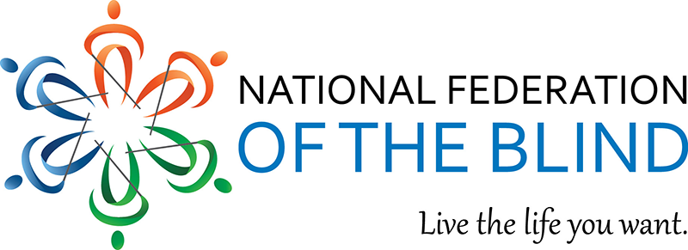

Membership Recruitment: Open House Gatherings – Mini Tool Kit
The National Federation of the Blind is offering monthly open house gathering teleconference calls for prospective members to learn about becoming a member and the benefits of being one. We ask that affiliates, chapters and divisions post to your social media and encourage people who may not yet know us well to check us out!
Here are several examples of content to share -- simply copy and paste the content to the corresponding platform. Excluding the email content, each bullet point represents one post to share at a time. If you have questions, please reach out to Karen Anderson at kanderson@nfb.org.

Twitter Posts
- Learn about becoming a member. Attend the open house gathering on Sunday August 18, 2019 at 4 p.m. EST with Federationists who will highlight membership and the benefits. Sign up by emailing membership@nfb.org.
- Not sure if attending a chapter meeting is right for you? Learn about the National Federation of the Blind on Sunday, August 18, 2019 at 4 p.m. EST. Sign up by calling 410-659-9314, extension 2509
- Are you curious about why it is beneficial to be a member of the National Federation of the Blind? Join our 1-hour long call on August 18 at 4 pm Eastern time. Sign up by calling 410-659-9314 extension 2509 or emailing membership@nfb.org.
- Have you been thinking about becoming a member of @NFB_Voice, but aren’t sure it’s for you? Join an hour-long call on August 18 at 4:00 pm Eastern and get your questions answered by some of our leaders. Sign up by calling 410-659-9314.

Facebook Posts
- NEW! National Federation of the Blind Open House! Join us for a Gathering for blind people curious about becoming a member of the National Federation of the Blind. Two upcoming opportunities:
Sunday, August 18, 2019 | 4 p.m. EST
Wednesday, September 18, 2019 | 8 p.m. EST
Learn about the federation, our philosophy, the membership, and separation of the facts from myths. Sign up by emailing membership@nfb.org or calling 410-659-9314, extension 2509.
- Have you been curious about the National Federation of the Blind? Are you wondering if becoming a member is the right choice for you? Would you like an opportunity to have some of your questions answered by leaders in the Federation? If so, we would love to have you join us for a conference call on Sunday, August 18, at 4:00 pm Eastern time. Sign up by calling 410-659-9314, or emailing membership@nfb.org.
- Share the event link: https://www.facebook.com/events/629540964217531/?ti=icl

Email Content
Not a member yet? Attend the Open House Gathering to learn why we need you and why you need us as well.
Sunday, August 18, 2019 | 4 p.m. EST
Wednesday, September 18, 2019 | 8 p.m. EST
Choose a date that works best for you. Learn more about the federation and why membership is crucial. Join the only organization that believes in the full capacity of blind people.
Our open house teleconferences are for individuals that are curious about the National Federation of the Blind. They offer opportunities for the following:
- meet our National President, Mark A. Riccobono
- receive information from and ask questions of other Federationists
- become informed about the benefits of membership
- dispel myths and misconceptions about the National Federation of the Blind
Sign up by emailing membership@nfb.org or calling 410-659-9314, extension 2509. We look forward to your participation!

