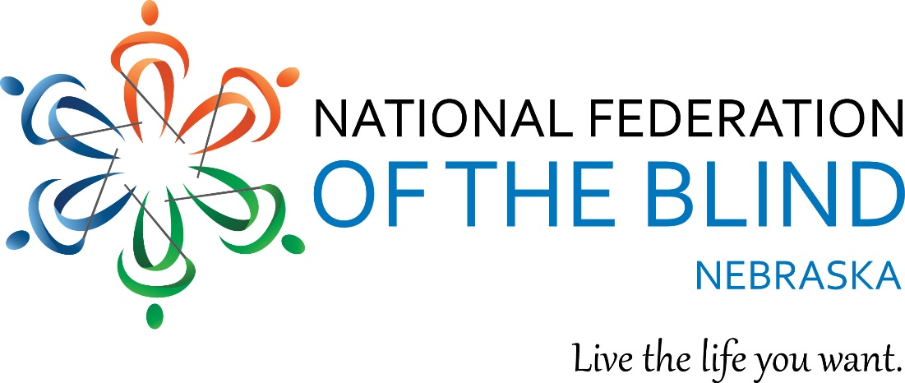
NFB of Nebraska 2019 State Convention
Love! Laugh! Live the Life You Want

It’s almost time for ’49! Reserve your hotel room now and prepare for a weekend of Federation family and fun.

- When: Thursday, October 10 to Sunday, October 13, 2019
- Where: Columbus River’s Edge Conference Center, 265 33rd Ave. Columbus, NE 68601

Call the hotel at (402) 564-1492 to reserve your room, and make sure to let them know you are with the NFB of Nebraska convention. Rooms of $99.95/night, plus tax.

Join NFB of Nebraska as we pan for gold in 2019. There’s something for everyone. Come together to celebrate, learn from and empower each other. Connect with blind Nebraskans fully engaged in living full lives the way they want. Connect with seniors, parents or students. Learn about legislative endeavors and what is happening nationally in the NFB. We will offer seminars on crafting, health and wellness, technology and more. There will be meetings for students, seniors and parents. We have nuggets of gold to offer everyone!

We are pleased to welcome our national representative Mr. Everette Bacon, a member of the national board of directors and president of our NFB of Utah affiliate. He also serves on the Disability Advisory Committee to the Federal Communications Commission, chairs the Utah Library Advisory Board and sits on the Utah Assistive Technology Council and the Library of Congress’ National Library Service for the Blind’s Audio Equipment Advisory Committee (Western Region).

Our 49th state convention will be jam packed with fun. Network with fellow blind and visually impaired Nebraskans during our hospitality kick-off on Thursday evening. Friday will be filled with seminars and sessions, and on Friday evening, party with NFBN as members showcase various talents. Do you sing, dance, tell jokes, read poetry? Come out and entertain us. Meet our state board Saturday morning and then find a meeting perfect for you. Saturday evening will be our annual banquet; Everette Bacon is our keynote speaker and his speech is sure to send us home rich with Federation wisdom. We will wrap up Sunday with more presentations, interactive activities and take care of a little business as well.

Throughout convention, we will also hold our baked good auction. So, don’t miss out on the 2019 convention.
To register or learn more, please visit http://www.ne.nfb.org/2019
Check back often for convention updates.

We look forward to seeing you in Columbus in October!

