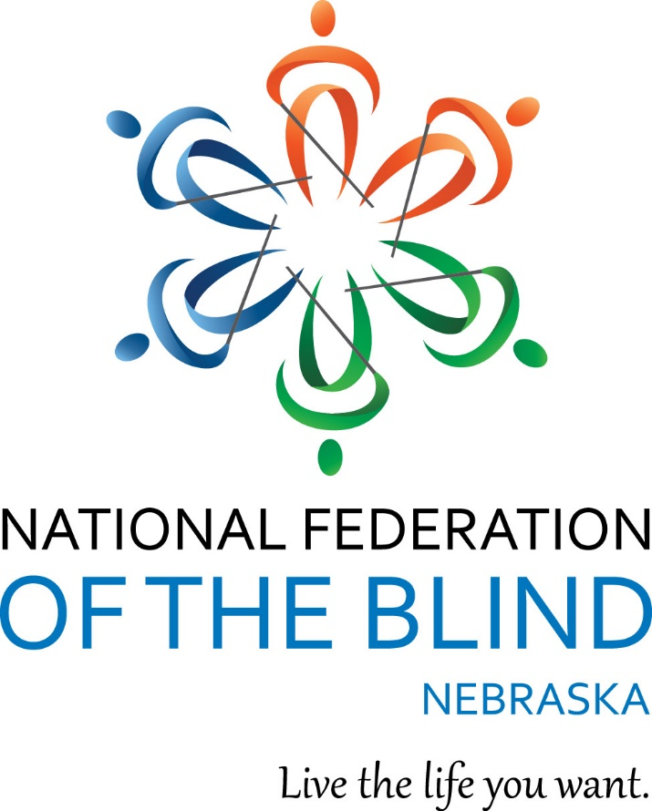

“Dream, Dare, Discover**!”**

**National Federation of the Blind of Nebraska**

**52nd Annual State Convention**

March 23 – 26, 2023

Lincoln Marriott Cornhusker Hotel

333 South 13th Street

Lincoln, NE 68508

**NATIONAL FEDERATION OF THE BLIND PLEDGE**

I pledge to participate actively in the efforts of the National Federation of the Blind to achieve equality, opportunity, and security for the blind; to support the policies and programs of the Federation; and to abide by its constitution.

**Registration**

All convention attendees are required to register. Registration with the convention entitles you to the convention room rate and qualifies you to win door prizes. If you have pre-registered for the convention, please go to the registration area to pick up your registration packet. If you did not pre-register, you may do so in the registration area. The onsite registration fee is $30.00, and banquet tickets purchased onsite will cost $55.00. We will adhere to the registration times strictly so that our registration workers can participate in all convention activities. See the agenda for a list of times and locations of the registration area.

Christine Boone, Chair, Convention Arrangements Committee

**Welcome from the Officers and Board of Directors**

Officers:

President, Jamie K. Richey, Lincoln, NE

First Vice President, Christine Boone, Lincoln, NE

Second Vice President, Michael Hansen, Lincoln, NE

Secretary, Kimberly Scherbarth, Kearney, NE

Treasurer, Cheryl Livingston, Lincoln, NE

Members of the Board of Directors:

Nancy Coffman, Lincoln, NE

Geralyn K. Konruff, Chappell, NE

Rachna Keshwani, Omaha, NE

Maura Loberg, Lincoln, NE

Linda Mentink, Columbus, NE

Rebecca Stevens, Gothenburg, NE

The National Federation of the Blind of Nebraska knows that blindness is not the characteristic that defines you or your future. Every day we raise the expectations of blind people, because low expectations create obstacles between blind people and our dreams. You can live the life you want; blindness is not what holds you back. Together with love, hope, and determination, we transform dreams into reality.

Connect with the National Federation of the Blind!

Like on Facebook: @nebraskasblind

Follow on Twitter: @nfbn

Subscribe on YouTube: @nationalfederationofthebli4597

Check Out Online: http://www.ne.nfb.org.

**We wish to extend sincere gratitude to this year’s convention sponsors!**

**Gold Level Sponsors**



ALLO Fiber

Creating, Connecting and Serving Gigabit Communities Since 2003

ALLO Fiber, founded in Imperial, Nebraska, in 2003, is a telecommunications company offering fiber telephone, long-distance, broadband, internet and television to residents and businesses. ALLO currently provides communications services to 34 cities across Nebraska, Colorado and Arizona. ALLO has developed a world-class network to expand business opportunities, create jobs and improve quality of life. We at ALLO take immense pride in providing residents and businesses with unmatched entertainment and communications options. It is our mission to create, connect and serve Gigabit communities.

(866) 481-2556

[www.allocommunications.com](http://www.allocommunications.com)

Christian Record Services, Inc. Logo

Christian Record Services, Inc.

Empower People Who are Blind to Engage Their Communities and Embrace the Blessed Hope

Each year, Christian Record Services, Inc. impacts thousands of lives through services provided to them without cost. All who are legally blind or have physical impairments that prevent them from holding reading material or focusing on ink print are eligible for the following free services:

* Full-Vision Books
* Zoo Buds
* National Camps for Blind Children
* Gift Bibles and Study Guides
* Subscription Magazines
* Naomi Chapman Turner Library for the Blind

Christian Record Services, Inc. is a ministry of the Seventh-Day Adventist Church in North America, serving people of all faiths and walks of life who are blind worldwide.

(402) 488-0981

info@christianrecord.org

www.christianrecord.org

**Silver Level Sponsors**

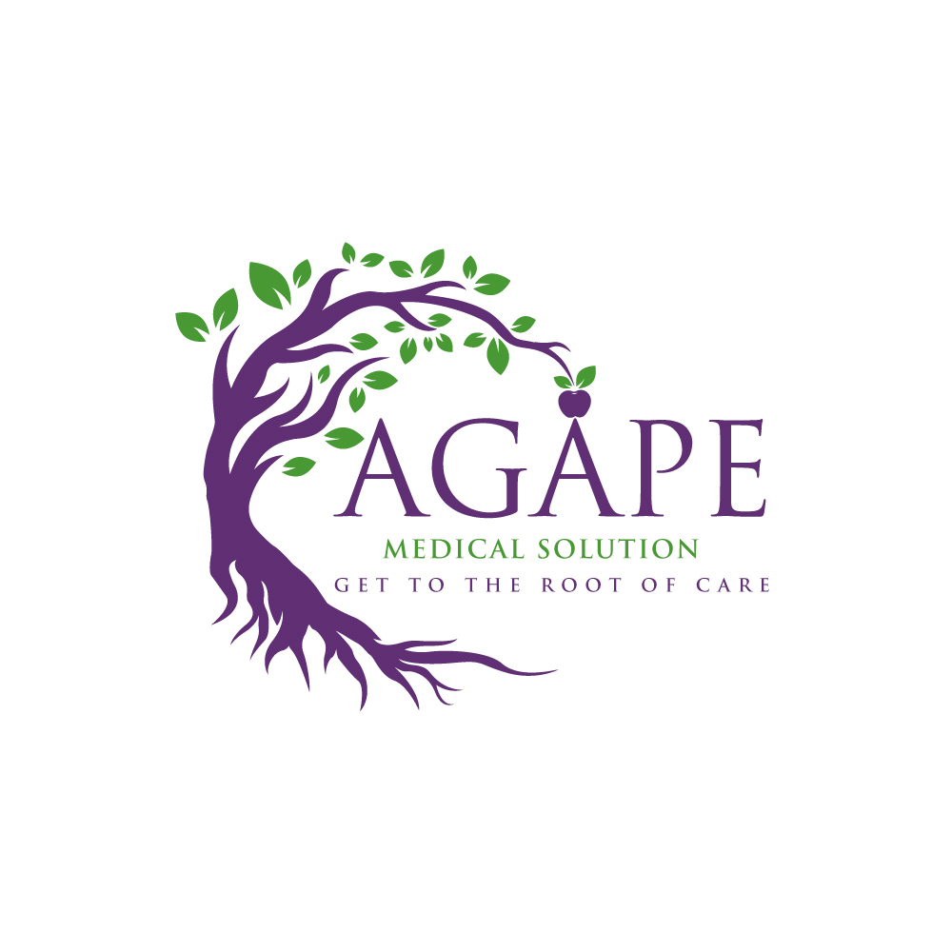

Agape Medical Solution, LLC

Matching The Best Nurses To The Best Opportunities

AGAPE was chosen for what it stands for, “Unconditional Love.” Agape Medical Solution, LLC is licensed, bonded and insured and we can match our medical staff to your needs. Whether your need is in long-term care facility, hospital, or clinic staff support, we can help you. We are extremely compassionate, skilled and experienced in caring for individuals who need acute hospital or long-term care.

Contact: Becca Stevens, Owner/ Director of Operations

(308) 529-7405

Becca@agapemedicalsolution.com

[www.agapemedicalsolution.com](http://www.agapemedicalsolution.com)

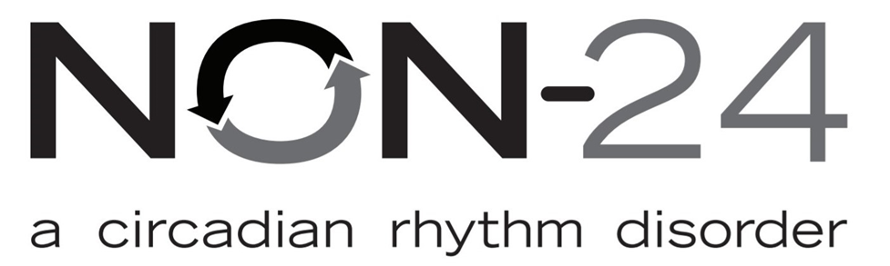

Vanda Pharmaceuticals, Inc.

Innovate in the Service of People’s Pursuit of Happiness

Non-24-Hour Sleep Wake Disorder (Non-24) is a serious chronic disorder that can lead to disrupted sleep-wake cycles. Up to 70% of people who are totally blind have Non-24 and may not even know it. Trouble falling asleep, staying asleep and daytime sleepiness are signs of Non-24 as well as waking up feeling groggy or tired.

Contact: Jennifer Lyman, Non-24 Nurse Educator

(202) 875-4714

jennifer.lyman@vandapharma.com

[www.vandapharma.com](http://www.vandapharma.com)

Lincoln Cabinet Logo


Lincoln Cabinet

Quality without Compromise

Lincoln Cabinet is a full-service design and remodeling company. We are known for kitchen and bathroom design, but we can do so much more!

Contact: Lori Wellman, Co-Owner

(402) 475-0650

info@lincolncabinet.com

[www.lincolncabinet.com](http://www.lincolncabinet.com)

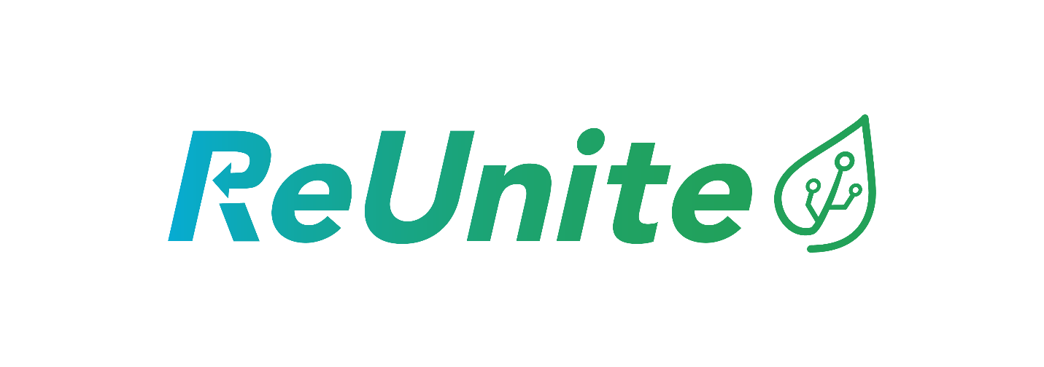

ReUnite

Recycling On-Demand

ReUnite makes it easy to request a curbside collection service. We partner locally to reuse, recycle, or properly dispose of what is collected. Our partners use our software to process, manage and track collections.

Contact: Tyler Jacobson, Co-Owner

(402) 853-3266

tyler@reunite.eco

[www.reunite.eco](http://www.reunite.eco)

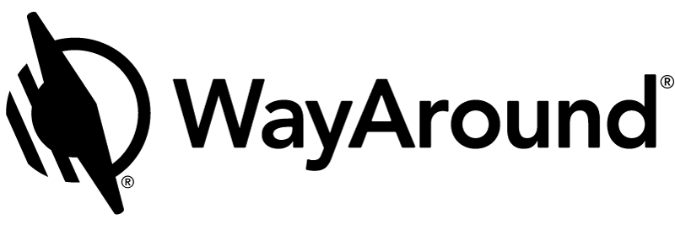

WayAround®

See beyond the limits of a visual world.

Born from the minds of two architects with vision loss, WayAround is more than just a revolutionary product. It's a movement led and fueled by people who may not have great eyesight, but who definitely have a vision. WayAround is the app for your smart device that provides on-demand details about everyday things. The simple tag-and-scan approach lets you quickly and easily identify things around you. WayAround was started with a can-do practicality and a lofty purpose: to provide limitless opportunities for people with vision loss. WayAround is providing accessible information at this year's convention. A WayTag will be placed on your badge when you check in at registration. Then, scan the WayTag with your iPhone or Android device to get accessible menus and the agenda. Be sure to download the free WayAround app for iOS or Android.

Contact: Jessica Hipp, Chief Operating Officer

(888) 898-4465

connect@WayAround.com

www.WayAround.com

**The National Federation of the Blind of Nebraska Welcomes Our Honored Guests!**

**National Representative: Mark A. Riccobono, President, National Federation of the Blind**

Born in Milwaukee, Wisconsin, Mark Riccobono was diagnosed with glaucoma and aniridia at age five. Nonetheless, Mark attended public schools, graduating with honors while active in debate and track. Mark earned a bachelor's degree in business administration at the University of Wisconsin-Madison. He became a member of its Iron Cross honor society and was the founding president of the Wisconsin Association of Blind Students. During his senior year, Mark was elected president of the NFB of Wisconsin. After graduation, Mark joined the Sears executive trainee program, and spent his free time advocating for the blind. He was appointed to the Wisconsin State Superintendent’s Blind and Visual Impairment Education Council and became the first director of the Wisconsin Center for the Blind and Visually Impaired, an agency responsible for statewide services to blind children. Afterward he took a position in Baltimore with the NFB and earned a Master of Science in Educational Studies from the Johns Hopkins School of Professional Studies in Business and Education.

Mark served as the executive director of the NFB Jernigan Institute until he was elected to serve as the NFB president in 2014. Mark and his wife Melissa live in Baltimore, Maryland, with their three children.

**Tyler Merren**

Tyler is a 4-time Paralympic athlete, Motivational Speaker, Personal Trainer and founder and CEO of ReVision Training, LLC. Born in Michigan with an eye condition known as Retinitis Pigmentosa, Tyler, despite his visual challenges, grew up with a love for sports and activities, which transferred into his Baccalaureate in Exercise Science and career as a Personal Trainer and Elite Athlete. His wife Leanne, who is also blind, and he have four children and currently live in Greenville, Michigan, where Tyler is working for Camp Tuhsmeheta, running his business, developing the ReVision Fitness audio fitness program, homeschooling his children, training for the USA Team and being the best husband and father he can be. Tyler believes that blindness is a challenge, not a barrier, and teaches that, with the right skills and determination, all things are achievable.

**David DeNotaris**

David is a speaker, trainer, and leading rehabilitation and business consultant. He has been a longtime Federationist, winning his first state scholarship in 1990 from the NFB of New Jersey. David has held several leadership positions, including NFB-Newsline® Coordinator and Job Opportunities for the Blind Coordinator. David has worked as a job coach, job developer, Coordinator of Assistive Technology for the New Jersey Commission for the Blind and has served as Director of the Pennsylvania Bureau of Blindness and Visual Services  and the Executive Director of the Pennsylvania Office of Vocational Rehabilitation. David is the founder and CEO of Sky’s the Limit Communications, LLC. He lives in Hershey, Pennsylvania, with his wife Mariann of 27 years and 3 children: David Jr, a law student at the University of Pittsburgh; MaryKate, a senior at the University of Scranton; and Emily, a freshman at Temple University; and fuzzy good friend Valentino, a silver lab.

**Eileen Rivera Ley**

Eileen is a longtime member of the National Federation of the Blind, having joined the organization while attending Harvard University. The NFB awarded her its top merit scholarship in 1986, supporting her studies at the Wharton School of Business. Upon graduation, Eileen worked as Administrative Director for the Johns Hopkins Low Vision Research and Rehabilitation Center. Since then, she has been a loyal and dedicated member of the Federation, assisting in local, state and national efforts to improve opportunities for blind and low vision people. Her work has focused extensively on the needs of those experiencing diabetes and low vision. She has held numerous positions within the NFB and at present she is a board member of the Diabetes Action Network.

Alongside her husband Thomas Ley, leader of the NFB Diabetes Action Network, Eileen advocated for the needs of Blind and Low Vision people with diabetes and their caregivers. Eileen and Tom authored the Federation’s bill of rights for blind diabetics; and after one of their children developed diabetes at age 4, Eileen became the Director of diabetes initiatives for the National Federation of the Blind. She and Tom collaborated on the creation of a fully accessible, talking glucose meter called the Prodigy Voice glucose meter. Eileen says: “I thank God for the National Federation of the Blind each day. This is a way of life, and it has made me who I am. I will always be at their service.” Eileen is the founder and CEO of Blind Savvy USA in Towson, Maryland; creating innovative training programs and resources to empower blind youth, and others, to unlock their highest potential.

**J.J. Meddaugh**

J.J. is the founder and CEO of A. T. Guys, a technology sales, training and consulting company based in Kalamazoo, Michigan. Since 2008, A T Guys has developed and distributed products and services to benefit people who are blind and visually impaired, and has partnered with numerous companies, including Fortune 500 businesses, on accessibility and usability projects. He enjoys goalball, playing the keyboard and local cuisines.

**Convention Details**

**Assistive Listening Devices**

Both FM-Loop and Bluetooth systems are available for those who need assistance. Visit the information table near the main doors of the Lancaster 4,5,6 rooms for details.

**Child Care**

Pre-registration was required for this service. Child care will be provided throughout the convention.

Please note the following schedule:

Friday: 8:30 a.m. - 5:30 p.m.

Saturday: 8:30 a.m. - 10:00 p.m.

Sunday: 8:30 a.m. - Noon

**Guide Dog Relief Areas**

The dog relief areas immediately adjacent to the hotel are on both the north and the south sides. These grassy areas are between the sidewalk and the street surrounded by a low curb. Additionally, there is a larger grassy area on the east side of 13th street directly across from the hotel. Please be courteous and clean up any waste.

**Door Prizes**

A variety of door prizes will be drawn during each general session and at the banquet. Attendees must be registered with the convention to be eligible for a door prize and must be present to win. Drop off all door prize donations in the registration area during the assigned registration times.

Kimberly Scherbarth, Chair, Door Prize Committee

**Agenda**

**Thursday, March 23, 2023**

6:00 - 8:00 p.m. Registration and Packet Pick-up

Renaissance Room – Mmezzanine Level

Christine Boone, Convention Arrangements Chair

6:00 - 9:30 p.m. Welcome Reception

Renaissance Room– Mmezzanine Level

Light Hors D’oeuvres and a cash bar will be available.

**Friday, March 24, 2023**

7:30 - 9:00 a.m. Registration and Packet Pick-up

Lower-Level Registration Desk

Christine Boone, Chair, Convention Arrangements Committee

7:30 - 8:30 a.m. Greater At-Large Chapter Meeting

Lancaster 6

This is the annual face-to-face meeting of the chapter. Chapter members are encouraged to attend, and guests are welcome!

Kimberly Scherbarth, President, National Federation of the Blind of Nebraska Greater At-Large Chapter

**General Session I**

**Lancaster 4,5,6**

9:00 a.m. Call to Order

Jamie K. Richey, President, National Federation of the Blind of Nebraska, Lincoln, NE

9:05 a.m. Invocation

Shane Buresh, Member, National Federation of the Blind of Nebraska, Lincoln, NE

9:15 a.m. Welcome to The Star City

Leirion Gaylor Baird, Mayor, City of Lincoln, Lincoln, NE

9:35 a.m. Beyond the Books: Updates from TBBS

Matt Hier, Studio Manager, Nebraska Library Commission Talking Book and Braille Service, Lincoln, NE

9:55 a.m. Beyond the Mic: The Latest and Greatest From RTBS

Bekah Jerde, Executive Director, Radio Talking Book Service, Omaha, NE

10:15 a.m. Fit Break

10:20 a.m. Not Just a Living, But a Life: Updates from NCECBVI

Dr. Tanya Armstrong, Superintendent, Nebraska Center for the Education of Children who are Blind or Visually Impaired, Lincoln, NE

10:45 a.m. Passion to Make a Difference: Updates on the Graduate Program in Visual Impairments

Mackenzie Savaiano, Associate Professor of Practice, University of Nebraska at Lincoln, Lincoln, NE

11:10 a.m. One Step at a Time

Alexander France, Omaha, NE

11:30 a.m. Adjourn

11:30 a.m. - 6:30 p.m. Exhibits

Lower-Level Lobby

Refer to the exhibitor packet for a list of exhibitors and descriptions.

Note: Prove you have visited all the exhibitors by getting your exhibitor card punched at each table and win some cash! The cards will be placed in a drawing on Sunday. Must be present to win.

Rachna Keshwani, member, Convention Arrangements Committee

Noon - 1:00 p.m. Keynote: Seeing the Champion Within

Lancaster 1,2,3

Tyler Merren, CEO, ReVision Training, LLC, Greenville, MI

1:00 - 5:00 p.m. Registration and Packet Pick-up

Lower-Level Registration Desk

Christine Boone, Chair, Convention Arrangements Committee

1:00 - 4:00 p.m. Silver Is Thought, Gold Is Decision: Senior Seminar and Annual Meeting

Arbor 1

When blindness comes, thought and decision are necessary to Live the Life You Want. The National Federation of the Blind can help you to reach the gold! Participate in this joint seminar between the Nebraska Commission for the Blind and Visually Impaired and the NFB of Nebraska Senior Division!

Robert Newman, President, National Federation of the Blind of Nebraska Senior Division

1:00 - 3:00 p.m. Accessible Fitness

Arbor 2

Grab your sweats and water bottle and get ready for a fully accessible fitness session for all levels of fitness with 4-time Paralympian, Personal Trainer and creator of ReVision Fitness - The Audio Fitness App! Work your way through a fully accessible workout with modifications to fit everyone’s fitness level. Discuss best ways to make fitness accessible and what resources are available to help you find your fit.

Tyler Merren, CEO, ReVision Training, LLC

3:00 - 5:00 p.m. Designing a Life of Wholeness

Ivanhoe Room

Learn how to live a life of design through wellness and the balancing of mind, body and spirit. Get tricks for goal setting, self-empowerment and tools you can use in your journey.

Becca Stevens, Owner, Trifecta Wholeness Consulting, LLC

4:00 - 6:45 p.m. Access Equals Success: Student Seminar and Annual Meeting

Olive Branch Room

Join the Nebraska Association of Blind Students as they partner with Sky's the Limit Communications, LLC and Blind Savvy USA; to deliver an interactive, memorable and meaningful student seminar that will help students prepare for success in school, community and one-day competitive employment.

Brandon Peters, President, Nebraska Association of Blind Students

7:00 p.m. NFB of Nebraska Board of Directors Meeting

Lancaster 4,5,6

This meeting is open to all!

8:00 p.m. Resolutions Committee

Lancaster 4,5,6

All attendees are encouraged to attend, as this is where you will learn about the resolutions for this year. Resolutions which pass the committee will then be voted on by the membership During general sessions of the convention. Resolutions are the birthplace of what becomes the policy and action of our affiliate.

Barbara Loos, Chair, Resolutions Committee

9:30 - 11:30 p.m. Trivia

Olive Branch Room

Grab your friends and join in the fun! Select items will be auctioned off and a cash bar will be available!

Deb and Jeff Altman, Facilitators

**Saturday, March 25, 2023**

7:00 - 7:30 a.m. Nominating Committee

Ivanhoe Room

This is the only closed meeting within the National Federation of the Blind of Nebraska.

Christine Boone, Chair, Nominating Committee

7:30 - 8:30 a.m. Yoga

Arbor 2

Beginner to expert, get motivated for the day!

Venus Lopez, Owner, Venus’ Yoga Flow

**General Session II**

**Lancaster 4,5,6**

9:00 a.m. Call to Order

Christine Boone, First Vice President, National Federation of the Blind of Nebraska, Lincoln, NE

9:05 a.m. Invocation

Dan Coffman, Member, National Federation of the Blind of Nebraska, Lincoln, NE

9:10 a.m. Presidential Report

Jamie K. Richey, President, National Federation of the Blind of Nebraska, Lincoln, NE

9:30 a.m. National Report

Mark A. Riccobono, President, National Federation of the Blind, Baltimore, MD

10:15 a.m. Fit Break

10:20 a.m. Empowering Blind Individuals, Promoting Opportunities, and Building Belief in the Blind

Carlos Servan, Executive Director, Nebraska Commission for the Blind and Visually Impaired, Lincoln, NE and Erin Brandyberry, Deputy Director of Services, North Platte, NE

10:50 a.m. The Journey Beyond Vision

Nina Rongisch, Director of Fund Development, Outlook Enrichment, Gretna, NE and Stephanie Skavdahl, Disability Services Coordinator, Bennington, NE

11:20 a.m. Reports and Resolutions

11:30 a.m. Adjourn

Noon - 1:00 p.m. Keynote: Transforming Obstacles to Opportunities Using the 4 F’s

Lancaster 1,2,3

David DeNotaris, CEO, Sky’s the Limit Communications, LLC, Hershey, PA

1:00 - 4:00 p.m. Skills That Can Pay The Bills and Give You Thrills!

Arbor 1

Join the Nebraska Commission for the Blind and Visually Impaired along with David DeNotaris and Eileen Rivera Ley to find out what employers are looking for and what employers want to know, but really cannot ask. Participate in mock interviews and learn how your network will improve your leg work.

David DeNotaris, CEO, Sky’s the Limit Communications, LLC and Eileen Rivera Ley, CEO, Blind Savvy USA

1:00 - 3:00 p.m. Accessible Fitness

Arbor 2

Grab your sweats and water bottle and get ready for a fully accessible fitness session for all levels of fitness with 4-time Paralympian, Personal Trainer and creator of ReVision Fitness - The Audio Fitness App! Work your way through a fully accessible workout with modifications to fit everyone’s fitness level. Discuss best ways to make fitness accessible and what resources are available to help you find your fit.

Tyler Merren, CEO, ReVision Training, LLC

1:00 - 3:00 p.m. Ask the Expert

Ivanhoe Room

Get all your technology questions answered and see product demonstrations from A. T. Guys.

J.J. Meddaugh, CEO, A. T. Guys

3:00 - 5:00 p.m. In Touch with Art

Arbor 2

Come join us and experience some fun. Let your fingers stroll through several tactile art projects. You will have an opportunity to tease your creativity with a variety of supplies and have something to show for your efforts.

Barbara Loos and Tammy Freitag, Facilitators

3:00 - 5:00 p.m. Show and Tail

Ivanhoe Room

Leap into the first annual guide dog breakout session! Whether you’re just interested in a guide, or you’ve been a handler for decades, this is your one stop shop for our 4-footed friends. Hear from a panel of handlers, as well as a leader of the National Association of Guide Dog Users. Get all your questions answered and enjoy some off-harness doggy cuddles!

Maura Loberg, Moderator

6:00 p.m. Cocktail Reception

Lancaster 1,2,3

7:00 p.m. Annual NFB of Nebraska Banquet

Lancaster 1,2,3

Barbara Loos, Master of Ceremonies, Lincoln, NE

Invocation: Christine Boone, First Vice President, National Federation of the Blind of Nebraska, Lincoln, NE

Keynote Address: Mark A. Riccobono, President, National Federation of the Blind, Baltimore, MD

NFBN Scholarship Presentation: Bob Burns, Chair, Scholarship Committee, Omaha, NE

Get on the PAC Plan: Barbara Loos, Chair, PAC Plan Committee, Lincoln, NE

9:30 - 11:30 p.m. Jailhouse Karaoke

Lancaster 1,2,3

Pay $10 to get a friend arrested! They must either pay bail or sing their way out of the slammer! Warrants for arrest can be found at registration and must be served by Friday evening. A cash bar will be available.

Maura Loberg, Vice President, Nebraska Association of Blind students

**Sunday, March 26, 2023**

7:30 - 8:30 a.m. Non-Denominational Devotions

Lancaster 3

Christine Boone and Linda Mentink, Facilitators

**General Session III**

**Lancaster 4,5,6**

9:00 a.m. Call to Order

Jamie K. Richey, President, National Federation of the Blind of Nebraska, Lincoln, NE

9:05 a.m. Invocation

Linda Mentink, Board Member, National Federation of the Blind of Nebraska, Columbus, NE

9:15 a.m. You’ve Got to Know When to Fold ‘Em

Shane Buresh, Member, National Federation of the Blind of Nebraska, Lincoln, NE

10:00 a.m. Fit Break

10:05 a.m. Reports:

Minutes of the 2022 NFB of Nebraska State Convention

Kimberly Scherbarth, Secretary, National Federation of the Blind of Nebraska, Kearney, NE

2022 Annual Treasurer's Report

Cheryl Livingston, Treasurer, National Federation of the Blind of Nebraska, Lincoln, NE

Roll Call of Chapters and Divisions

A. Columbus Area Chapter

B. Greater At-Large Chapter

C. Lincoln Chapter

D. Omaha Chapter

E. Nebraska Association of Blind Students

F. Senior Division

Resolutions Committee Report

Barbara Loos, Chair, Resolutions Committee, Lincoln, NE

Scholarship Awards

Bob Burns, Chair, Scholarship Committee, Omaha, NE

Nominating Committee Report

Christine Boone, Chair, Nominating Committee, Lincoln, NE

Elections

11:30 a.m. Why Am I a Federationist?

Michael Hansen, Second Vice President, National Federation of the Blind of Nebraska, Lincoln, NE

11:45 a.m. Crossing the Finish Line

Noon Adjourn