B E N E F I T C O N C E R T
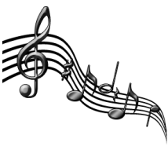D U LIKE MUSIC?
Delta Upsilon
Joins with the Nebraska Association of Blind Students
for a night of Music!!!

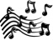Bathtub DogsRacktavoChances Areand more...
Friday, April 23rd at the Sheldon from 6:30-9:00
12 th & R St Lincoln, NE 68523- (402) 472-2461

Benefit this Benefit by attending!!
For ticket Information call
Stephanie Wagle- (402) 515-2221
or…
Mike Mazgai- (402) 709-9432
or…
Any of the friendly Delta Upsilon brothers

“Any of us would be thrilled to sell you $5 tickets before the show or you can get in for $8 at the
door!” -Any of us

All show proceeds go towards seminars and events put on by the Nebraska Association of Blind Students; a student run and funded group who believes with the right tools, every blind student can be successful and independent.
Tell your friends, tell your loved ones, tell your enemies, tell everybody you know to come and support.


