
The Nebraska Association of Blind Students (NABS) Presents The 2011 Student Seminar:
Puzzle it Out- Collecting the Pieces of Success!

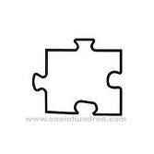
What: It’s time for the Third Annual NABS student Seminar. We have gone beyond the horizons of our dreams and dived into the depths of our potential and now we are putting the puzzle pieces of our future together! This is an opportunity to learn the skills that can help you, your child or your student succeed, as well as network with fellow blind students, parents and teachers across Nebraska, and of course have fun!!
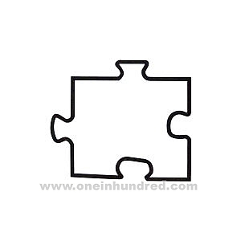
When: The seminar begins at 6:00 PM on Friday, March 26, and ends Sunday, March 28 at 11:00 AM, so don’t worry about missing any class!

Where: Doubletree Guest Suites
7270 Cedar St.
Omaha, NE, 68124
Who: Blind Students of all ages, and the parents and teachers who want to see them succeed.

Cost: The $20 registration fee will cover the cost of both your room and meals for the duration of the seminar.

Scholarships are available for participants who are unable to cover the $20 registration. Preference will be given to those who request assistance first. Contact Karen Anderson (402-319-7645) if interested

